

COMP390

2022/23

Reinforcement Learning in Unity

Student Name: Zherui Fan

Student ID: 201600330

Supervisor Name: Flavia Alves

DEPARTMENT OF

COMPUTER SCIENCE

University of Liverpool

Liverpool L69 3BX



COMP390

2022/23

Reinforcement Learning in Unity

DEPARTMENT OF

COMPUTER SCIENCE

University of Liverpool

Liverpool L69 3BX

**1. Abstract**

**2. Table of Contents**

**3. Introduction & Background**

**3.1 Introduction**

This is a research-based project, which aims to use state-of-the-art reinforcement learning algorithms to train agents in different simple video game environments in Unity, make a comparative analysis of the results, then make a further study on the algorithm with better performance, including finding methods to optimize the agent model trained by chosen algorithm and exploring the inner structure and implementation of algorithm at the code level.

**3.2 Background**

**3.2.1 Reinforcement Learning**

Reinforcement learning (RL) is one of three basic machine learning paradigms, alongside supervised learning and unsupervised learning [1]. Unlike the supervised learning, reinforcement learning doesn’t need labelled input/output pairs (i.e. explicit final goal), and there is no need to correct sub-optimal actions explicitly [1]. The main focus of reinforcement learning is to make the agent act based on the environment, change the behavioral decision through self-balancing, and finally achieve the maximum expected benefit [2]. Reinforcement learning algorithms are mainly divided into two categories: Value-Based algorithm and Policy-Based algorithm [3]. A classic Value-Based algorithm is the Q-learning algorithm, which maximizes the expected benefits of all subsequent actions from the current state by building a table containing actions and states [3]. However, because a Q table needs to be built, Q-learning algorithm can only solve the problem that actions and states can be counted and the number is small [3]. One of the most basic Policy-Based algorithms is the Policy Gradient algorithm, it updates the parameters of the policy network by calculating the gradient of the income expectation [3]. However, Policy Gradient algorithm can only use the return to update the parameters after each training session and cannot update them in real time, so the training efficiency is poor and it is easy to not converge [3]. Because both types of algorithms have their advantages and disadvantages, the Actor-Critic (AC) framework ---- a framework that combines the advantages of Value-Based algorithm and Policy-Based algorithm, is often used [3]. Most of popular algorithms are based on the AC framework, including Trust Region Policy Optimization (TRPO) algorithm and Proximal Policy Optimization (PPO) algorithm, these two algorithms are part of the best current algorithms in theory and practice [3]. Over the next decade, reinforcement learning will enable one of the biggest breakthroughs in AI field, enabling algorithms to learn from environments to achieve arbitrary goals instead of fixed actions [2]. The "reasoning ability" that reinforcement learning brings to agent is a key feature of intelligence, and it really gives the machine the ability of learning and thinking by itself [4].

**3.2.2 RL Algorithms with best performance in modern game area**

In recent years, Proximal Policy Optimization (PPO) and Soft Actor-Critic (SAC) have emerged as two of the most effective reinforcement learning algorithms in the domain of modern game reinforcement learning. PPO is a policy gradient method that has been shown to be robust to hyperparameter choices and can scale to large-scale problems [5]. It achieves state-of-the-art results in various game environments, such as Atari games, MuJoCo physics simulations, and humanoid locomotion, surpassing other popular algorithms such as Trust Region Policy Optimization (TRPO) and Advantage Actor-Critic (A2C) [5]. PPO has been shown to have improved sample efficiency, stability, and ease of use compared to previous methods [6].

SAC, on the other hand, is a model-free off-policy algorithm that uses a soft actor-critic framework to optimize the policy and value function [7]. SAC maximizes a trade-off between the expected return and the entropy of the policy, resulting in more diverse and exploratory behavior [7]. SAC has been shown to achieve state-of-the-art performance on a wide range of continuous control tasks, including game environments , compared to other model-free algorithms such as Deep Deterministic Policy Gradient (DDPG) and Twin Delayed DDPG (TD3) [8]. SAC has also been shown to be robust to different choices of hyperparameters and able to learn effectively from high-dimensional observations such as images [9].

In summary, the superior performance of PPO and SAC in modern game reinforcement learning is supported by empirical studies that demonstrate their ability to achieve state-of-the-art performance across a variety of tasks and environments. PPO and SAC also have several characteristics that make them particularly well-suited to this domain, including robustness to hyperparameters, scalability, improved sample efficiency, and more diverse and exploratory behavior [5][7][9]. These factors contribute to their status as two of the most widely used and effective reinforcement learning algorithms in modern game development.

**3.2.3 PPO&SAC: Detailed Algorithm**

**1) Proximal Policy Optimization (PPO) [5]**

**·Overview**

Proximal Policy Optimization (PPO) is a family of policy gradient methods for reinforcement learning that aim to improve the stability and sample efficiency of traditional policy gradient methods. The basic idea of PPO is to optimize a surrogate objective function that approximates the policy gradient, while constraining the policy update to a "trust region" around the current policy to ensure that the policy remains close to the original distribution.

All variants of PPO consist of two main components: a sampling procedure and an optimization procedure. In the sampling procedure, the agent interacts with the environment by taking actions according to the current policy and collecting a batch of trajectories. These trajectories are used to estimate the advantage function, which measures the advantage of taking an action in a particular state compared to the expected value of the state. The advantage function is then used to compute the surrogate objective function.

In the optimization procedure, the policy is updated by minimizing the surrogate objective function using a stochastic gradient descent algorithm such as Adam. The gradient is computed using samples from the current batch of trajectories, and the policy is updated by taking a step in the direction of the gradient, subject to the trust region constraint.

PPO-Clip (PPO2) is the most widely used variant of PPO. The PPO-Clip algorithm updates the policy by minimizing a clipped surrogate objective function, which constrains the policy update to a trust region around the current policy. The clipped surrogate objective function is defined as:

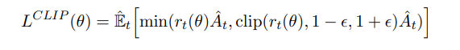

where θ is the policy parameters, At is the advantage function, and rt(θ) is the ratio of the probability of the action under the new policy and the old policy. The clip function constrains the policy update to a small range around the current policy, preventing large changes that could lead to instability. The hyperparameter ε controls the size of the trust region.

PPO-Penalty(PPO1), on the other hand, is a variant of PPO that uses a penalty function to constrain the policy update. The PPO-Penalty algorithm updates the policy by minimizing a surrogate objective function that includes a penalty term that discourages the policy from straying too far from the current policy. The penalty function is defined as:

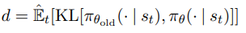

where π θ (·|st) is the new policy, π θ old(·|st) is the old policy, and KL[A, B] is the  adaptive KL divergence between the policies. The surrogate objective function is defined as:

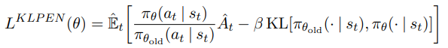

where β is a hyperparameter that controls the importance of the penalty term. The PPO-Penalty algorithm encourages the policy to stay close to the current policy, while still allowing for updates that improve the expected reward.

**·Pseudocode**

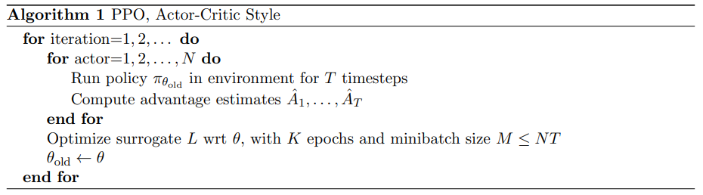

**·Key characteristics**

PPO1:

* Use a clipped surrogate objective function to constrain the policy update to a trust region around the current policy. This allows PPO1 to update the policy more efficiently and with greater stability compared to traditional policy gradient methods.
* Use a fixed KL penalty term to constrain the policy update, which can lead to instability in certain types of environments or policies. To address this issue, PPO1 incorporates a heuristic that adjusts the strength of the penalty term based on the divergence between the new and old policies.

PPO2:

* Also use a clipped surrogate objective function to constrain the policy update to a trust region around the current policy. However, PPO2 uses a different clipping method that constrains the ratio of the probabilities of the actions under the new and old policies. This method has been shown to be more effective and robust than the clipping method used in PPO1.
* Incorporate an adaptive KL penalty term that adjusts the strength of the constraint on the policy update based on the divergence between the new and old policies. This improves the flexibility of PPO2 to handle different types of environments and policies compared to PPO1.

Overall, PPO2 is an improvement over PPO1 in terms of stability and efficiency.

**2) Soft Actor-Critic (SAC) [7]**

**·Overview**

Soft Actor-Critic (SAC) is a model-free, off-policy algorithm for reinforcement learning that aims to learn policies that are both stable and efficient. The key innovation of SAC is the use of a soft value function as a critic, which provides a more accurate estimate of the expected return than traditional value functions. The soft value function is learned by minimizing the Kullback-Leibler (KL) divergence between the policy and a target distribution, while maximizing the expected reward.

The SAC algorithm consists of three main components: an actor network (policy network) that learns the policy, a critic network (value network) that learns the soft value function, and a target network that is used to stabilize the learning process. In the training procedure, the actor and critic networks are updated by minimizing the loss functions that correspond to their respective objectives.

The actor network is trained using the maximum entropy reinforcement learning framework, which encourages exploration by maximizing the entropy of the policy distribution. The objective function for the actor is defined as:

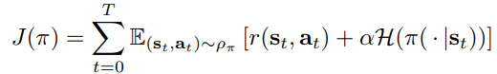

where π is the actor parameters, r(st, at) is the reward function, H(π(·|st)) is the entropy of the policy distribution, and α is a hyperparameter that controls the importance of entropy regularization. The actor is trained using stochastic gradient descent to maximize the objective function.

The critic network is trained using the soft Q-learning algorithm, which estimates two soft Q-values that correspond to the state-action value function and the state value function. The soft Q-values are learned by minimizing the KL divergence between the policy and a target distribution, while maximizing the expected reward. The soft Q-learning objective function is defined as:

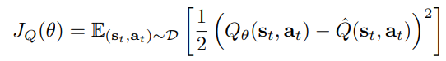

where QΘ(st, at) is the soft Q-value, θ is the critic parameters, and:

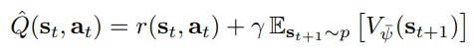

The target value is computed as a combination of the expected reward and the soft value function of the next state. The soft value function is computed by taking the minimum of the two soft Q-values of the next state.

To improve the stability of the learning process, SAC uses a target network that is updated slowly to match the current actor and critic networks. The target network is used to compute the target values for the soft Q-learning objective function, and is updated by exponential moving average of the current network parameters.

The temperature parameter in SAC controls the degree of exploration by scaling the entropy of the policy distribution. The temperature parameter is updated during training using a gradient descent step that maximizes the expected entropy of the policy distribution.

**·Pseudocode**

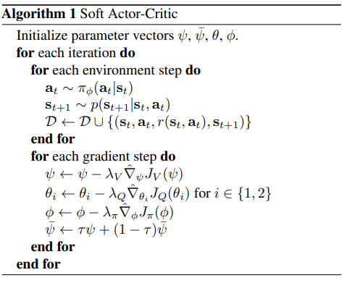

**·Key characteristics**

* Use a soft value function as a critic, which provides a more accurate estimate of the expected return compared to traditional value functions. The soft value function is learned by minimizing the KL divergence between the policy and a target distribution, while maximizing the expected reward.
* Incorporate a maximum entropy framework that encourages exploration by maximizing the entropy of the policy distribution. This allows SAC to learn more diverse and robust policies that can adapt to different types of environments and tasks.
* Use a temperature parameter to control the degree of exploration, which can be tuned to balance between exploration and exploitation. This allows SAC to learn policies that are both efficient and adaptable to different types of environments.

**4. Aims & Objectives**

**4.1 Aims**

* Use two different reinforcement learning algorithms to train agent model in 4 different simple video games.
* Successfully analyse the training results and find a particular reinforcement learning algorithm performs better.
* Explore how to train a better agent model by using existing algorithm in 1 more game and try to reimplement this algorithm.

**4.2 Objectives**

* Successfully use Unity to run 4 simple video games.
* Successfully understand the game environment (like reward setting) of each simple video game.
* Successfully use PPO and SAC algorithm to train agent model in each game.
* Successfully generate the training results which can be analysed.
* Successfully identify the algorithm that performs better overall.
* Explore the way to train a better agent model while using RL algorithm in a new game.
* Successfully Reimplement the better algorithm at the code level.

**5. Design**

Because this project focuses more on research purpose, this part will mainly talk about the design of research process.

**5.1 The First Aim**

Based on the background part, two reinforcement learning algorithm are chosen: Proximal Policy Optimization (PPO) and Soft Actor-Critic (SAC).

And four simple video game environments are chosen:

3DBall, Crawler, FoodCollector, Pyramids.

All the algorithms and simple video environments are provided by Official Unity ML-Agents Toolkit.

Here is an overview of the four games and why they are a good choice for comparing the performance of PPO and SAC algorithms:

1) 3DBall: In this simple environment, an agent must balance a ball on a platform. The agent receives a reward for the amount of time the ball stays on the platform, and the task becomes progressively harder as the platform tilts. This game tests the algorithms' ability to learn and adapt to a single object manipulation task. It serves as a good baseline to compare PPO and SAC since it is relatively simple and does not involve other complexities.

2) Crawler: In this environment, an agent must learn to control a multi-legged robot to navigate a terrain. The agent is rewarded for moving forward as fast as possible. This game introduces the challenge of coordinating multiple parts to achieve a common goal, testing the ability of PPO and SAC to learn complex, coordinated actions. It also provides a more complicated scenario compared to 3DBall, shows how the algorithms scale to more complex tasks.

3) FoodCollector: In this game, multiple agents compete in a confined space to collect food items while avoiding poisonous items. Agents receive positive rewards for collecting food and negative rewards for collecting poison or colliding with other agents. This environment introduces competitive and cooperative aspects, as agents need to balance exploration and competition. It allows the testing of PPO and SAC in a multi-agent scenario and evaluation about their performance in handling inter-agent interactions.

4) Pyramids: In this environment, agents must navigate a large, maze-like space to find and manipulate objects to reach a goal. The agents are rewarded for completing the task as quickly as possible. This game presents a more complex exploration challenge, as the agents need to make decisions about which path to take and how to interact with objects. It tests the algorithms' ability to learn efficient exploration strategies, handle large state spaces, and develop "curiosity" in complex environments.

These four games form a progressive sequence that tests the capabilities of the PPO and SAC algorithms in different aspects, from single-object manipulation to multi-agent interactions and exploration in large environments.

**5.2 The Second Aim**

As the primary objective of this section is comparing which algorithm performs better overall, based on the principle of controlling variables, this section will not involve any changes to the environment, hyperparameters, or agent components.

After completing training agents using 2 algorithms in 4 game environments, the training results of each agent will be presented in the form of diagrams. By plotting various parameters over time, the learning progress, stability, and efficiency of each algorithm can be deeply understood.

Here are some key parameters to evaluate an algorithm:

1) Cumulative Reward: This is the total reward collected by the agent over time. A higher cumulative reward indicates better performance on the task. This is the main measure to compare which algorithm performs better in solving the given task.

2) Episode Length: This is the number of time steps an agent takes to complete an episode. In some cases, shorter episode lengths can indicate more efficient learning, as the agent is able to complete the task more quickly. This parameter can provide insights into the time efficiency of the algorithms.

3) Entropy: Entropy measures the randomness of the agent's policy. A higher entropy indicates that the agent is exploring more and taking diverse actions, while a lower entropy means the agent is more focused on exploiting known good actions. This parameter shows the trade-off between exploration and exploitation of the algorithms.

4) Policy Loss: Also known as the actor loss, it measures how well the agent's policy predicts the optimal actions in a given state. Lower policy loss indicates that the algorithm is more accurate in predicting the value of taking certain actions. This parameter can show which algorithm is better at estimating action values and making decisions.

5) Value Loss: Also known as the critic loss, it measures how well the agent's value function estimates the true value of a state or the value of taking an action in a state. A lower value loss indicates that the algorithm is better at estimating the value of being in certain states. This parameter can show which algorithm’s value estimation is more accurate.

6) Q1/Q2 Loss: For SAC, it uses two Q-value functions to estimate action values, the Q1 and Q2 losses represent the difference between the predicted and actual Q-values. This parameter can show how accurately the algorithms are estimating action values.

However, while policy/value loss and entropy can provide insights into the learning dynamics of the individual algorithms, comparing the performance of PPO and SAC based on their policy/value loss and entropy directly is not ideal, as these algorithms have different loss function and entropy function designs, learning approaches, and objectives. The policy and value losses in each algorithm are specific to their learning dynamics and don't necessarily have a one-to-one correspondence.

In addition, in most reinforcement learning environments, the Episode Length does not significantly impact the evaluation of algorithms. This is because many game environments award points based on how long the agent can maintain a particular state. In this case, the Episode Length is directly proportional to the Cumulative Reward and can be replaced by it. In other game environments, the length of each episode is fixed, making the Episode Length irrelevant. Therefore, the priority of Episode Length can be reduced to the minimum in this context, and will not be considered in most cases.

As a conclusion, the following metrics will be presented to compare the performance of the PPO and SAC algorithms in this project. The importance and priority of these metrics gradually decrease from top to bottom:

1) Cumulative Reward: The higher the highest cumulative reward of an algorithm, the better the performance of this algorithm. In the context of reinforcement learning, Cumulative Reward refers to the total reward that an agent accumulates within one episode, rather than a continuous accumulation that increases with each episode. It is also called the "episodic reward" or "episode return".

2) Stability: The more stable the Cumulative Reward of an algorithm, the better the performance of this algorithm. An algorithm is considered stable if it converges to a good policy without significant oscillations or degradation in performance. Stability is an essential aspect of reinforcement learning, as unstable algorithms can lead to divergence, poor performance, or failure to learn an optimal policy.

3) Convergence Speed: The faster an algorithm reaches its highest cumulative reward, the better the performance of this algorithm. Comparing the rate at which the algorithms converge to optimal or near-optimal policies can provide insights into their learning efficiency.

4) Real Training Time: The less the time consumed during training process, the better the performance of this algorithm. The real training time must also be considered as it represents the actual time cost invested.

**5.3 The Third Aim**

To explore how selected algorithms can be used to train better agents, an open-source game environment called AI Racing Kart was chosen. This game consists of a simple racing environment with complex tracks and multiple cars. The agent can control the car's forward and backward movements, as well as its continuous turning. The agent's objective in this game is to complete one lap around the track as quickly as possible, with a higher score awarded for faster completion. The algorithm chosen in the second aim will be used to train an agent in this game environment with self-defined agent script.

Subsequently, the focus will be shifted back to the 3DBall environment. A PPO algorithm will be implemented from scratch to train the agent for the 3DBall environment, and its results will be compared with those of the PPO algorithm provided by ml-agents, aiming to analyze the potential for improvement.

**5.4 Structure Arrangement of Main Contents**

The first and second aims will be arranged in the Implementation part, at the end of implementation part, a small conclusion will be presented regarding which algorithm performs better.

Then the third aim will be arranged in the Testing part, because they are all about testing and exploring the better algorithm.

**6. Implementation**

**<Declaration**: All the game environments and algorithm used in this section are from the **sample project of Official Unity ML-Agents Toolkit Release19**. Source code: <https://github.com/Unity-Technologies/ml-agents/releases/tag/release_19>**>**

**All the code screenshot except complete code are well-commented or be explained before/after itself.**

Every simple video game environment part will contain following section:

- Simple introduction about game

- Environment appearance

- Environment explanation (including description of important components, script interpretation and presentation of training hyperparameter configuration)

- Training results of each algorithm and the comparison between two algorithms

- Summary

**6.1 Common information**

1) Necessary components

After setting up the environment, to start training, a series of components need to be mounted under the agent. The following three components are required and critical:

- Behavior Parameters: To drive the agent, developers need to attach the Behavior Parameters component under the agent to adjust various parameters.

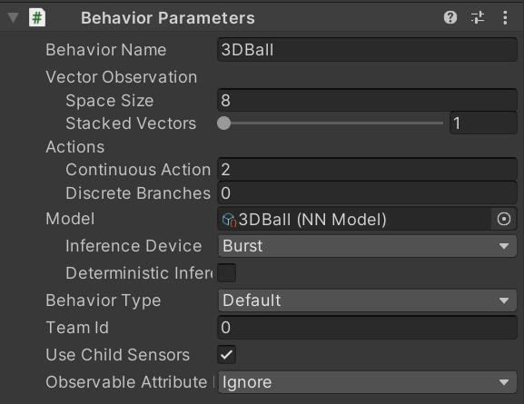

Developers need to modify the Space Size parameter, which represents the input dimension (for example, position input is usually three-dimensional, velocity and angular velocity are both three-dimensionaland, rotation involves quaternion, so it is four-dimensional). Action represents the output, with Continuous Action as continuous action output, and Descrete Branch as discrete action output. All the input and output size are computed from the agent script.

The name in the Behavior Name field must be consistent with the name on the second line of the training hyperparameter configuration file. If developer want to train different agents with different configurations, only need to add configuration files with different names and use that name in the corresponding agent's Behavior Name field.

- Decision Requester: This component provides a convenient way to trigger the decision-making process of the agent. The number of steps to take decisions and whether to execute actions when decisions are not taken can be adjusted.

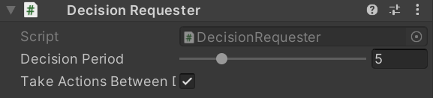

- Agent Script: This script must inherit the Agent class. By default, only one parameter MaxStep needs to be set, and setting it to 0 means unlimited.

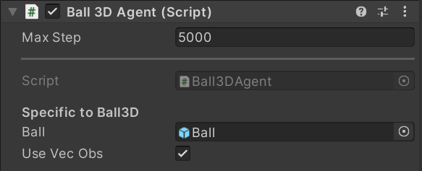

2) Common methods in agent script

In the agent script, ml-agents provides several common methods:

- Initialize(): This method initializes the environment, retrieves component information, and sets parameters.

- CollectObservations(): This method collects various environmental information during the current game, including the position and velocity of the agent. ML-Agents automatically generates tensors for these data and performs calculations. This method is used to set the input for the neural network. If the input is from a camera instead of a vector, this function does not need to do anything.

- OnActionReceived(): This method implements the actions taken in one step during the game. It receives the output from the neural network, translates it into actions for the agent, sets the reward function, and checks whether the game has ended.

- OnEpisodeBegin(): This method handles tasks that need to be done when each game ends and a new one begins, such as resetting position information.

- Heuristic(): If developer want to operate the agent ourselves, we also need to define this method. This way, the game can collect the output information from the player and learn from their thinking, greatly promoting the training process.

- CollectDiscreteActionMasks(): This method is used to block certain unnecessary AI actions in special situations, such as preventing agents from going beyond the boundaries of the map.

**6.2 3DBall**

**6.2.1 Introduction**

In the 3DBall environment, agents are tasked with controlling a platform to balance a ball. The environment consists of multiple platforms, each with an agent controlling it. These agents can move their platforms in two dimensions (forward/backward and left/right) to balance the ball and prevent it from falling. The longer the agents can balance the ball on their platforms, the higher their cumulative reward.

1) Agent:

Each agent in the 3DBall environment has two primary components: observations and actions.

- Observations: The agent receives a set of observations from the environment, which are used to make decisions. In 3DBall, the observations consist of the position, rotation, and velocity of the platform and the position and velocity of the ball.

- Actions: Based on the received observations, the agent takes actions to control the platform. In 3DBall, actions are continuous and have two dimensions: one for horizontal movement (left/right) and one for vertical movement (forward/backward). Each action value ranges from -1 to 1, with negative values moving the platform left or backward, and positive values moving the platform right or forward.

2) Reward system:

The reward system is crucial in reinforcement learning, as it guides the agent's learning process. In the 3DBall environment, the agent is rewarded as follows:

- Positive Reward: The agent receives a reward of +0.1 for every step the ball remains on the platform. This encourages the agent to balance the ball for as long as possible.

- Negative Reward: If the ball falls off the platform, the agent receives a negative reward, and the episode ends. In some implementations, there may not be an explicit negative reward, but the termination of the episode implicitly signals failure to the agent.

**6.2.2 Appearance**

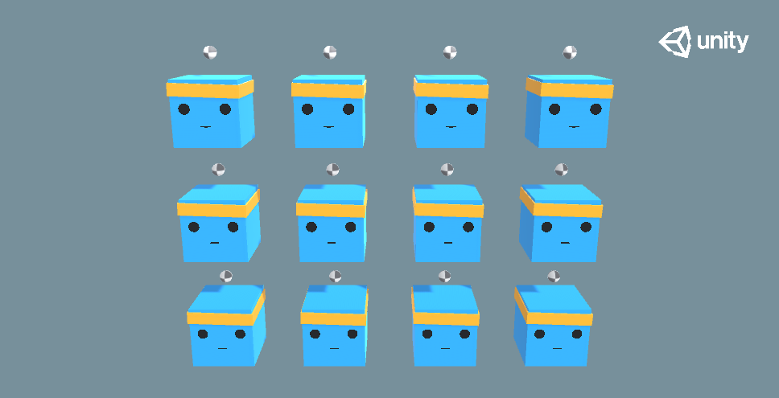

**6.2.3 Environment**

1) Important components

- Behavior Parameters

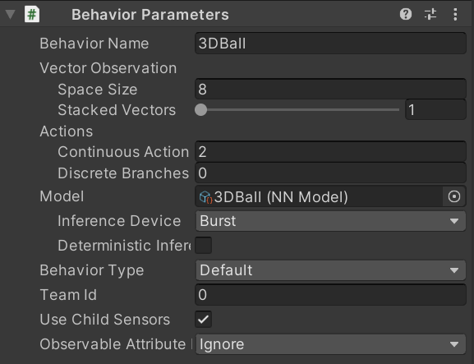

Space Size (Input Size): 8 dimensions

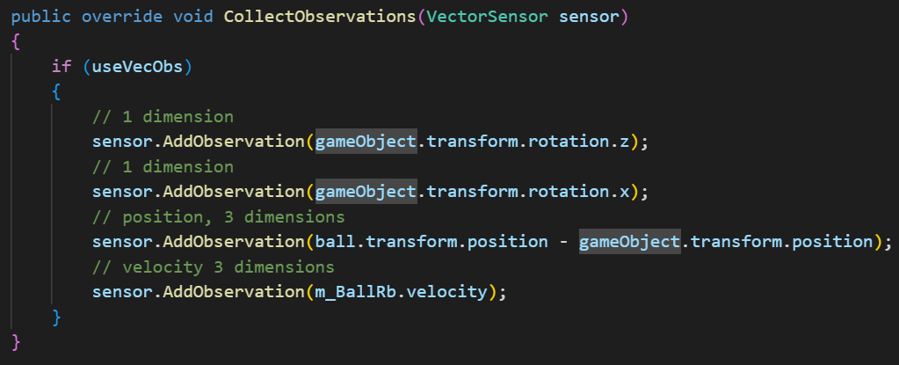

Continuous Action (Output Size): 2 dimensions

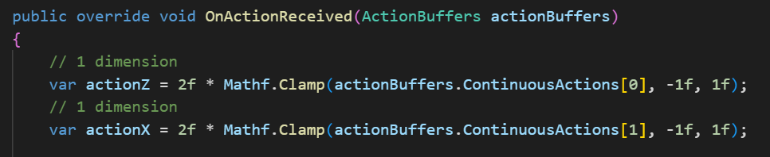

2) Agent script

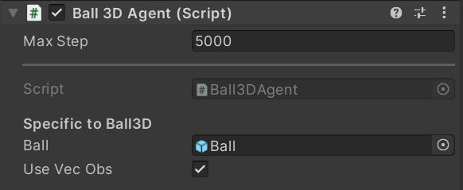

Complete code:

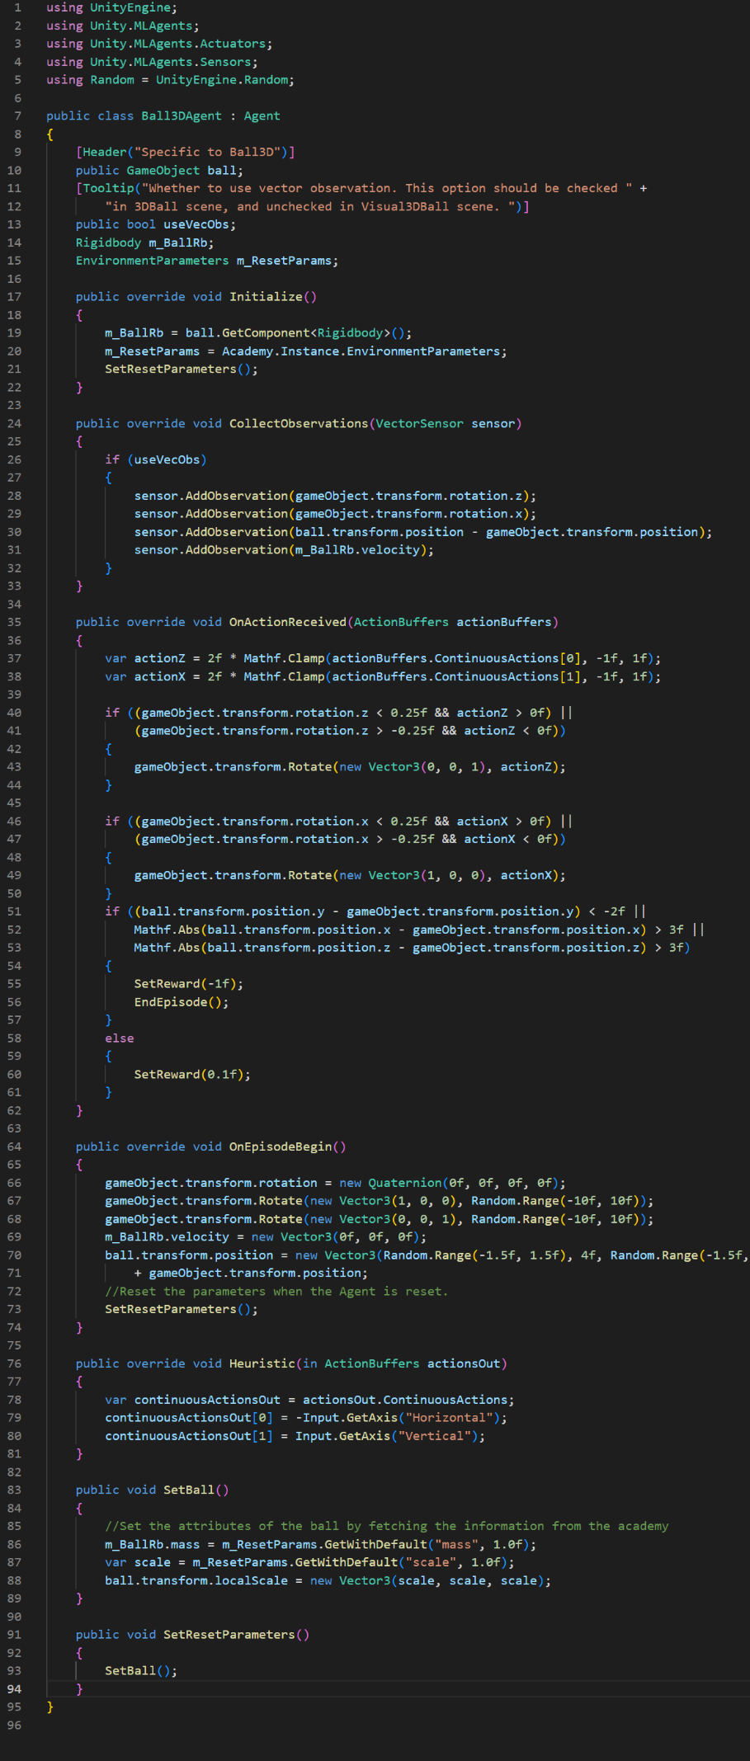

Here are some important methods:

- CollectObservations()

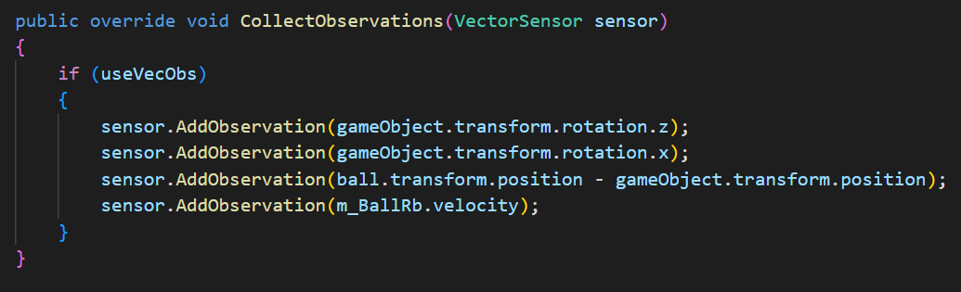

This method is responsible for collecting observations from the environment to be used by the agent for decision-making. If useVecObs is true, the method collects the following observations:

The platform's rotation along the z-axis.

The platform's rotation along the x-axis.

The position of the ball relative to the platform.

The velocity of the ball.

- OnActionReceived()

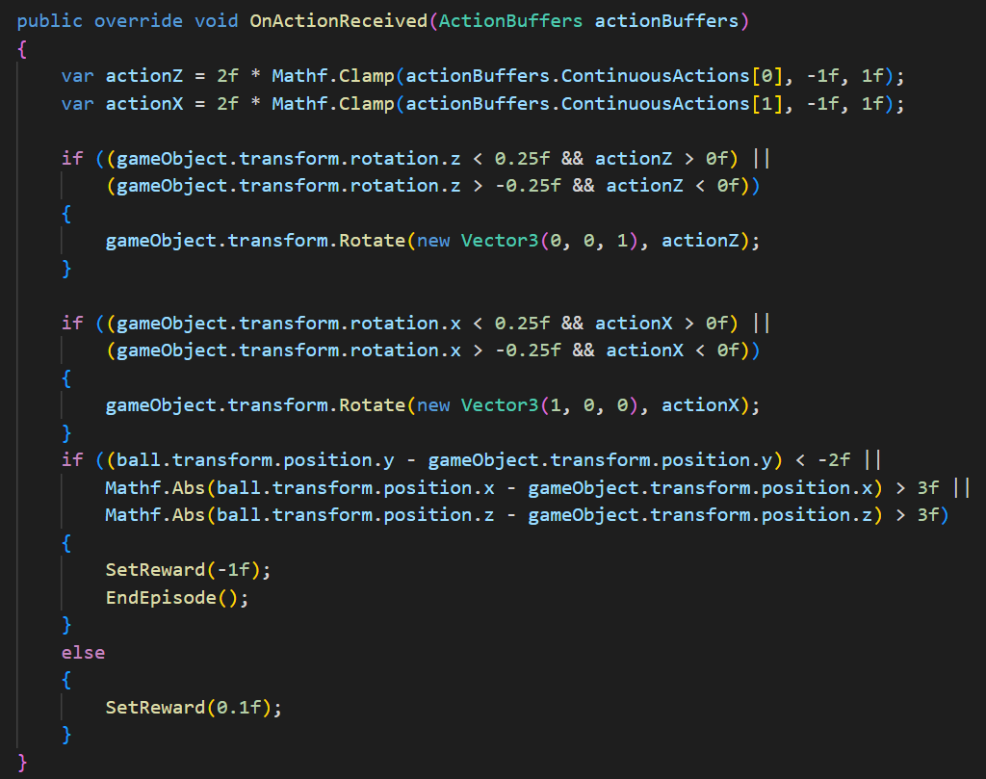

This method handles the agent's actions based on the received action buffers. It processes continuous actions (actionZ and actionX) to control the rotation of the platform along the z-axis and x-axis. It also calculates the reward based on the ball's position relative to the platform. If the ball falls off the platform or goes too far, the agent receives a negative reward (-1f), and the episode ends. Otherwise, it receives a positive reward (0.1f).

- SetBall() and SetResetParameters()

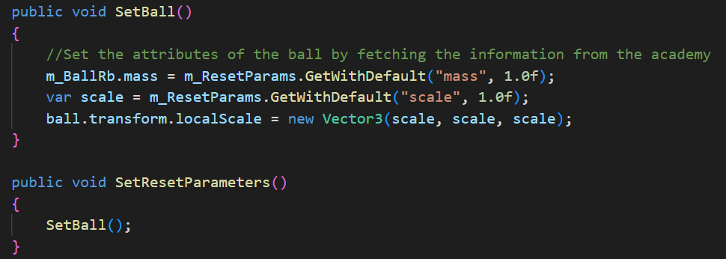

SetBall() sets the ball's mass and scale based on the environment parameters.

SetResetParameters() calls SetBall() to reset the ball's attributes (mass and scale) based on the environment parameters. This method is called during the agent's initialization and at the beginning of each episode.

3) Training hyperparameter configuration

PPO:

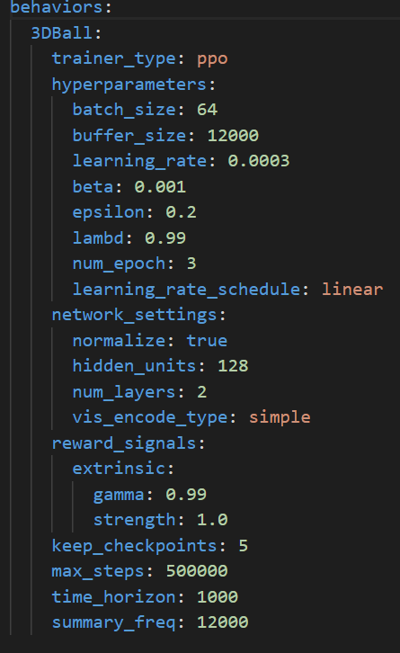

SAC:

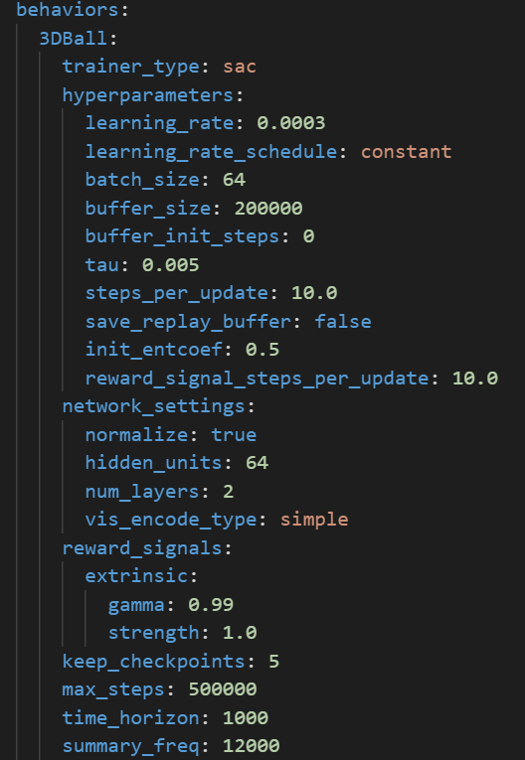

**6.2.4 Training results and comparison**

PPO result:

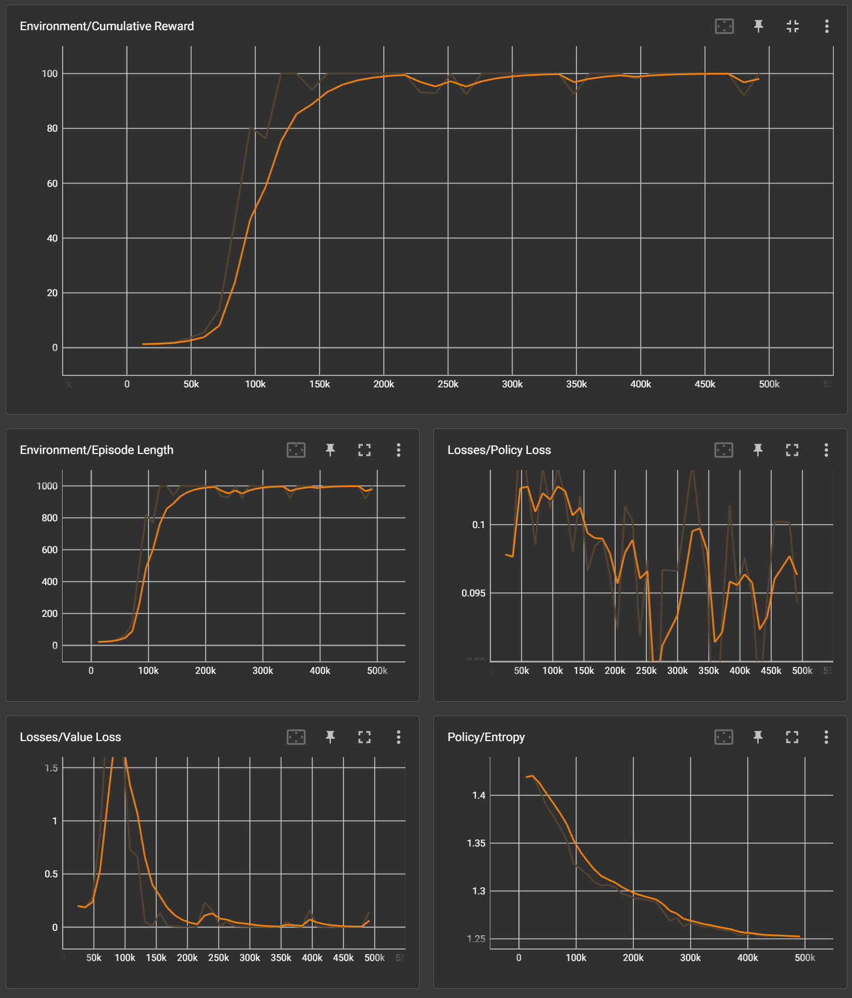

SAC result:

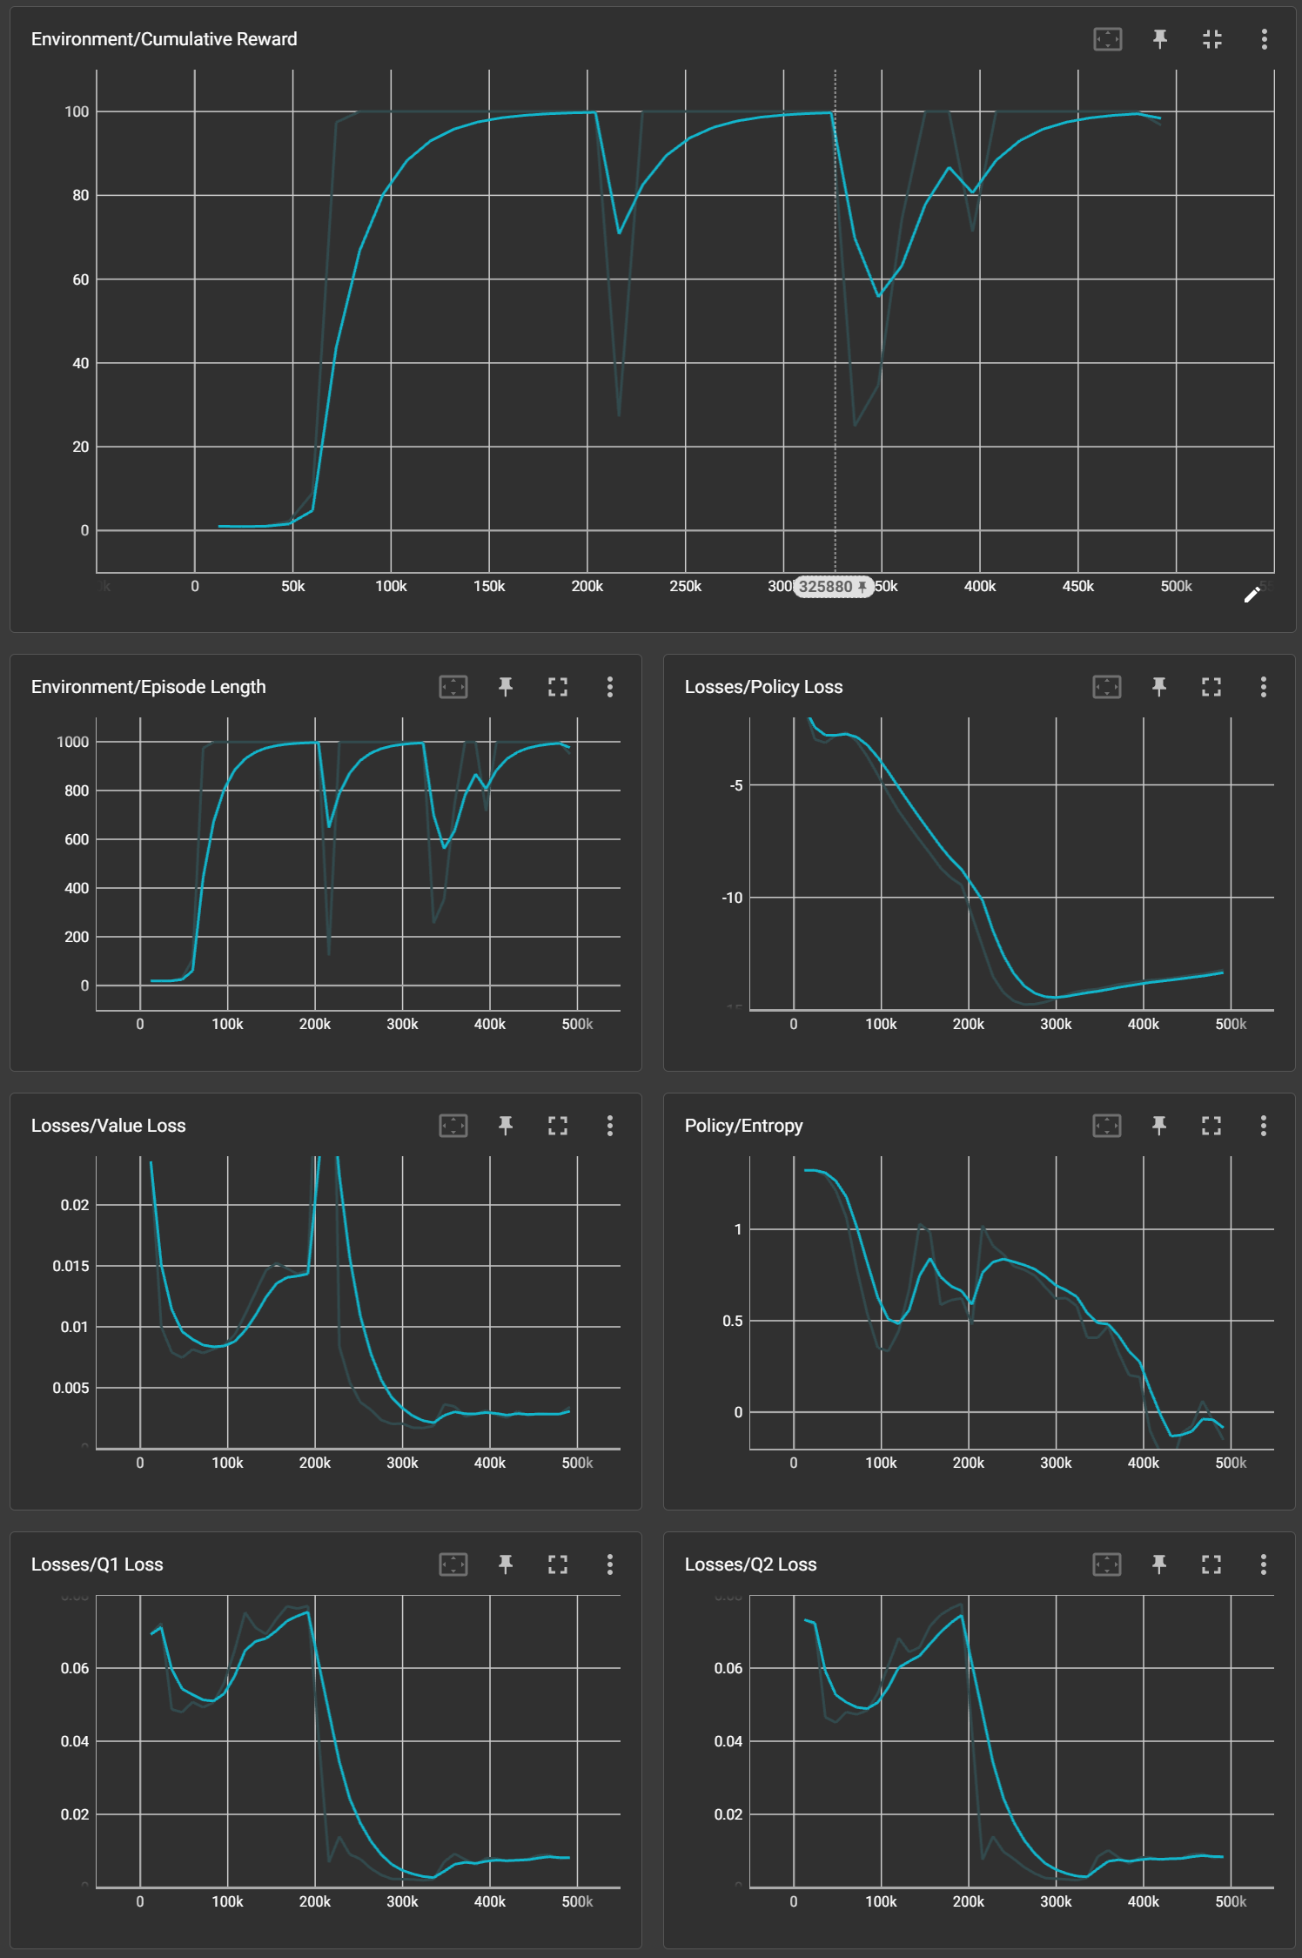

Comparison:

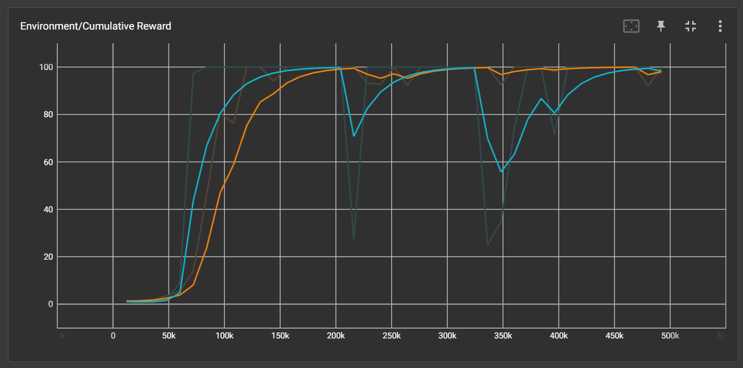

Comparison metrics:

1) Cumulative Reward:

According to the diagram, both algorithms have reached a maximum Cumulative Reward of 100, indicating that they performed equally well on this metric.

2) Stability:

According to the diagram, the result of the SAC algorithm shows severe oscillations, with a record of dropping down to 60 points after reaching the maximum Cumulative Reward. Meanwhile, the PPO algorithm is extremely stable, and it has never dropped below 90.

3) Convergence Speed:

According to the diagram, the result of the SAC algorithm is shown to increase more rapidly and smoothly than it of the PPO algorithm, and it reaches the highest Cumulative Reward with a slight time advantage over PPO.

4) Real Training Time:

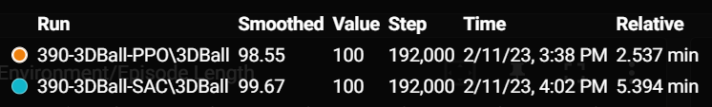

The time consumed by PPO is the half of SAC.

**6.2.5 Summary**

In summary, although SAC has a slight advantage in convergence speed, it lags behind PPO in stability. SAC also need to consume more time. Therefore, PPO performes better in relatively simple environment.

**6.3 Crawler**

**6.3.1 Introduction**

The Crawler environment consists of a multi-legged creature, referred to as the Crawler, placed on a flat surface. The agent's objective is to learn an efficient locomotion strategy for moving the Crawler toward a target while maintaining its balance. The environment showcases the use of ML-Agents for training agents with more complex control schemes, involving multiple degrees of freedom and hierarchical control structures.

1) Agent:

The agent in the Crawler environment has two primary components: observations and actions.

- Observations: The agent receives a set of observations from the environment, used to inform decision-making. In the Crawler environment, the observations include the ground contact status, joint strength, target walking speed, and the relative position and orientation of the target.

- Actions: Based on the received observations, the agent takes actions to control the Crawler's joints. In the Crawler environment, actions are continuous and consist of target angles and joint strengths for each joint. The agent must learn to generate appropriate target angles and joint strengths to achieve efficient locomotion.

2) Reward System:

The reward system in the Crawler environment is designed to encourage agents to learn effective locomotion strategies. The agent is rewarded based on the following:

- Ground Contact Penalty: The agent receives a minus reward for touching the ground with Crawler’s body. This encourages the agent to develop a stable and balanced locomotion strategy.

- Matching Velocity Reward: The agent receives a reward for matching the target walking speed. This reward is computed based on the difference between the actual speed and the goal walking speed. This encourages the agent to develop a locomotion strategy that maximizes forward movement.

- Look At Target Reward: The agent receives a reward for aligning the Crawler's forward direction with the target direction. This encourages the agent to develop a locomotion strategy that aligns with the desired direction.

- Target Reward: The agent receives a reward for toughing and “eat” the target box. This is a very regular reward setting.

**6.3.2 Appearance**

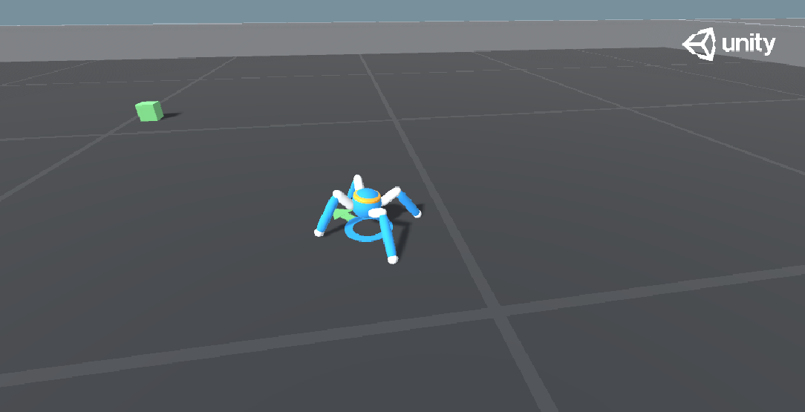

**6.3.3 Environment**

1) Important components

- Behavior Parameters

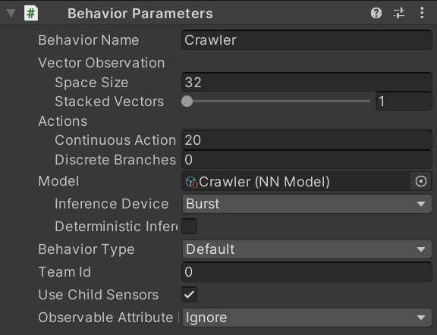

Space Size (Input Size): 32 dimensions

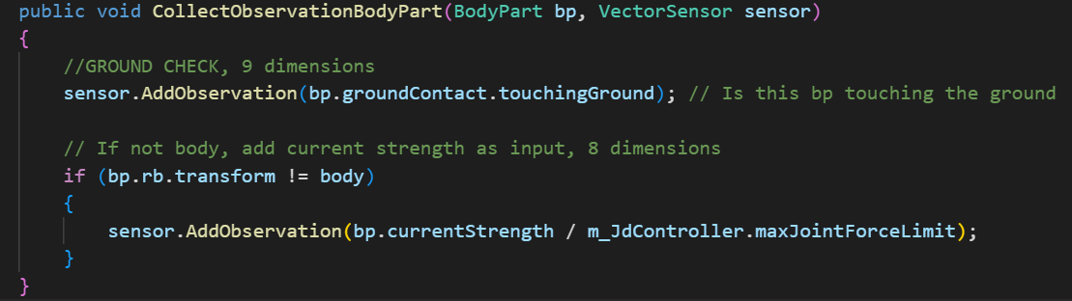

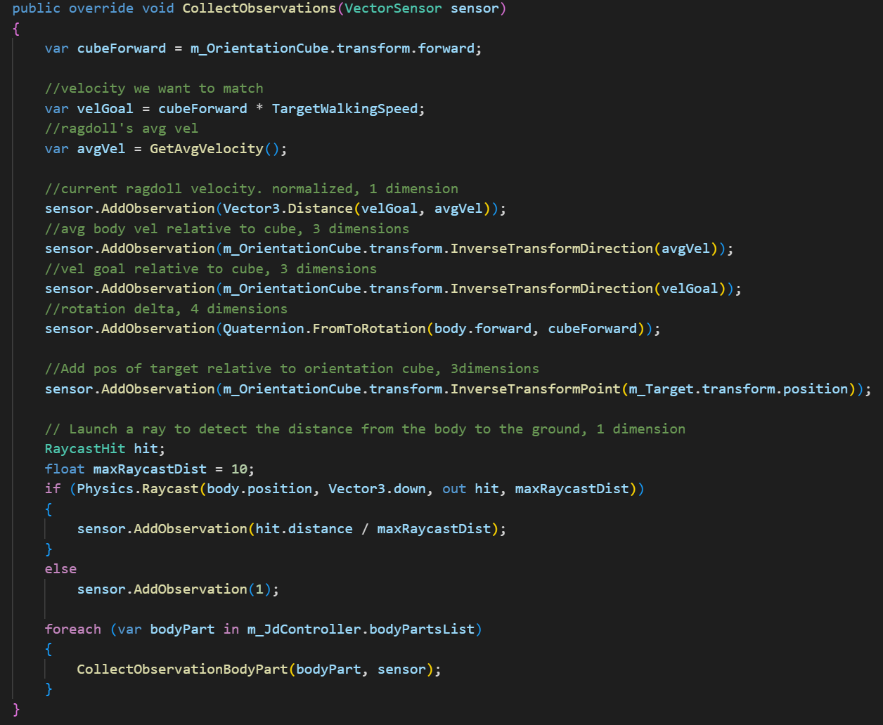

Continuous Action (Output Size): 20 dimensions

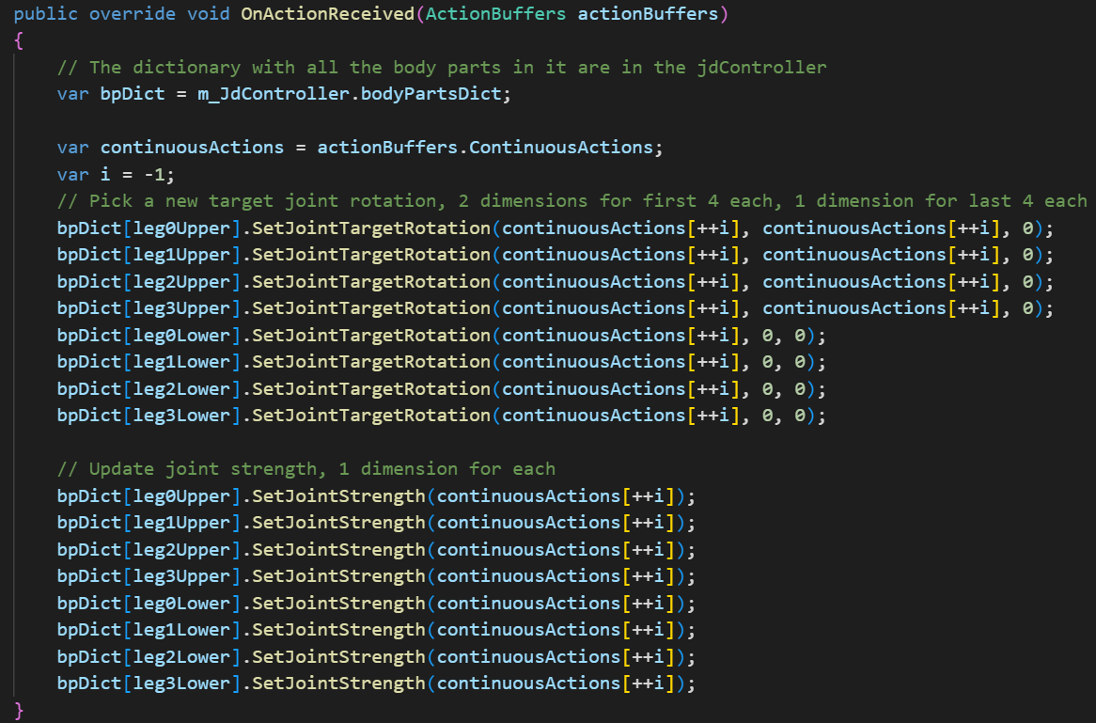

- Ground Contact

Each part of the body is configured with a Ground Contact script that can detect whether that part has touched the ground.

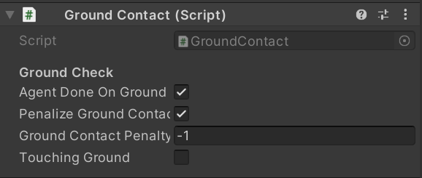

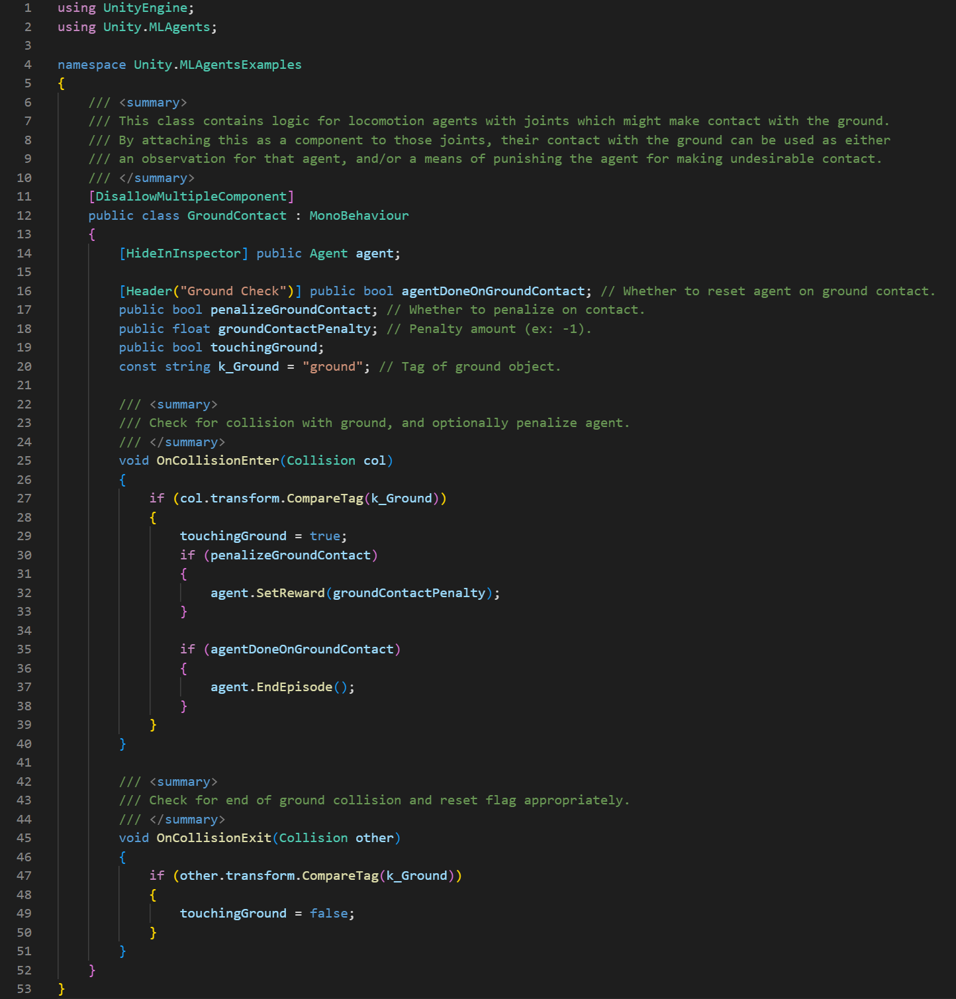

- Joint Drive Controller

This script is responsible for controlling various joints.

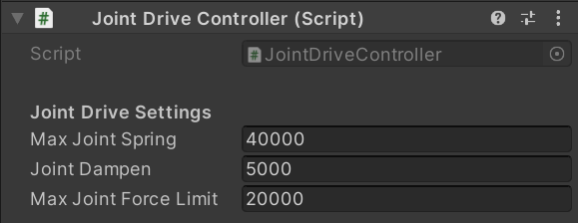

This script consists of two classes:

BodyPart: This method mainly serves to manage multiple body parts, and can update the force and torque of each part of the body in real time, which is used by the agent to collect information related to body parts.

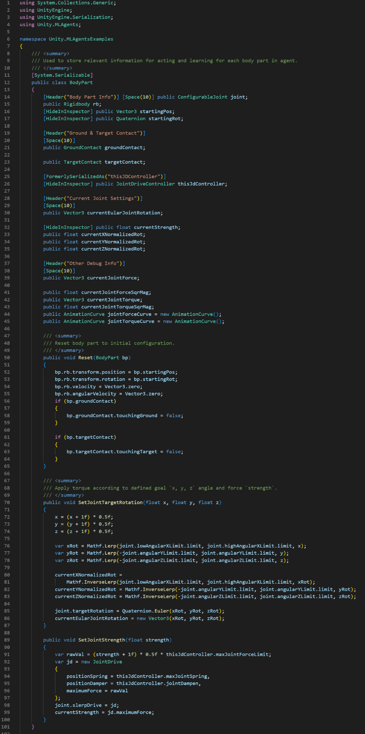

JointDriverController: As the name, this class defines controller of each joint.

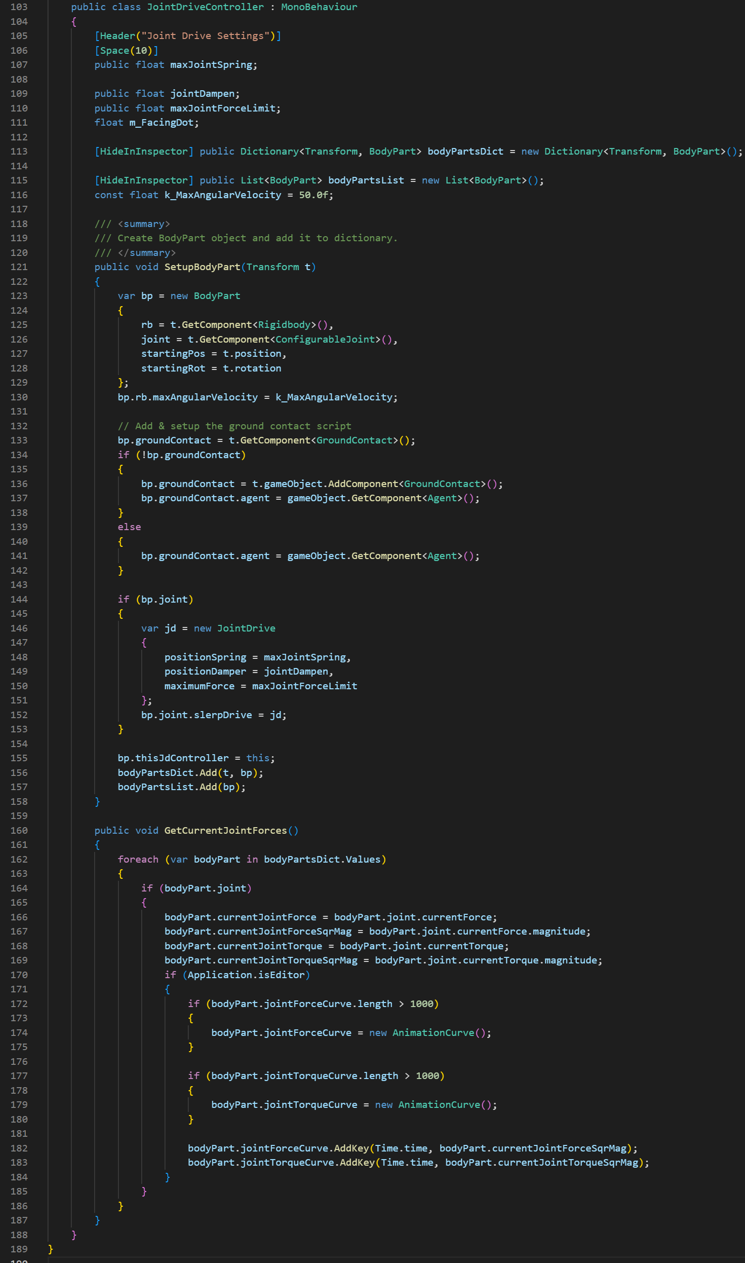

This script will not take effect on its own, requiring calls from other scripts to take effect.

2) Agent script

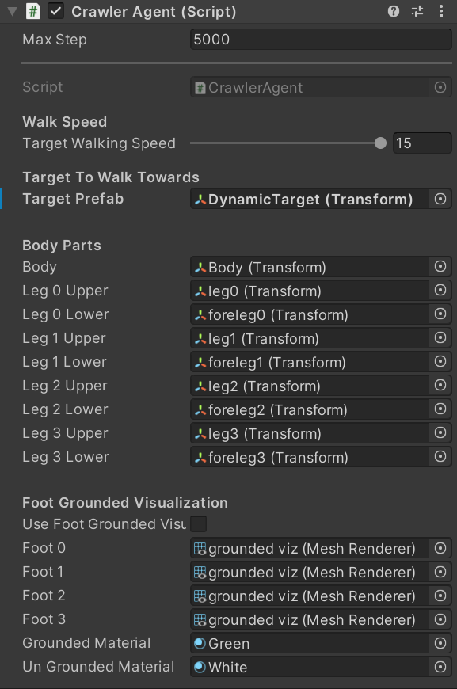

Complete code:

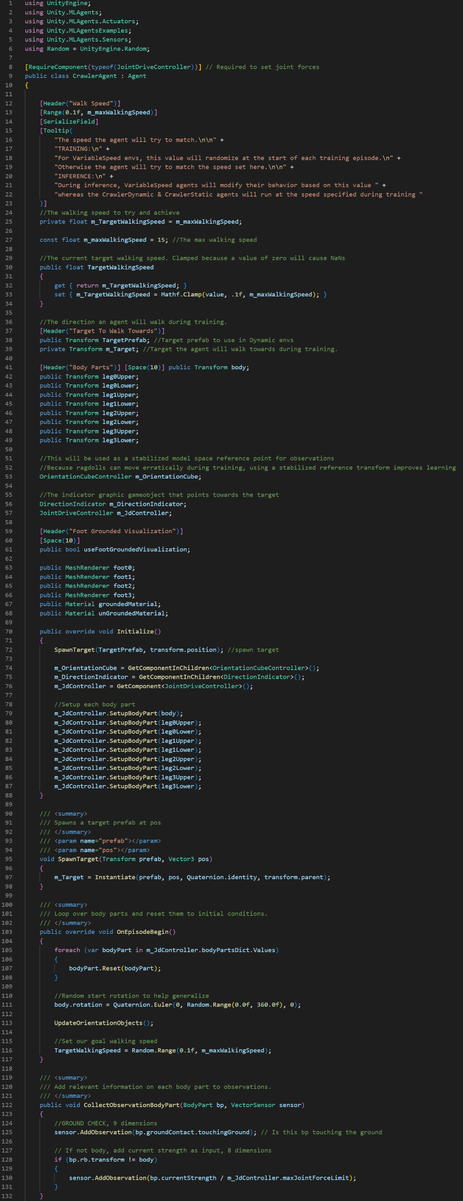

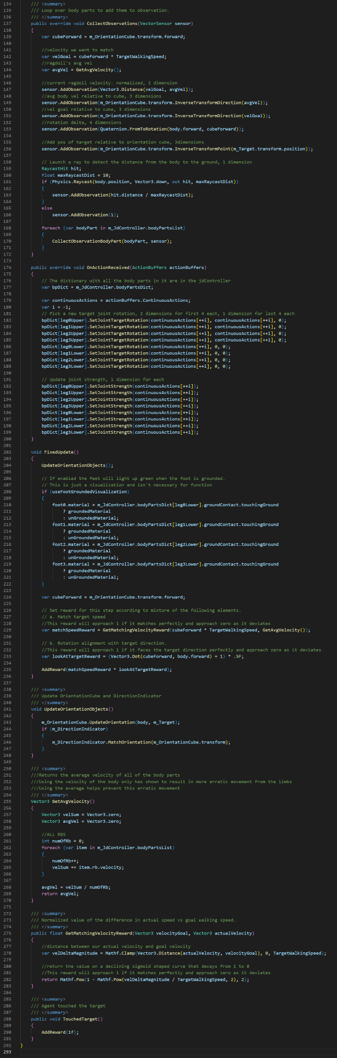

Here are some important methods:

Due to the increasing complexity of the environment and agent scripts, as well as the dimensions of inputs and outputs being mentioned in the Behavior Parameters part, the conventional input method (CollectObservations()) and output method (OnActionReceived()) will no longer be described in this and subsequent environment.

- FixedUpdate():

This method is called at a fixed interval (not influenced by frame) during the simulation. It updates the orientation objects (orientation cube and direction indicator) and calculates the reward based on the agent's performance in matching the target speed and orientation.

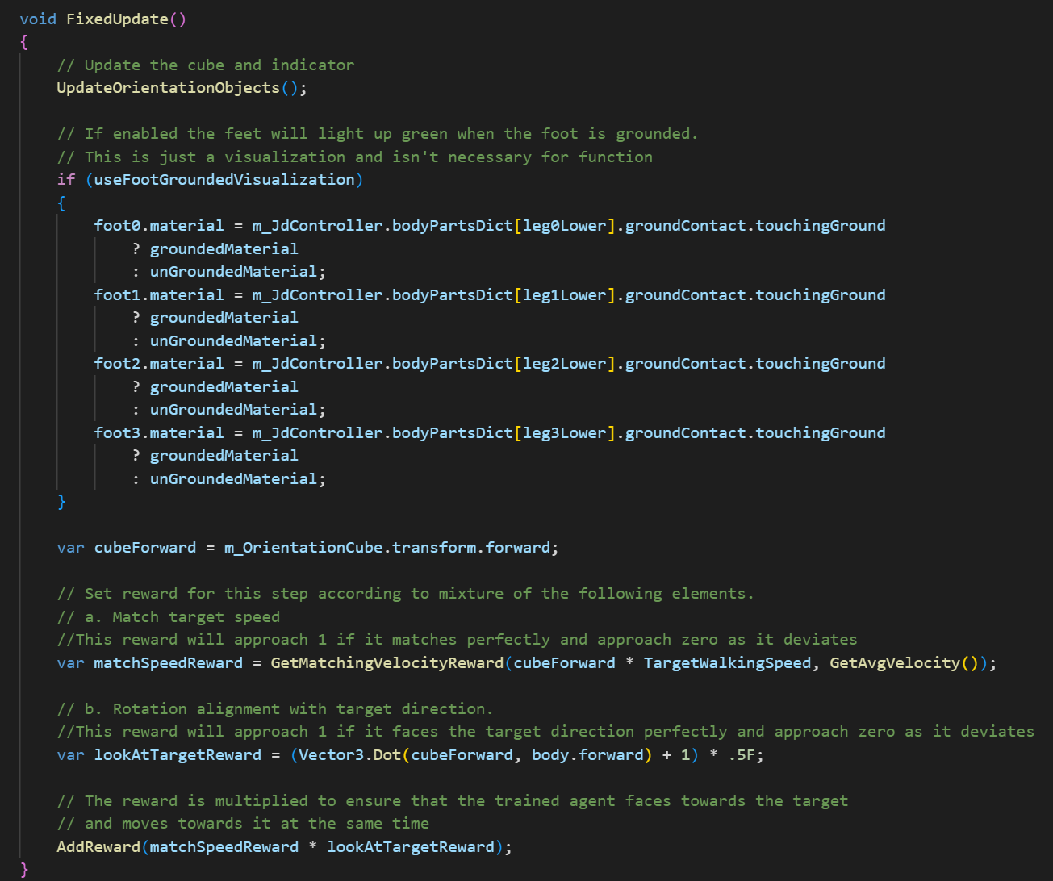

There are two methods called in this method:

- UpdateOrientationObjects()

It constantly updates the position and rotation of the cube object on the agent to always face towards the target, while also updating the position and rotation of the indicator below.

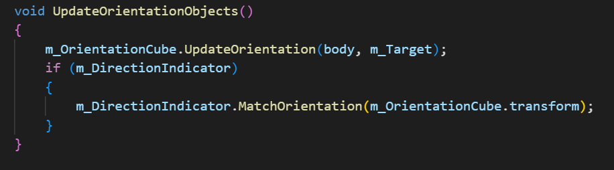

- GetMatchingVelocityReward()

This method takes in the target speed and actual speed as inputs, and outputs a reward. The smaller the distance between the two speeds, the higher the reward. The reward is a normalized value that ranges from 0 to 1, with 1 representing perfect velocity matching.

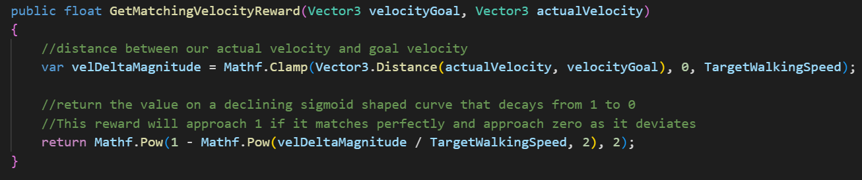

3) Training hyperparameter configuration

PPO:

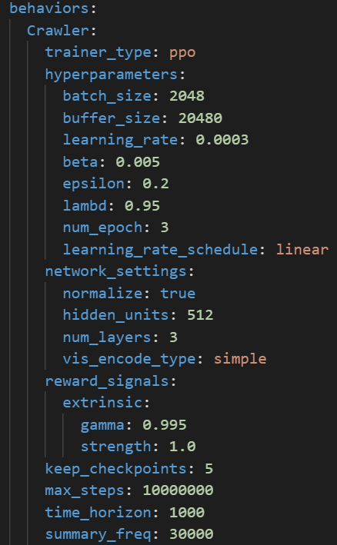

SAC:

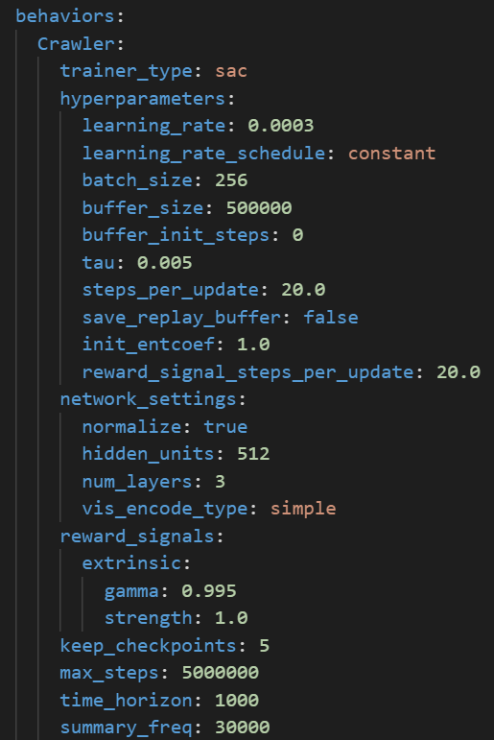

**6.3.4 Training results and comparison**

PPO result:

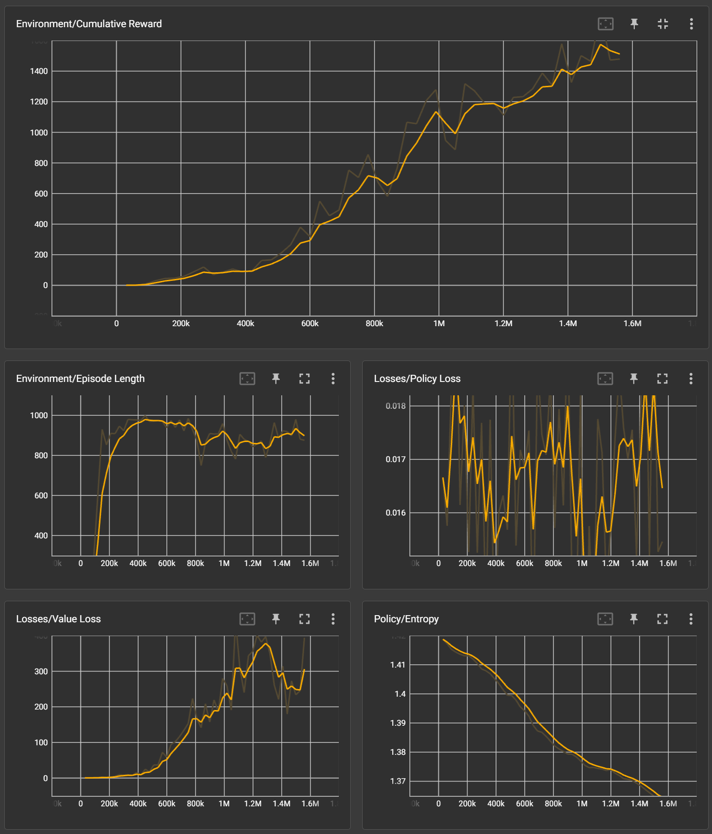

SAC result:

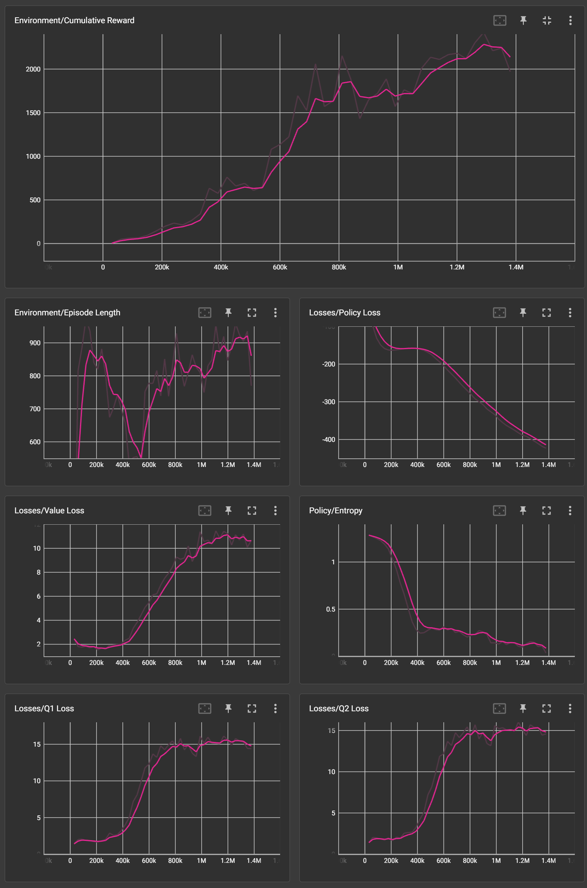

Comparison:

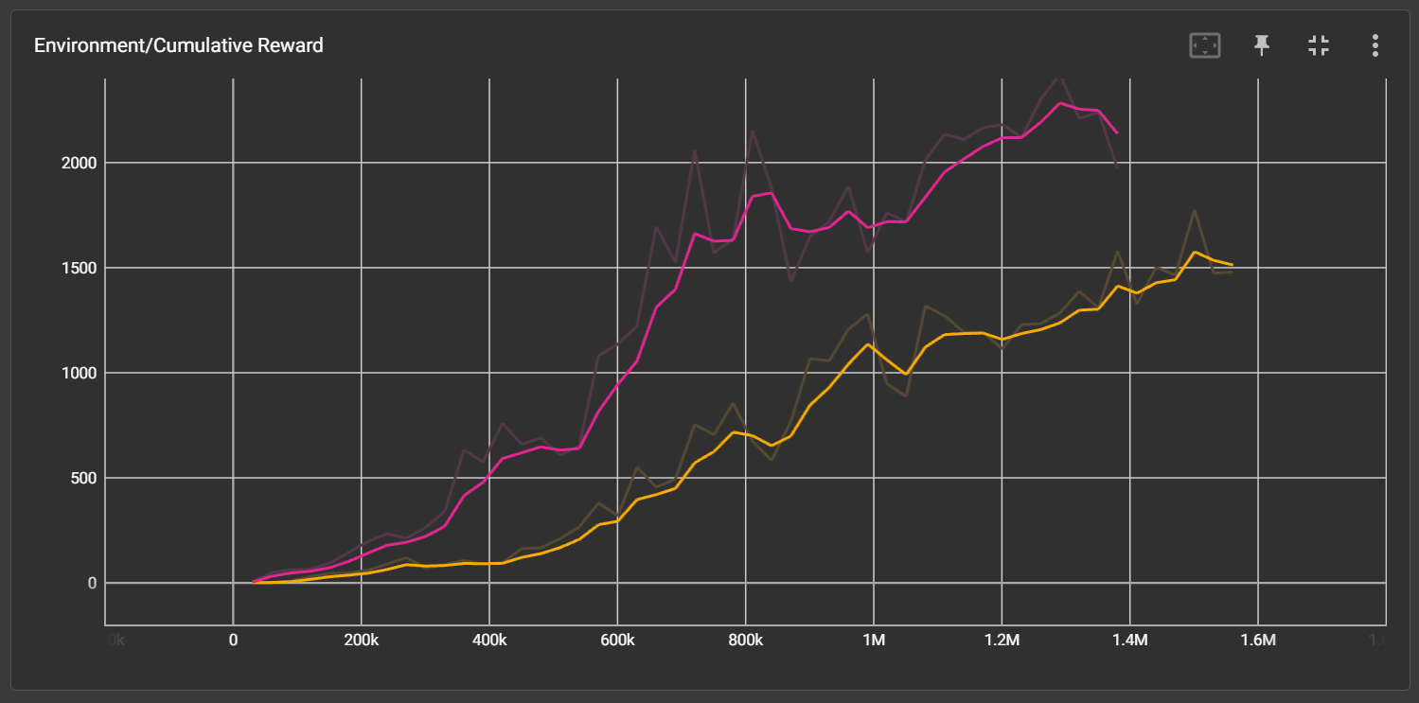

Comparison metrics:

1) Cumulative Reward:

According to the diagram, the cumulative reward of SAC remains higher than that of PPO.

2) Stability:

According to the diagram, the improvements of both algorithms are relatively stable, but PPO is slightly more stable than SAC.

3) Convergence Speed:

Because there is a very clear difference in the first metric, there is no need to compare this metric further.

4) Real Training Time:

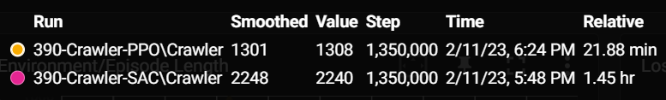

SAC consumes much more time than PPO.

**6.3.5 Summary**

In summary, although PPO has a slight advantage in stability and a large advantage in real training time, SAC’s cumulative reward is much better. Therefore, SAC performs better in this more complicated scenario.

**6.4 FoodCollector**

**6.4.1 Introduction**

The FoodCollector environment is designed to train agents to navigate and collect objects in a 3D environment. Agents are tasked with collecting good food objects and avoiding bad food objects while also having the ability to freeze other agents using a laser, in order to indirectly increase their own advantages. The environment highlights the use of reinforcement learning for training agents with more advanced control schemes and decision-making abilities, considering both continuous and discrete action spaces.

1) Agent:

The agent in the FoodCollector environment has two primary components: observations and actions.

- Observations: The agent receives a set of observations from the environment, used to inform decision-making. In the FoodCollector environment, the observations can include the agent's local velocity, frozen state, and laser shooting state.

- Actions: Based on the received observations, the agent takes actions to control its movement and laser shooting. In the FoodCollector environment, actions are both continuous and discrete. Continuous actions control the agent's movement (forward, right, and rotation), while discrete actions control the agent's laser shooting.

2) Reward System:

The reward system in the FoodCollector environment is designed to encourage agents to learn effective strategies for collecting good food objects and avoiding bad ones. The agent is rewarded as follows:

- Good Food Reward: The agent receives a reward of +1 for collecting a good food object, which increases the agent's total score.

- Bad Food Penalty: The agent receives a penalty of -1 for collecting a bad food object, which decreases the agent's total score.

**6.4.2 Appearance**

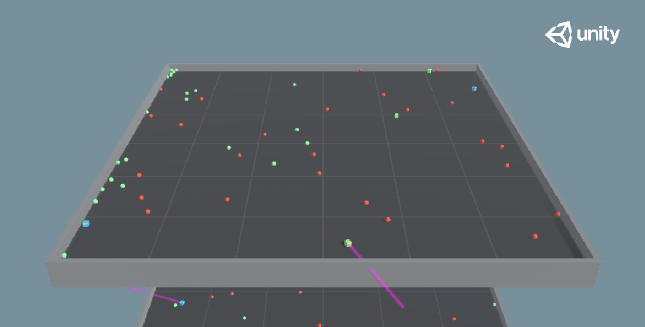

**6.4.3 Environment**

1) Important components

- Behavior Parameters

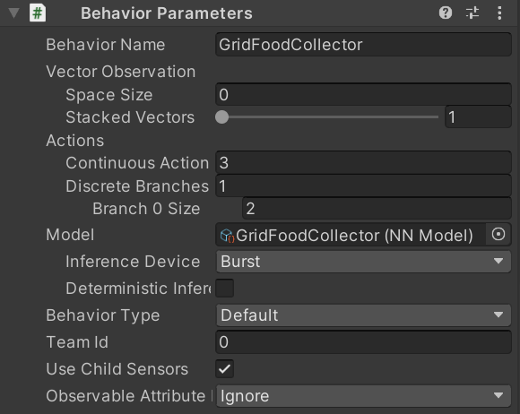

Space Size (Input Size): 0 dimensions

Here can config if get input by setting useVectorObs and useVectorFrozenFlag two parameters, but both of them are not used in this environment.

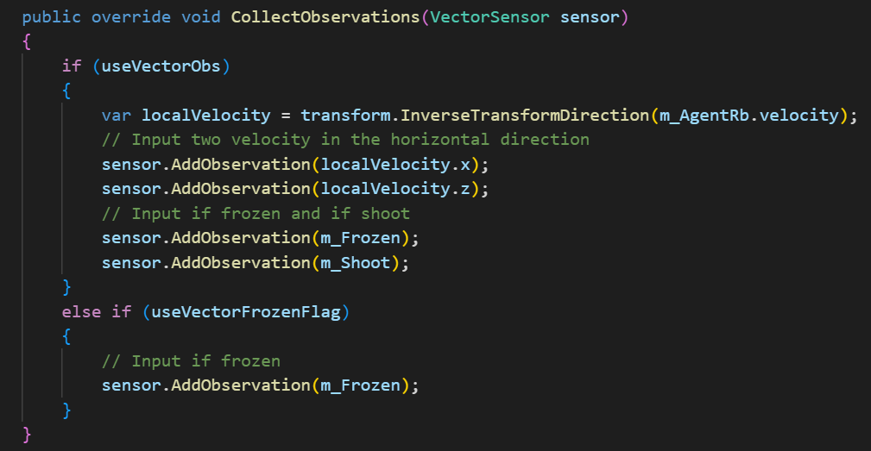

Input size = 0, is that means that the agent doesn't receive any observations about the positions of other agents or the food objects? Yes. However, this does not mean that the agent cannot detect other agents or shoot the laser.

In this particular script, the agent is designed to be trained with visual input. Instead of using vector observations, the agent can use visual observations from cameras attached to the agent. The agent uses these visual observations to detect other agents and food objects in the environment.

When the agent uses visual input, the neural network receives image data from the cameras and learns to process that information to make appropriate decisions. The agent will learn how to detect other agents and shoot the laser based on the visual input provided through the cameras.

Continuous Action (Output Size1): 3 dimensions

Discrete Branch 0 Size(Output Size2): 2 dimensions

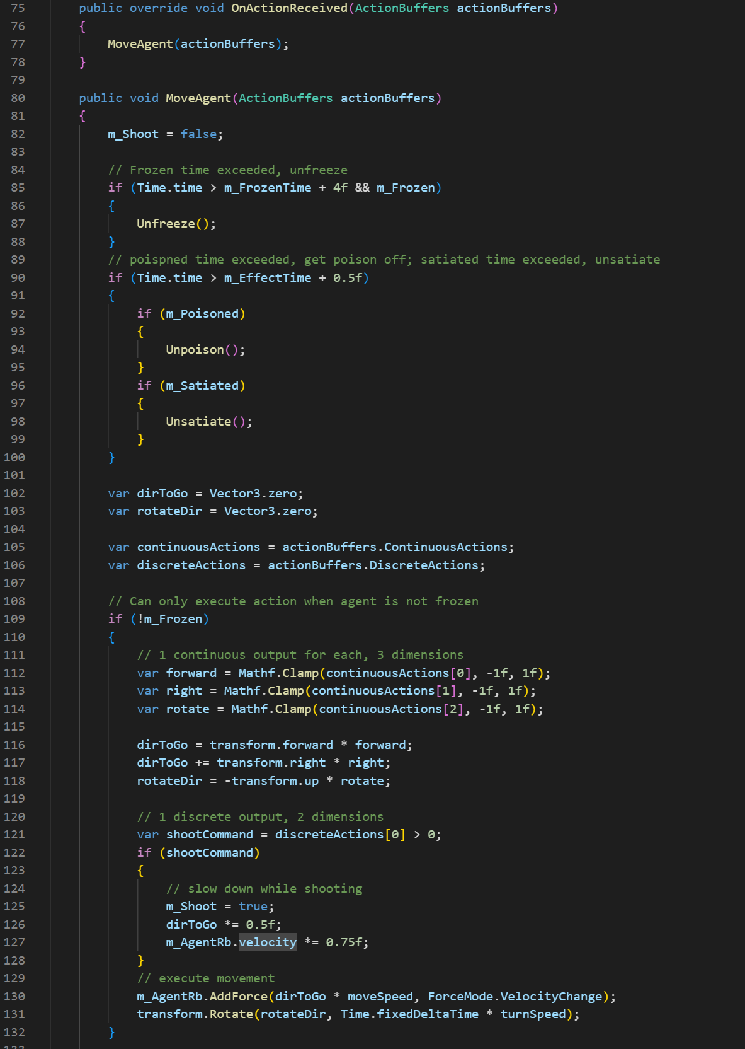

- Grid Sensor

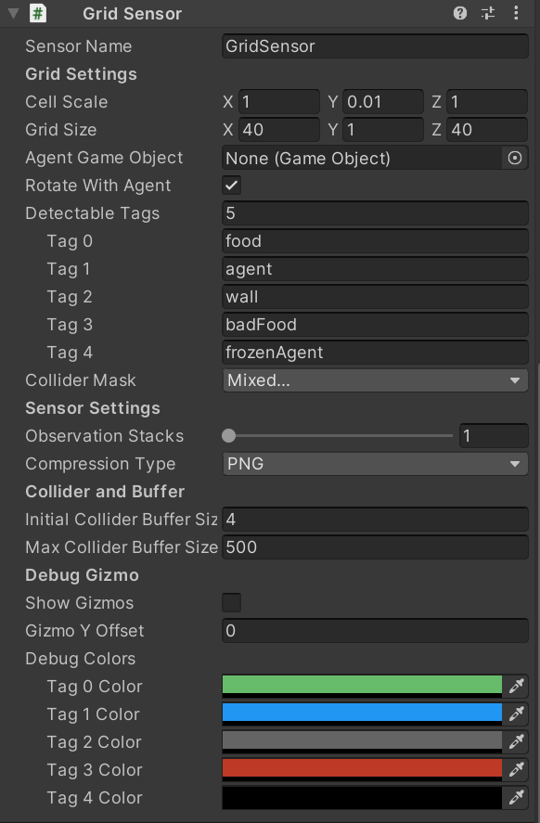

The Grid Sensor uses a set of grid-shaped boxes as queries for observation:

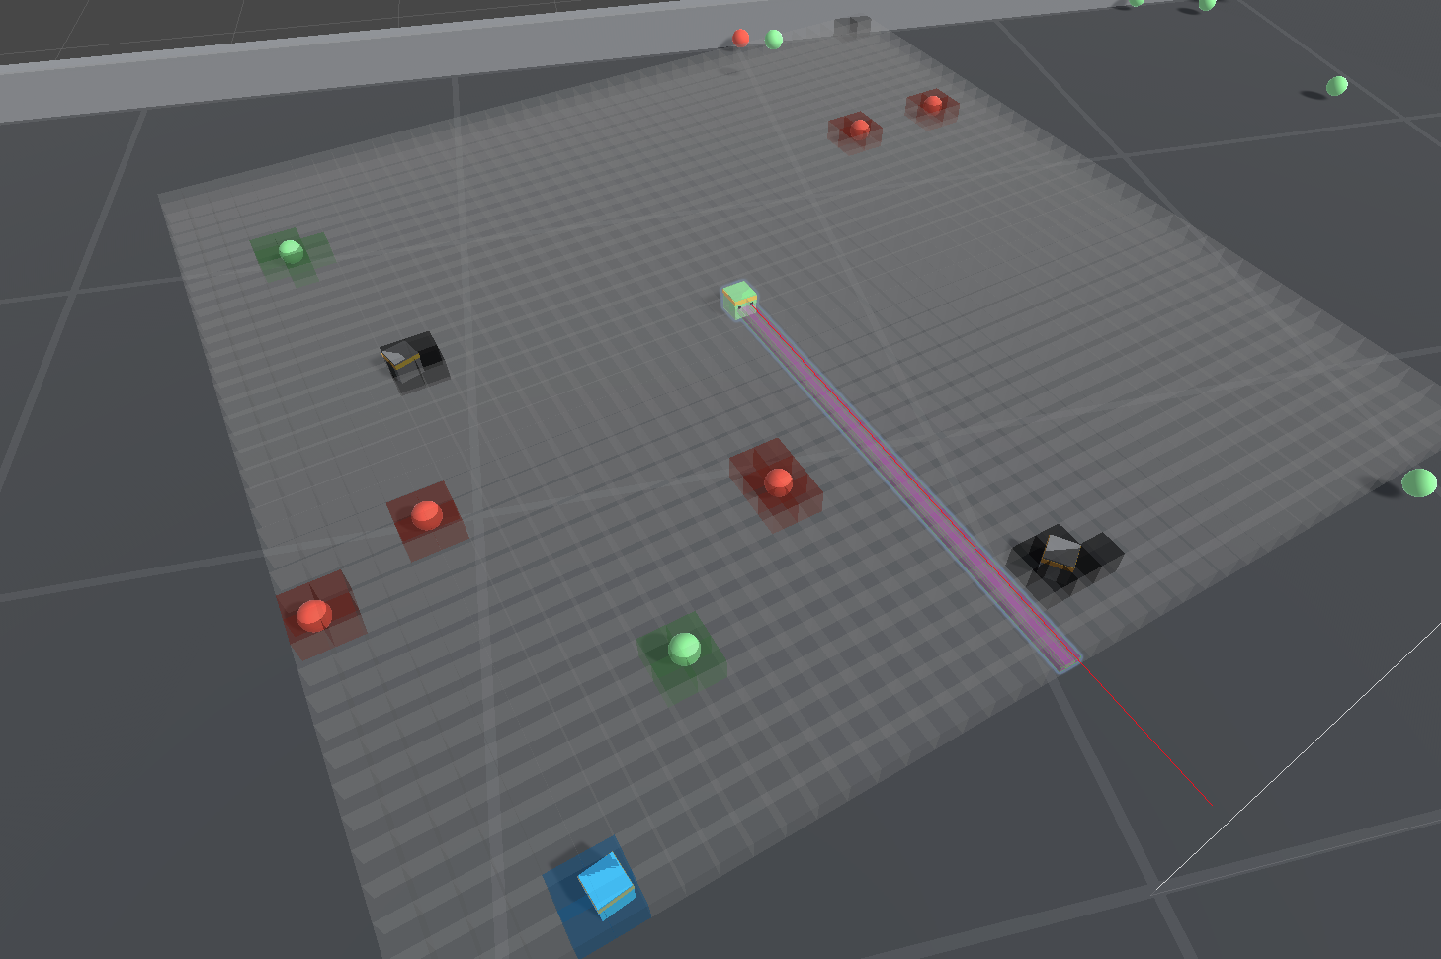

Grid-based observations combine the advantages of two-dimensional spatial representation in visual observations and the flexibility of defined detectable objects in RayCast observations. The sensor uses a set of grid-shaped boxes as queries and provides a top-down 2D view around the agent.

During observation, the sensor detects the presence of detectable objects in each grid cell and encodes them as one-hot representation. The information collected from each cell forms a 3D tensor observation, which is fed into the agent policy's convolutional neural network (CNN) as in visual observations. The corresponding label for an object is tagged on the grid when a collision occurs.

Therefore, in the 2D plane observation, the input dimension is the number of grids multiplied by the number of tags. In this case, the sensor is directly mounted on the agent itself, with 40 grids in the z-axis (forward/backward direction), 40 grids in the x-axis (left/right direction), 1 grid in the y-axis (up/down direction), and the detection labels include: food, bad food, other agents, frozen agents, walls, and nothing detected, for a total of 6 detection labels. Therefore, there are 40 * 40 * 6 = 960 observation dimensions.

- Script: Food Generation Control

This script is mounted on an empty object, and it does not operate on its own. It needs to be called in the script mounted on the agent.

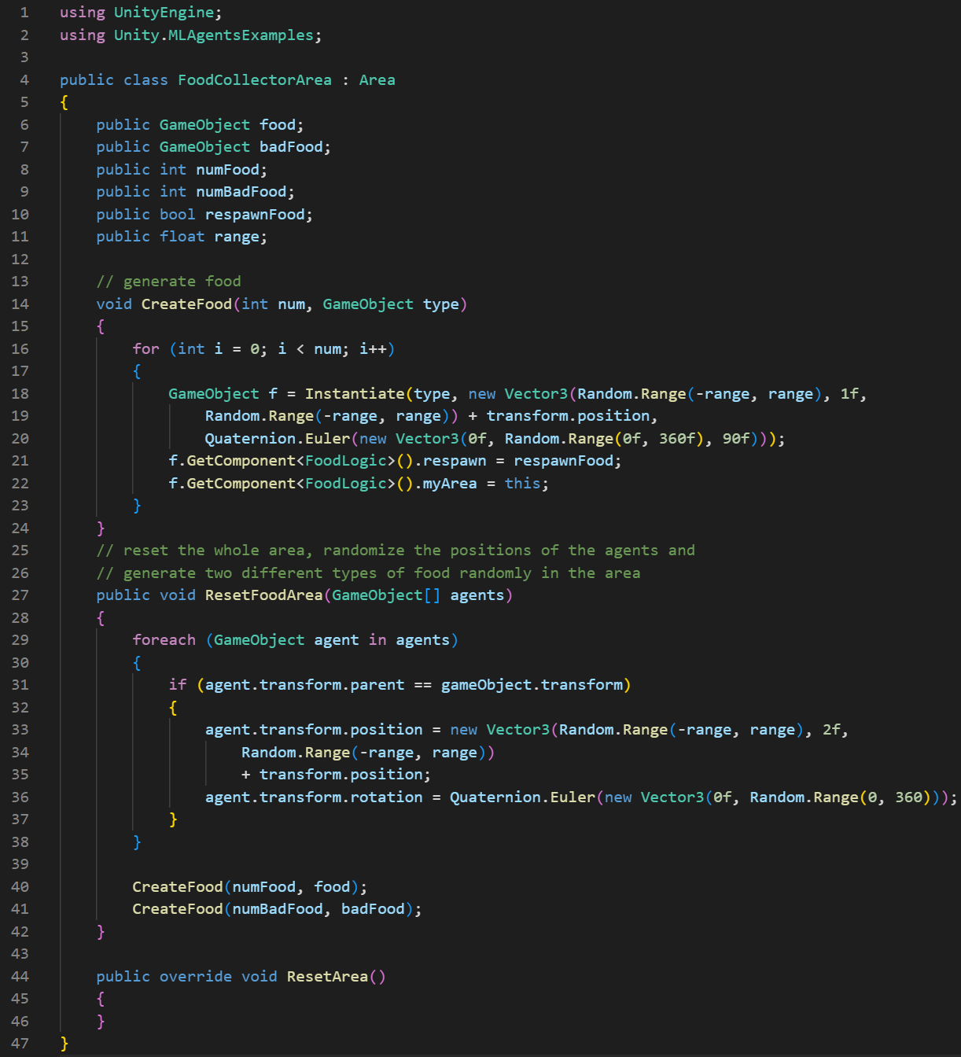

- Script: Handling of Food After Being Eaten

This script is mounted on food, also needs to be called in the script mounted on the agent.

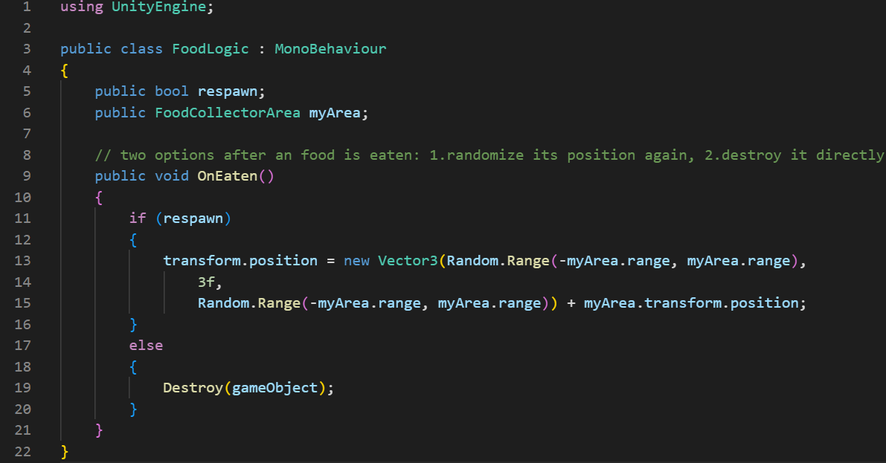

2) Agent script

Complete code:

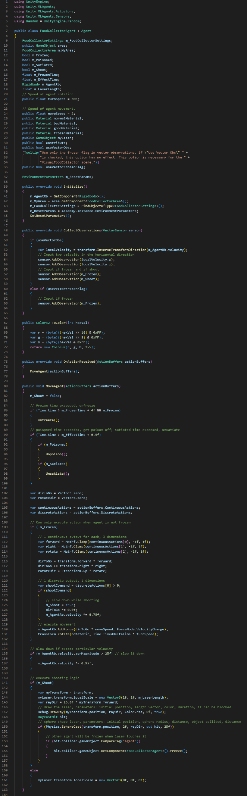

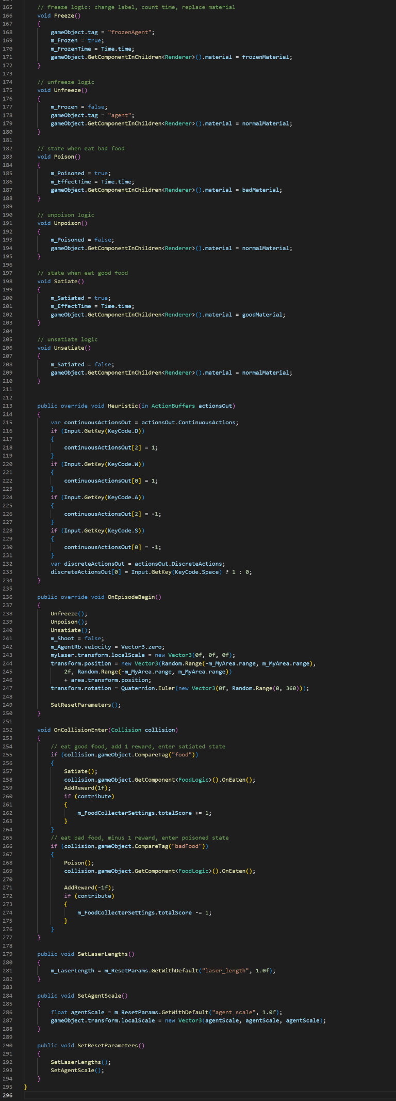

Here are some important methods:

- MoveAgent() and a series of action methods:

MoveAgent() is a method used solely to define the actions that an agent can perform. It defines that an agent can only perform actions when it is not frozen. Actions include the agent's movement and rotation based on the continuous actions received from the neural network. It also handles shooting based on a discrete action. The series of methods under it are used to define a series of states for the agent, such as frozen and poisoned.

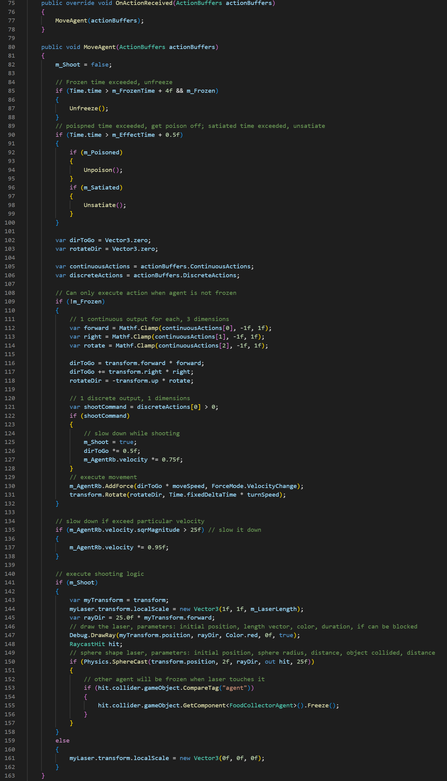

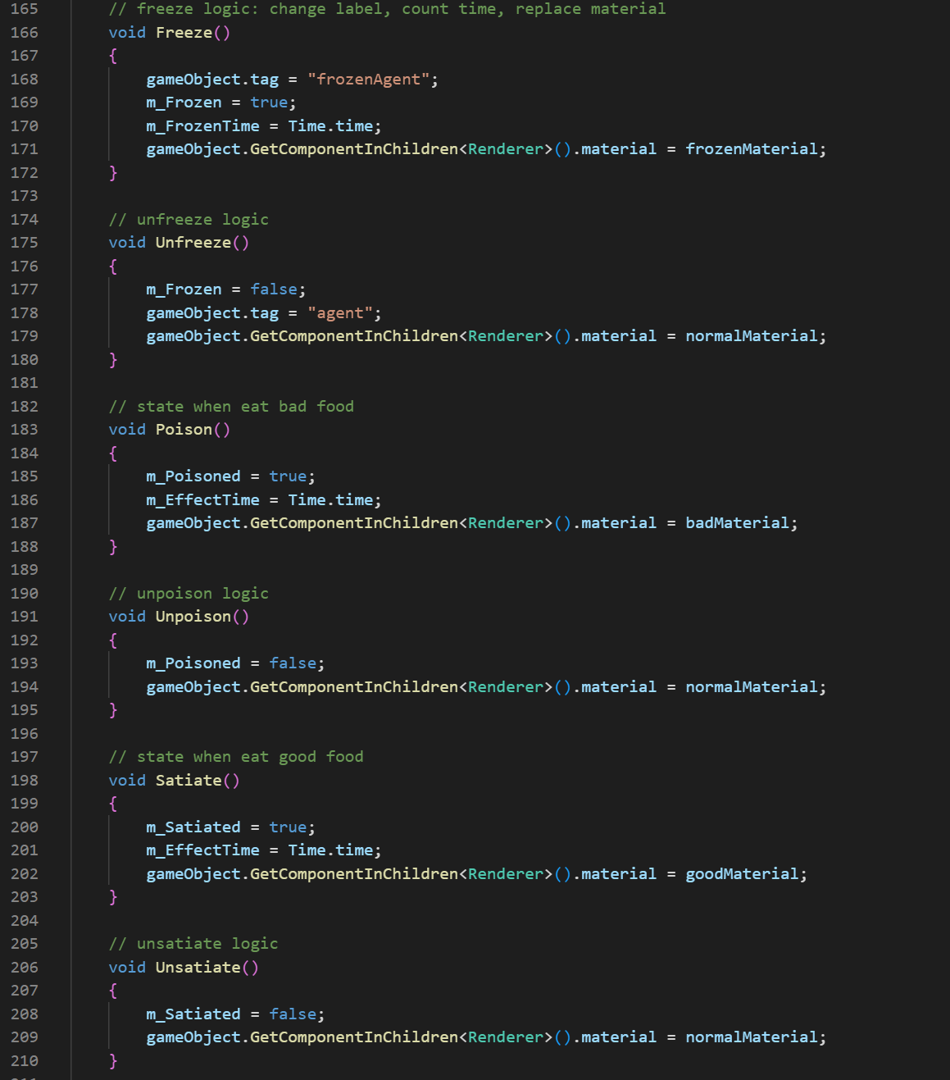

- OnCollisionEnter():

This method detects collisions between the agent and food objects, updating the agent's state and reward accordingly.

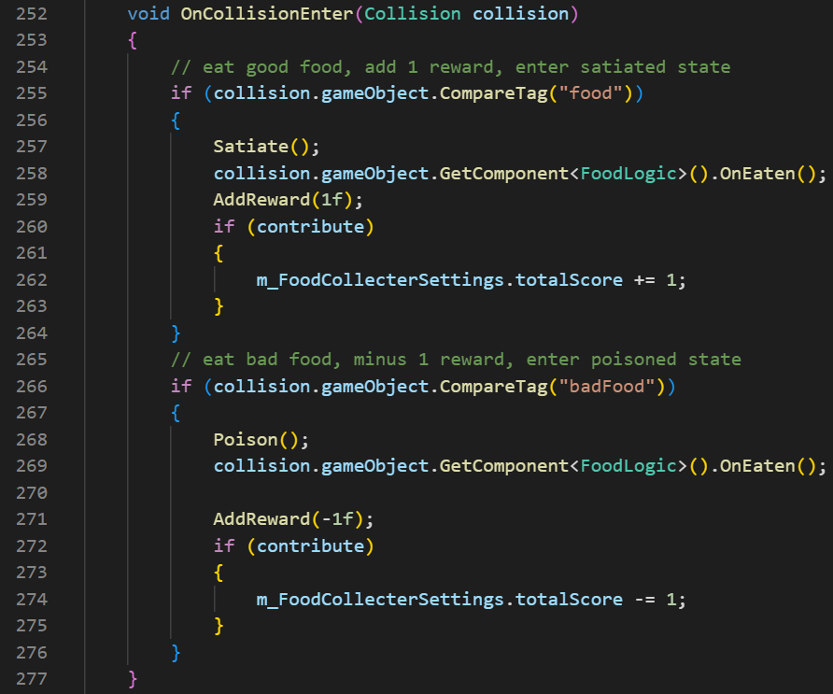

3) Training hyperparameter configuration

PPO:

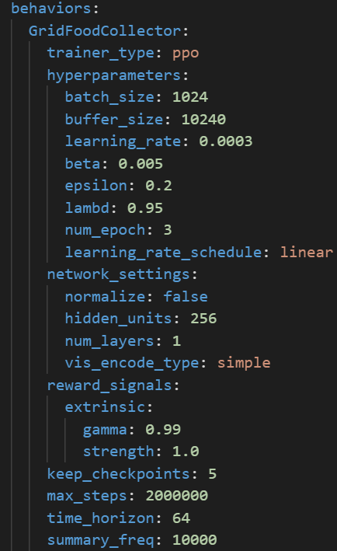

SAC:

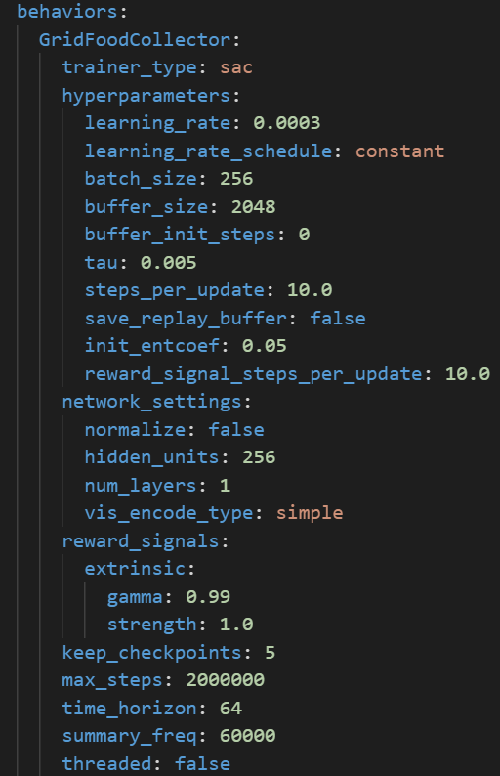

**6.4.4 Training results and comparison**

PPO result:

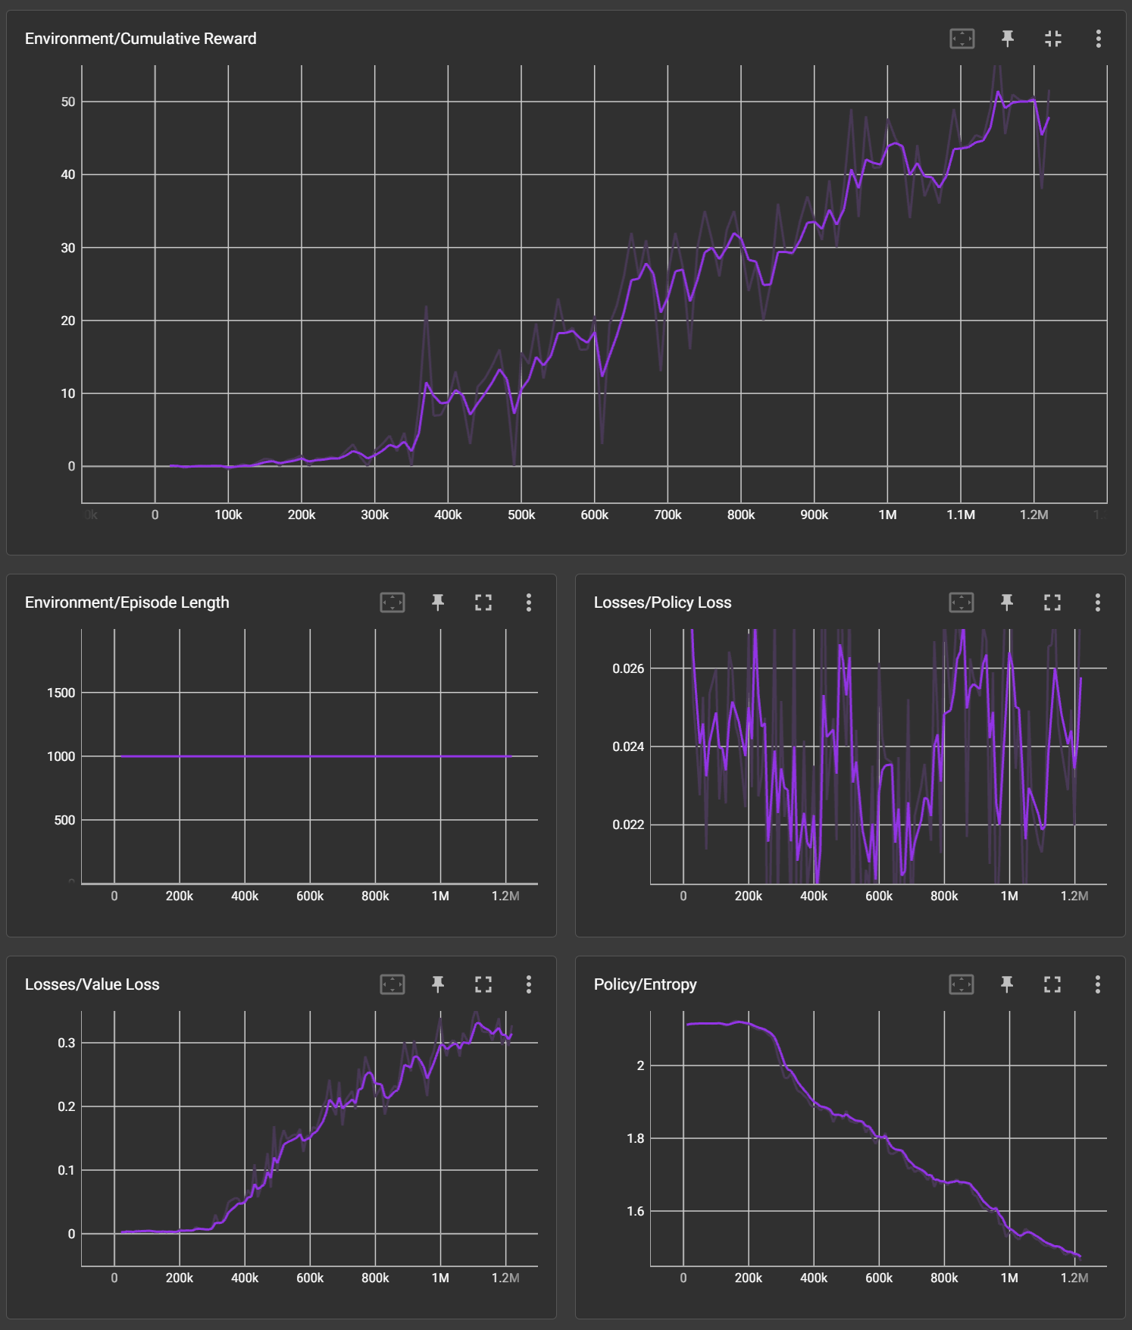

SAC result:

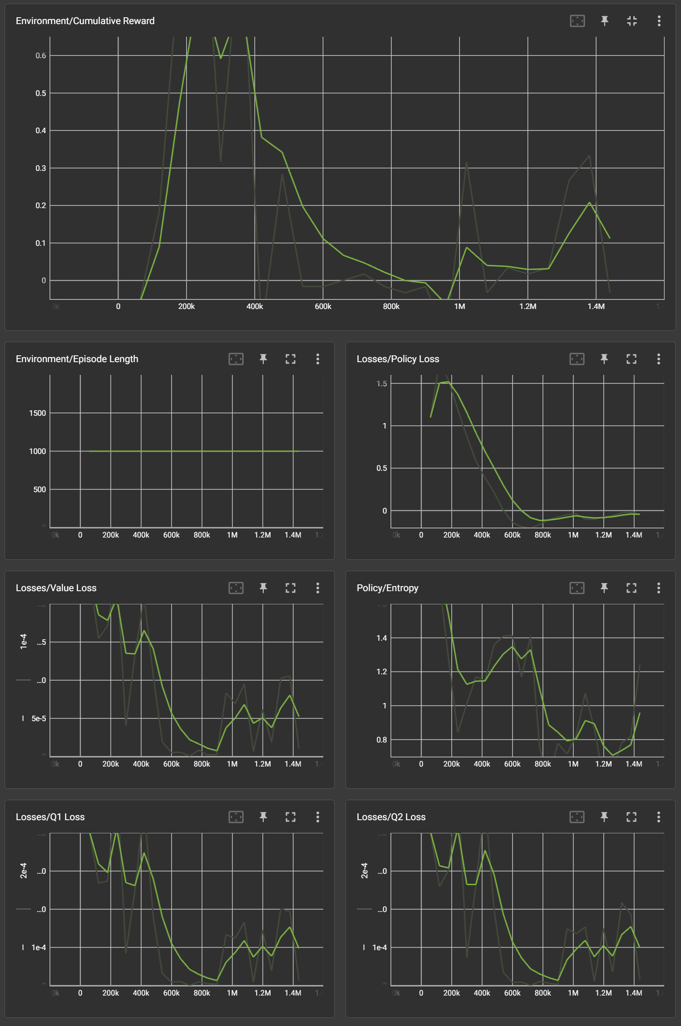

Comparison:

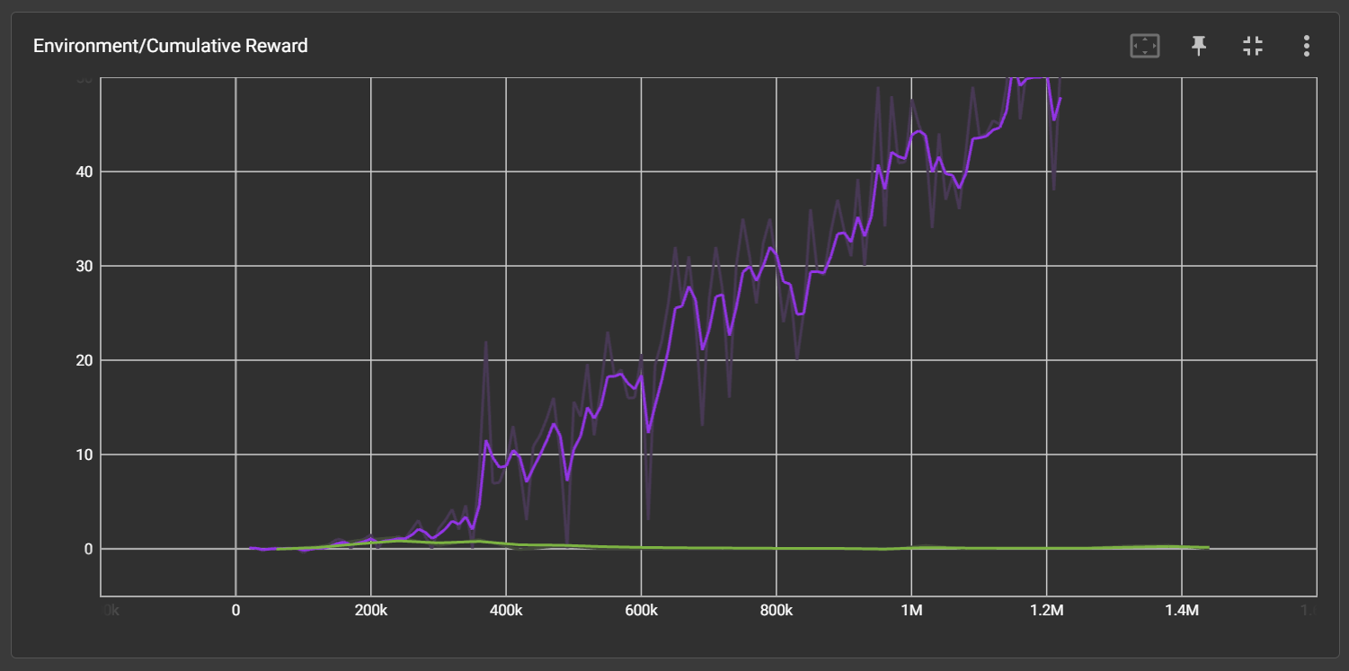

Comparison metrics:

1) Cumulative Reward:

According to the diagram, the cumulative reward of PPO remains much higher than that of SAC. The results shown by SAC indicate that it is not well-suited for this type of task.

2) Stability:

Due to the significant difference in the first metric, there is no need to compare this metric further.

3) Convergence Speed:

Due to the significant difference in the first metric, there is no need to compare this metric further.

4) Real Training Time:

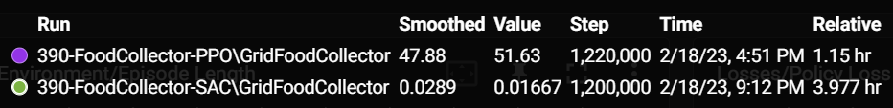

SAC consumes much more time than PPO.

**6.4.5 Summary**

In summary, SAC is definitely not suited for this kind of multi-agent task that need to train agents with more advanced control schemes and decision-making abilities. Besides, SAC consumes much more time when training. Therefore, PPO performs better.

**6.5 Pyramids**

**6.5.1 Introduction**

The Pyramids environment aims to train agents to navigate in a 3D environment and avoid obstacles while searching for a target. Agents must find a randomly generated switch in a relatively large environment, which, when pressed, generates a pyramid in the scene. The agent then needs to push the pyramid and obtain the green block at the top of the pyramid. This environment tests algorithms' ability to learn efficient exploration strategies, handle large state spaces, and cultivate curiosity in complex environments.

1) Agent:

The agent in the Pyramid environment has two primary components: observations and actions.

- Observations: The agent receives a set of observations from the environment, used to inform decision-making. In the Pyramid environment, the observations can include the state of the switch and the agent's local velocity.

- Actions: Based on the received observations, the agent takes actions to control its movement. In the Pyramid environment, actions are discrete, which control the agent's movement (forward, backward) and rotation (left, right).

2) Reward System:

The reward system in the Pyramid environment is designed to encourage agents to learn effective strategies for reaching the goal while avoiding obstacles. The agent is rewarded as follows:

- Goal Reward: The agent receives a reward of +2 for reaching the goal, which increases the agent's total score.

- Time Penalty: The agent receives a small penalty of -1/MaxStep for each step taken, which encourages the agent to reach the goal as quickly as possible.

**6.5.2 Appearance**

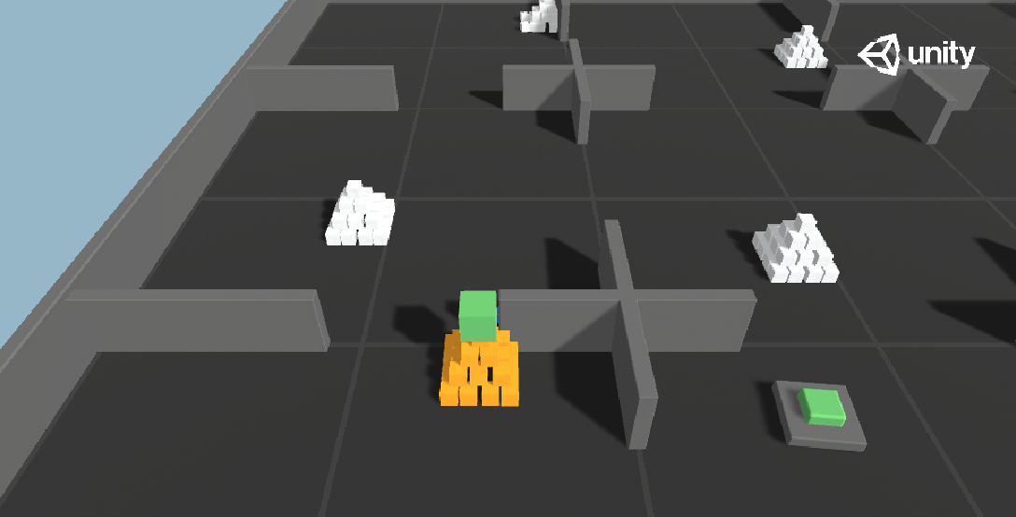

**6.5.3 Environment**

1) Important components

- Behavior Parameters

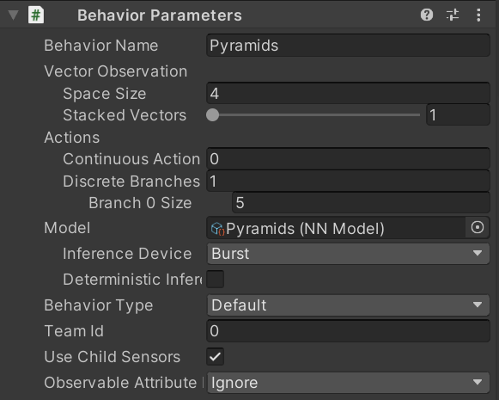

Space Size (Input Size): 4 dimensions

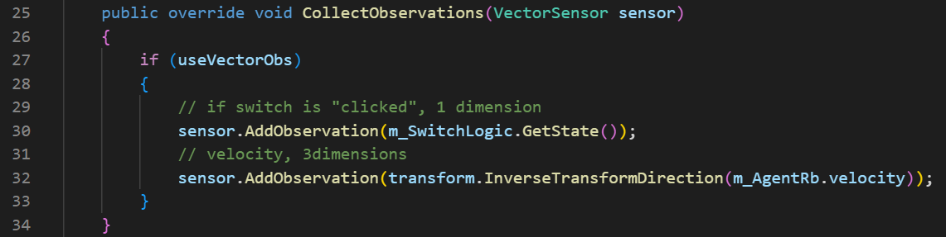

Discrete Branch 0 Size (Output Size): 5 dimensions

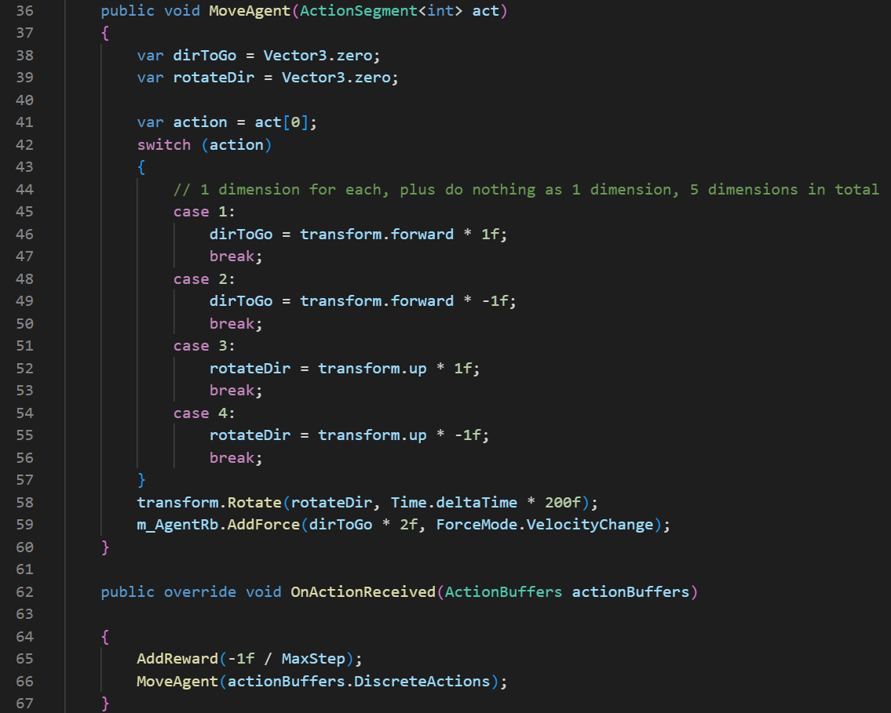

- Ray Perception Sensor 3D

In addition to the 4 dimensions in the Space Size, the agent also uses additional sensors as inputs. As shown in the screenshot, the agent uses three Ray Perception Sensor 3D to obtain stereoscopic views from top, middle, and bottom. The three sensors only have slight differences in parameters. Each layer of the top, middle, and bottom has seven rays, totaling 21 rays. The labels detected by each ray include walls, stones in the target pyramid, stones in the regular pyramid, target blocks, closed switches, and open switches.

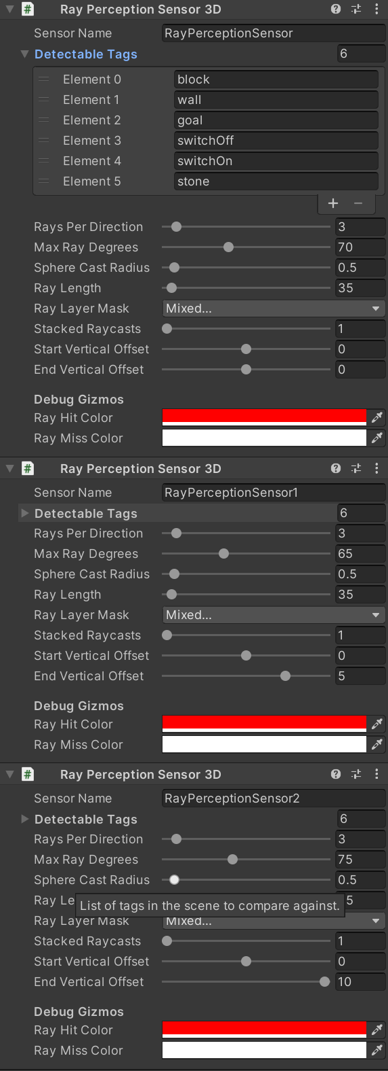

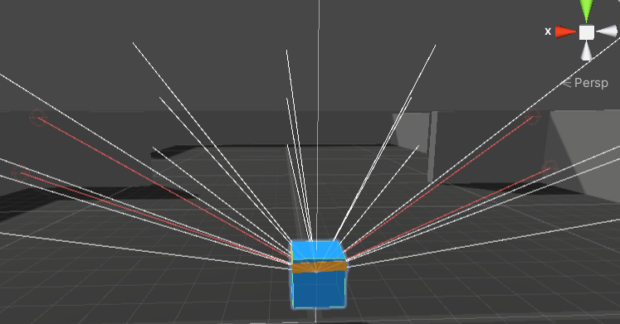

- Script: PyramidArea

It is the script controlling the whole environment.

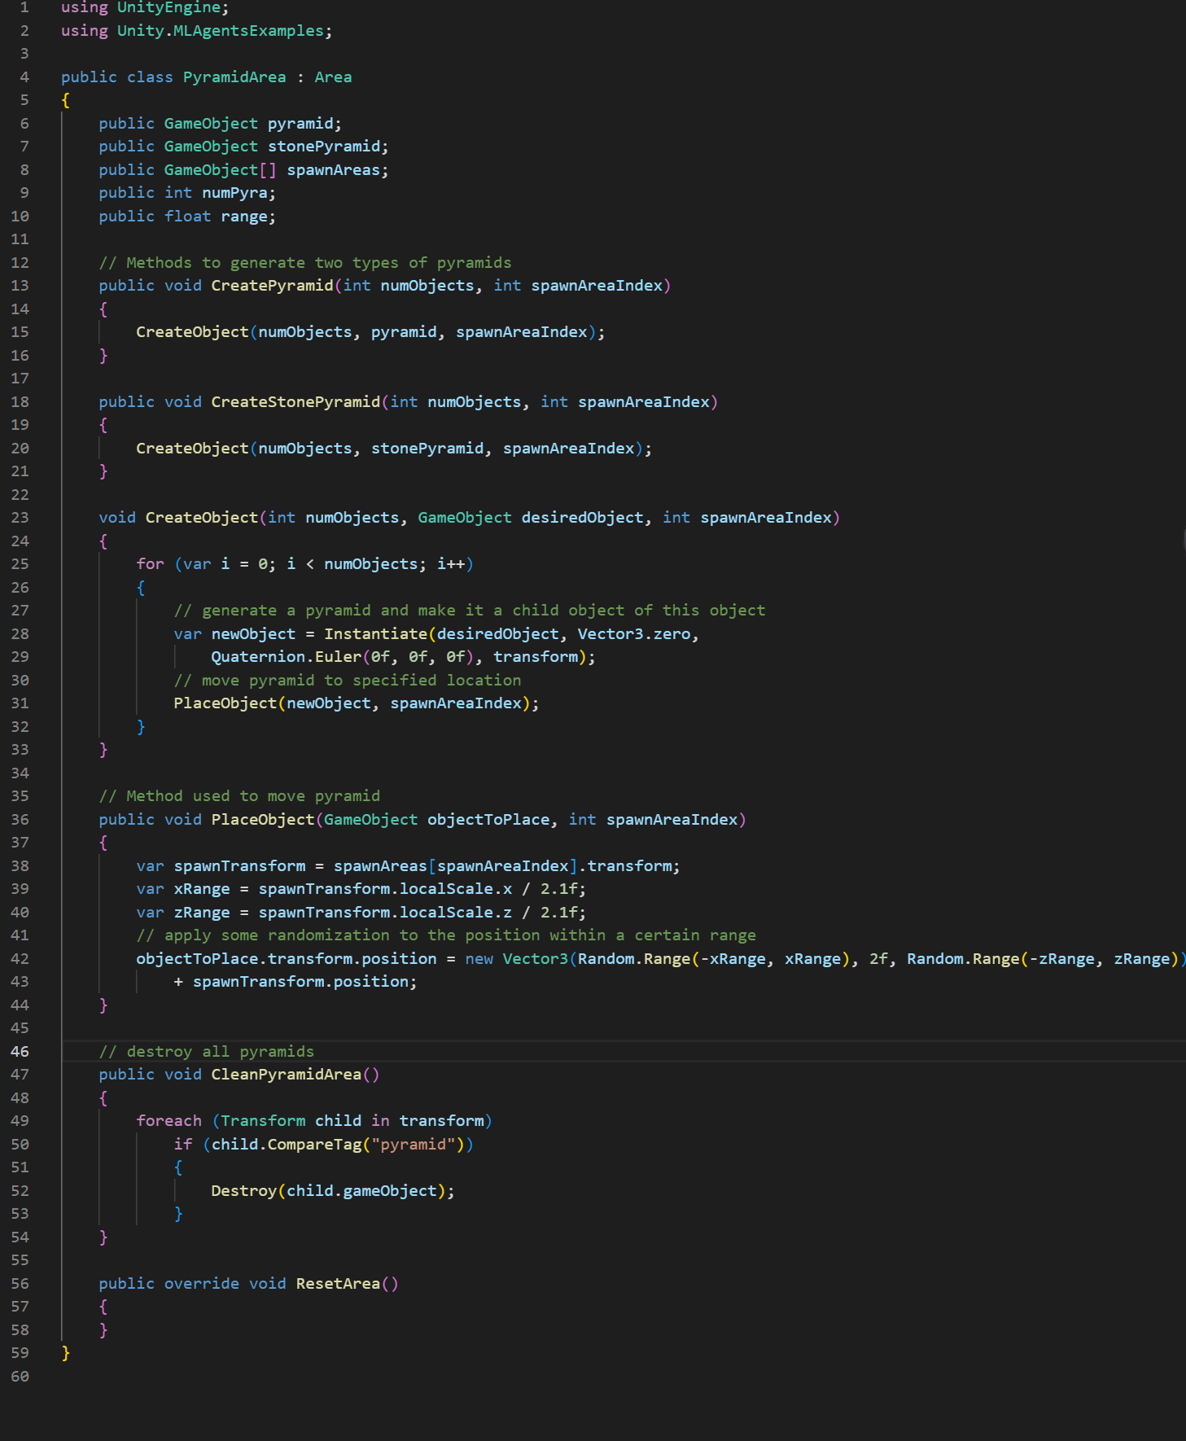

2) Agent script

Complete code:

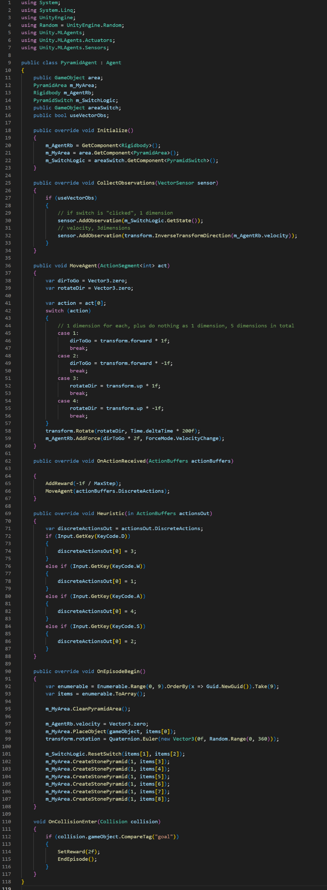

Here are some important methods:

The agent script for Pyramids has few methods that require special explanation, but its OnEpisodeBegin() method is slightly more complex than other game environments, so here's an explanation with comments:

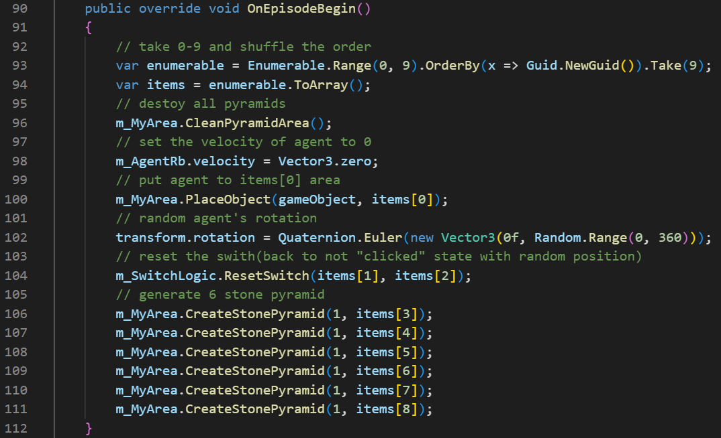

3) Training hyperparameter configuration

PPO:

As shown in the last few lines of this configuration file, PPO applies a Curiosity mechanism, this will be discussed below.

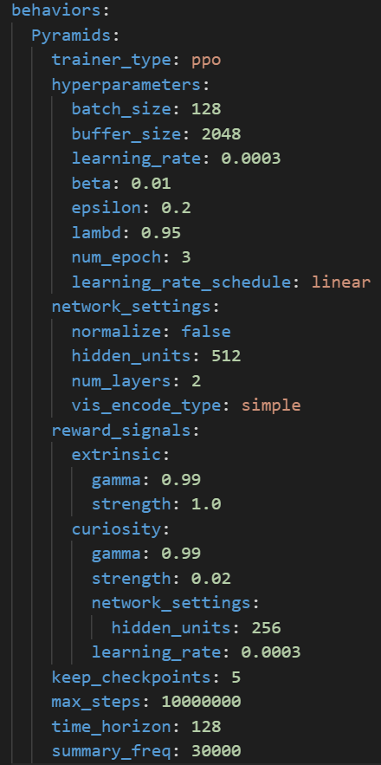

SAC:

As shown in the configuration file, SAC also applies a new mechanism called GAIL instead of Curiosity.

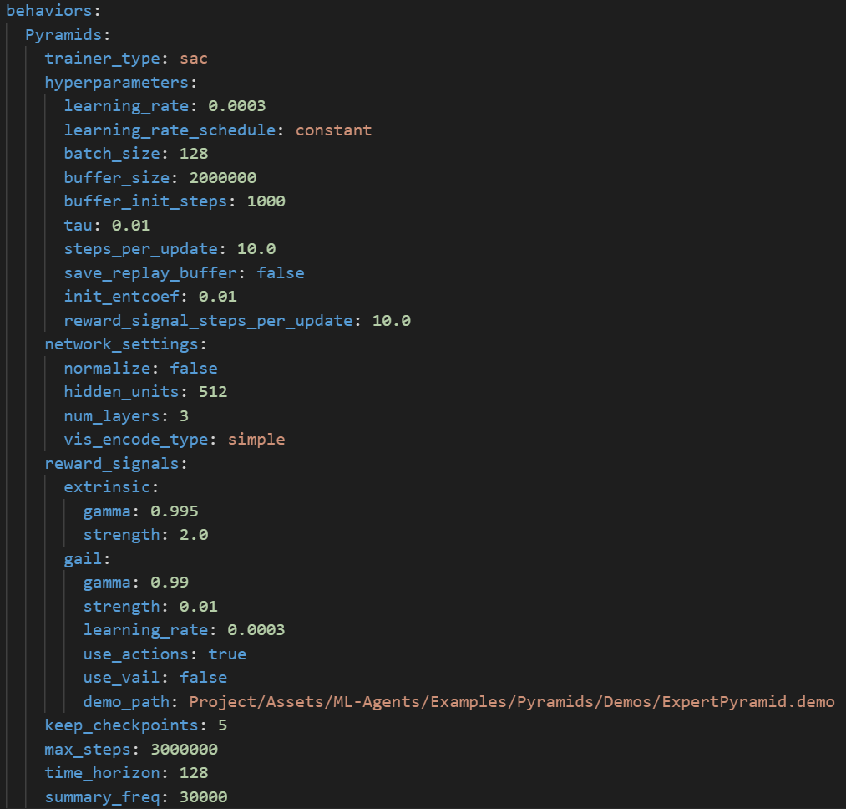

Due to the sparse rewards, it is almost impossible to achieve good results using conventional methods. Therefore, PPO need to apply a Curiosity mechanism to encourage the agent to explore unknown things and obtain rewards, which can effectively promote the progress of training.

Here is the explanation of Curiosity and GAIL:

Curiosity:

It is an intrinsic motivation mechanism that encourages the agent to explore the environment more effectively. It is often used to augment the extrinsic rewards provided by the environment. The idea behind curiosity is to reward the agent for taking actions that lead to novel or unexpected states. This helps the agent explore the environment better and discover optimal policies, especially when extrinsic rewards are sparse or delayed.

GAIL:

Generative Adversarial Imitation Learning (GAIL) is an imitation learning technique used to train agents by learning from expert demonstrations rather than relying solely on rewards from the environment. GAIL leverages the framework of Generative Adversarial Networks (GANs) to match the distribution of the expert's behavior.

In GAIL, there are two neural networks: the policy network (the agent) and the discriminator network. The policy network generates actions, while the discriminator network distinguishes between actions produced by the expert and actions produced by the agent. The agent's goal is to generate actions that can "fool" the discriminator into thinking that they are from the expert. The training process involves updating both the policy and discriminator networks in an adversarial manner.

**6.5.4 Training results and comparison**

PPO result:

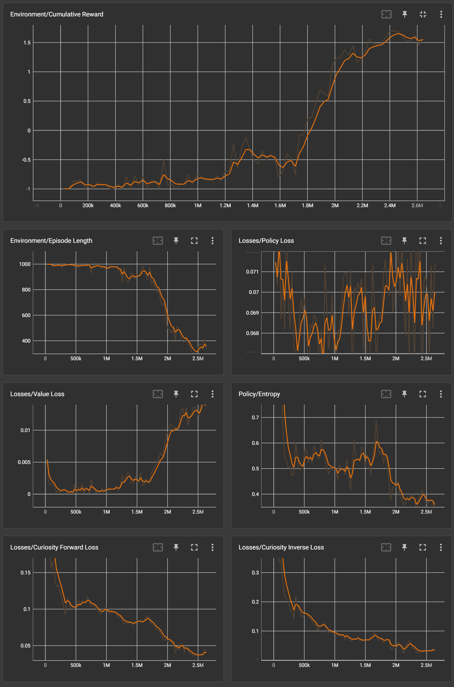

SAC result:

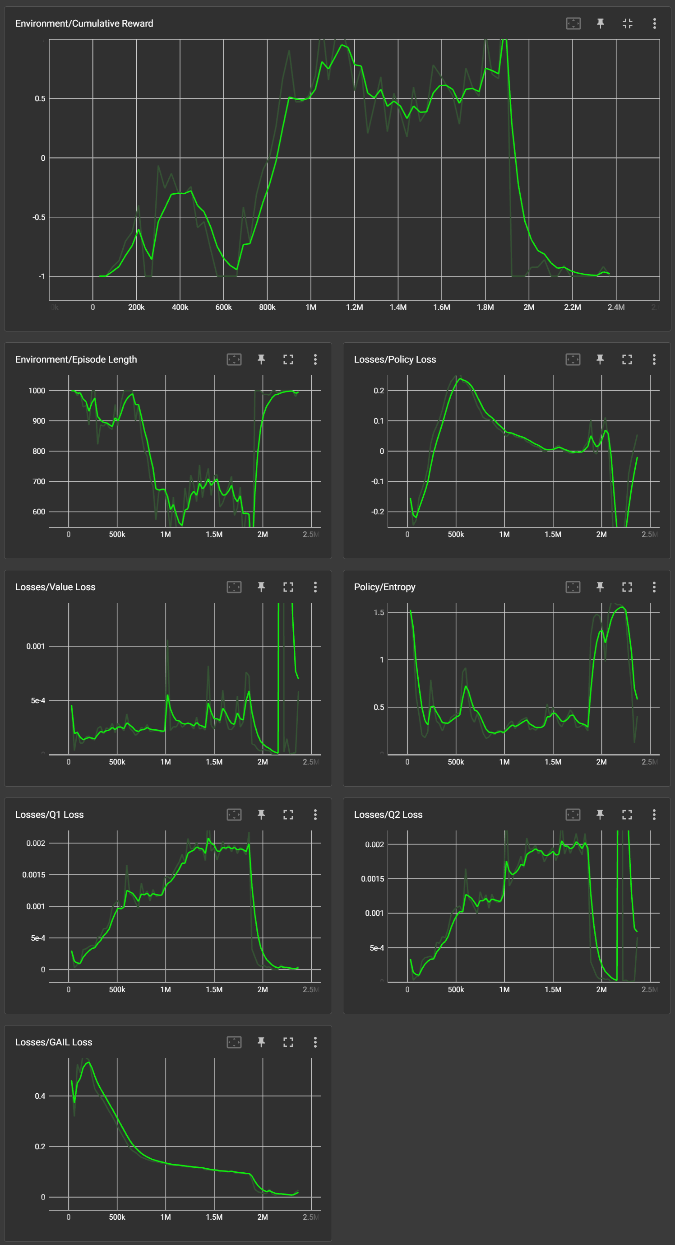

Comparison:

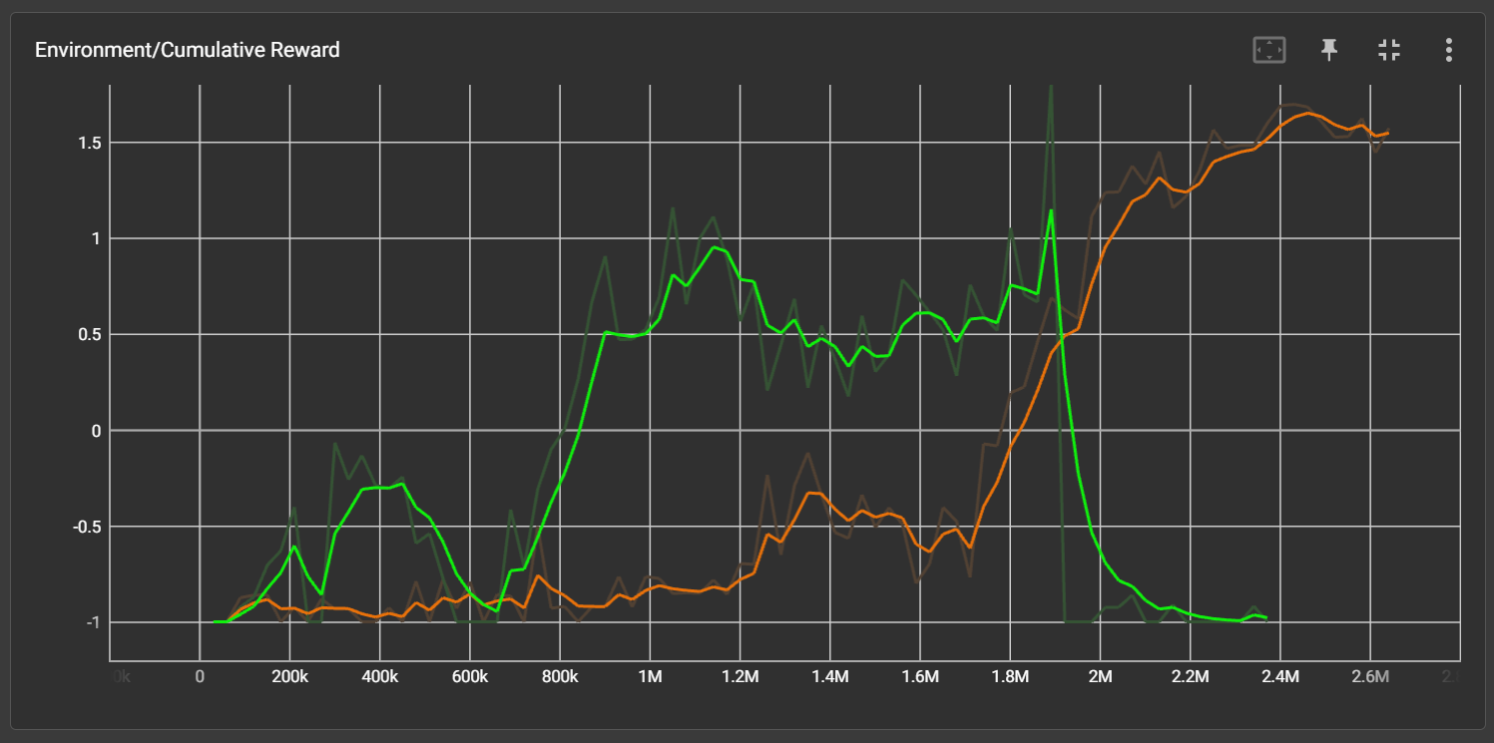

Comparison metrics:

1) Cumulative Reward:

According to the diagram, the highest cumulative reward of PPO is higher than that of SAC.

2) Stability:

The result of PPO has remained steadily on the rise, while SAC's result has fluctuated significantly and even dropped back to the bottom after reaching the peak for a period.

3) Convergence Speed:

Because there is a clear difference in the first metric, there is no need to compare this metric further.

4) Real Training Time:

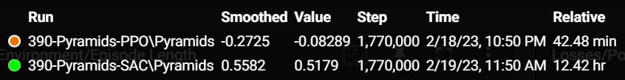

The time consumed by SAC is completely unacceptable, while PPO is very fast.

**6.5.5 Summary**

In summary, PPO outperforms SAC in all metrics, and SAC also has completely unacceptable real training time. Therefore, PPO performs better in complex environment which requires algorithm to have efficient exploration strategies, handle large state spaces, and develop "curiosity".

**6.6 preliminary conclusion**

According to the summary of 6.2 to 6.5:

1) 3DBall: PPO is better

2) Crawler: SAC is better

3) FoodCollector: PPO is better

4) Pyramids: PPO is better

Moreover, regardless of whether the cumulative reward of PPO is higher than SAC, its stability has always been higher than SAC. I believe that in the field of reinforcement learning, stability is a very important metric.

Therefore, PPO performs better overall.

**7. Testing & Evaluation**

**7.1 Testing: Agent Script Exploration - AI Racing Kart**

**<Declaration**: The game environment used in this section is an **open-source game environment: AI-Racing-Karts** in GitHub. Source code: <https://github.com/Sebastian-Schuchmann/AI-Racing-Karts>**>**

This section will start from the initial version to describe the impact of changes in the environment and script on the behavior of the trained agent, aiming to demonstrate the points to pay attention to when exploring using reinforcement learning to train a well-performing agent. There will be a brief conclusion at the end of this section to summarize the points to be noted when setting up the environment and writing the script. For the convenience of describing the exploration process, the first person perspective will be used in some parts of this section.

**7.1.1 Environment Introduction**

The AI Racing Karts environment is designed to train agents to drive a kart in a racing track using reinforcement learning. Agents must learn to navigate the track by reaching a series of checkpoints in the shortest possible time. The environment highlights the use of reinforcement learning for training agents in more complex environments, focusing on continuous control tasks and advanced navigation strategies.

1) Agent:

The agent in the AI Racing Karts environment has two primary components: observations and actions.

- Observations: The agent receives observations from the environment, which inform its decision-making. In the AI Racing Karts environment, the agent uses raycast observations to detect the track's boundaries and other objects in the environment.

- Actions: Based on the received observations, the agent takes continuous actions to control its kart. In the AI Racing Karts environment, the agent's actions include steering, acceleration and deceleration.

2) Reward System:

The reward system in the AI Racing Karts environment is designed to encourage agents to learn effective strategies for navigating the track quickly. The agent is rewarded as follows:

- Time penalty: The agent receives a small negative reward for each tick, encouraging the agent to drive faster and complete the track in a shorter time.

- Checkpoint reward: The agent receives a reward when it passes a checkpoint. This reward encourages the agent to hit checkpoint, in order to complete whole race (but this kind of reward setting has problem, which will be talked later).

- Lap completion reward: The agent receives a reward when it hit the final checkpoint. This reward encourages the agent to complete the whole lap.

- Checkpoint penalty: The agent receives a penalty if it takes too long to reach the next checkpoint or goes off the track. This penalty discourages the agent from taking shortcuts or deviating from the track.

**7.1.2 Appearance**

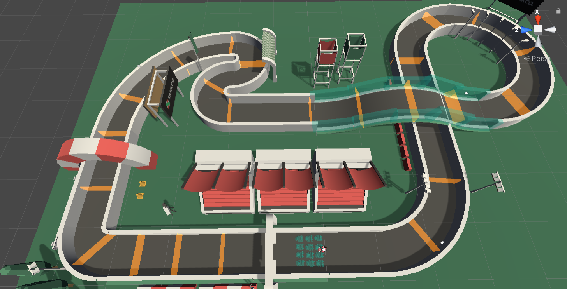

**7.1.3 Environment**

1) Important components

- Behavior Parameters

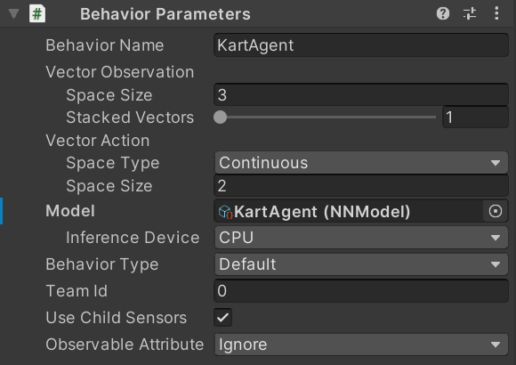

Space Size (Input Size): 3 dimensions

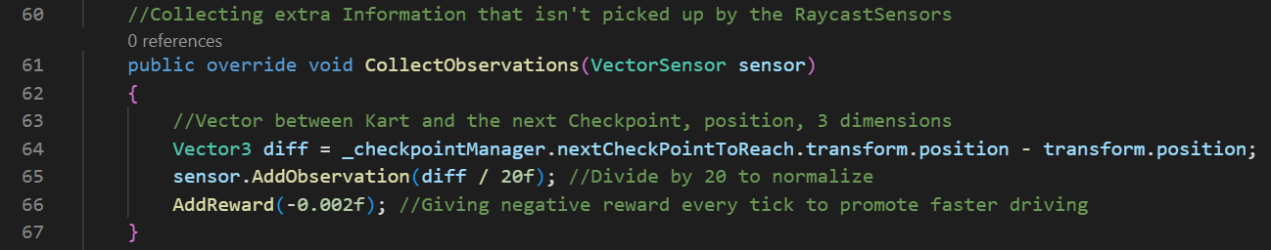

Continuous Action (Output Size): 2 dimensions

(The structure of action part in the screenshot is different, it is because the version of Unity is different, and the version need to adapt this open-source project)

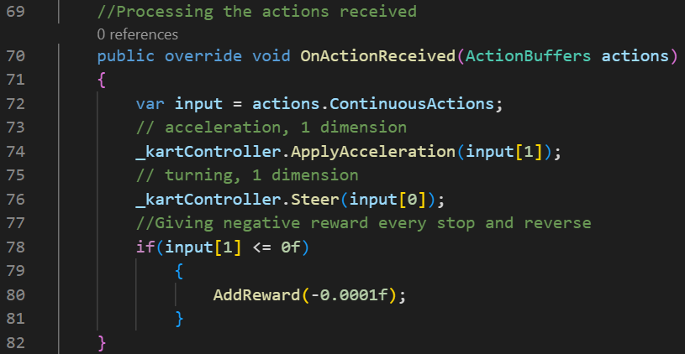

- Ray Perception Sensor 3D

There are 4 rays on the side of the kart for detecting walls, and 2 rays on the front for detecting checkpoints. The labels detected by each ray are: Wall and Checkpoint.

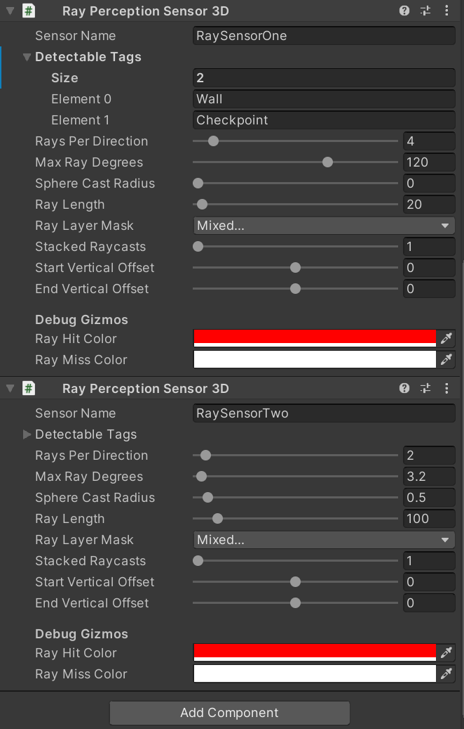

- Script: CheckpointManager.cs

The CheckpointManager script is responsible for handling the checkpoint system in the AI Racing Karts environment. It manages the checkpoint progression for the agent, ensuring that it follows the correct sequence of checkpoints while racing around the track. It also handles rewards and penalties based on the agent's performance.

Since there will be a single section to explain the reward setting later on, detailed content will not be discussed here. Below is the code and comments:

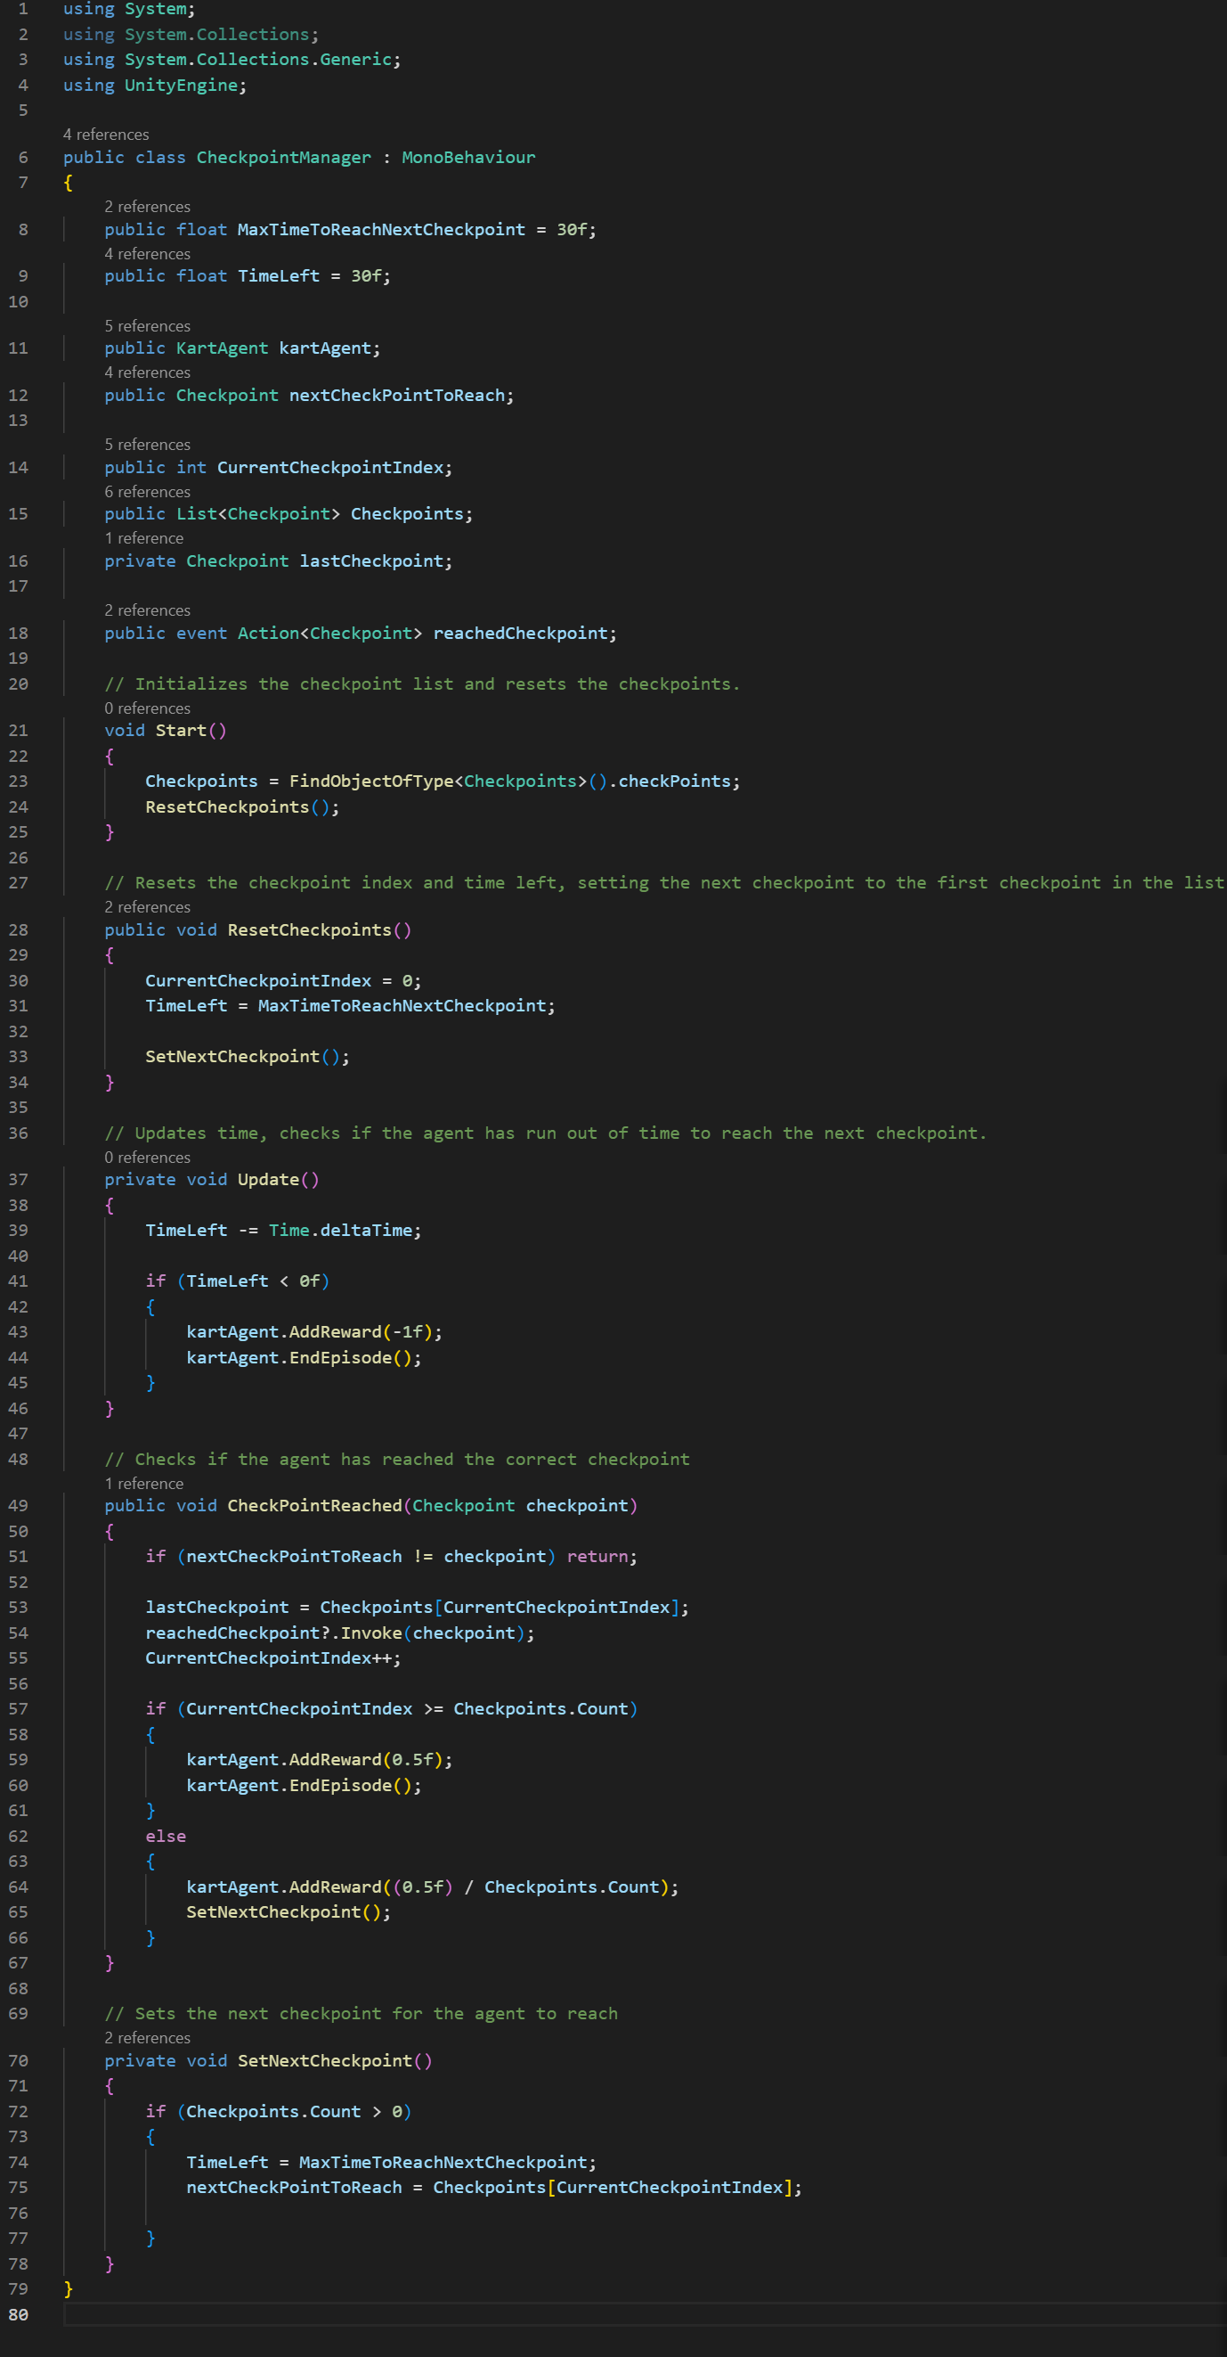

2) Agent script

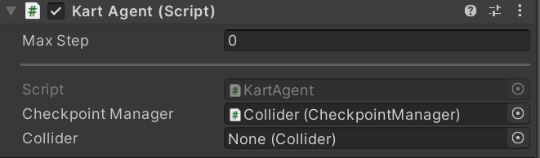

Complete code with comments:

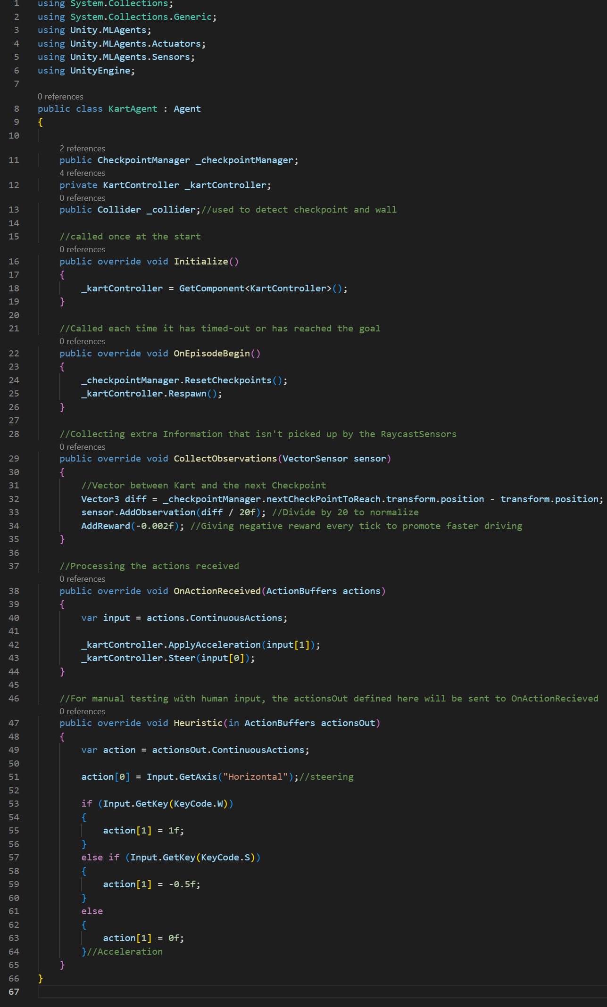

3) Reward system (detailed)

All reward name comes from 7.1.1 Environment Introduction.

- in KartAgent.cs

Time penalty (line 34):

The agent receives a small negative reward of -0.002 for each tick, encouraging the agent to drive faster and complete the track in a shorter time.

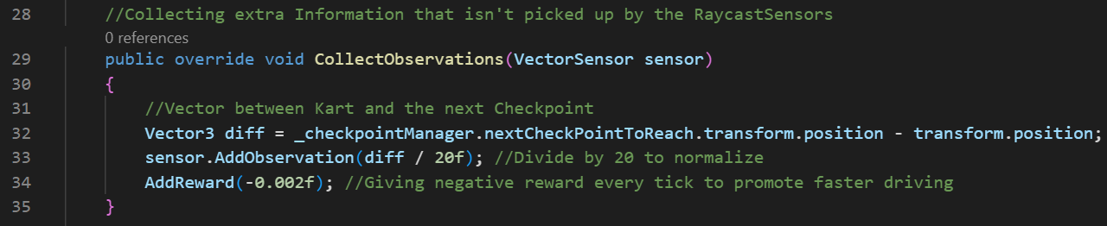

- in CheckpointManager.cs

Checkpoint reward (line 64):

It awards the agent a reward when it reaches a checkpoint. The reward is 0.5 divided by the total number of checkpoints, ensuring that the total reward for reaching all checkpoints is 0.5. This reward encourages the agent to reach checkpoint, in order to complete the race.

Lap completion reward (line 59):

It awards the agent a reward of 0.5 when it hit the final checkpoints. This reward encourages the agent to complete a whole lap.

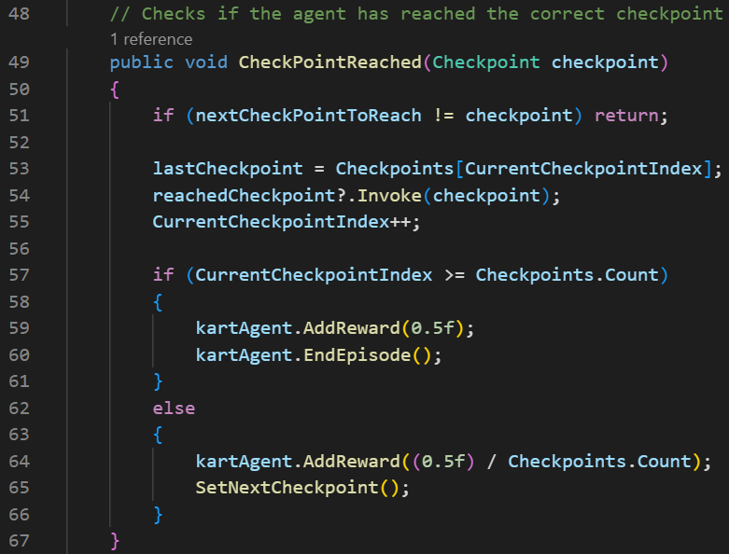

Checkpoint penalty (line 43):

It applies a penalty of -1 if the agent takes too long to reach the next checkpoint (i.e., when TimeLeft becomes negative), and this agent's episode also ends.

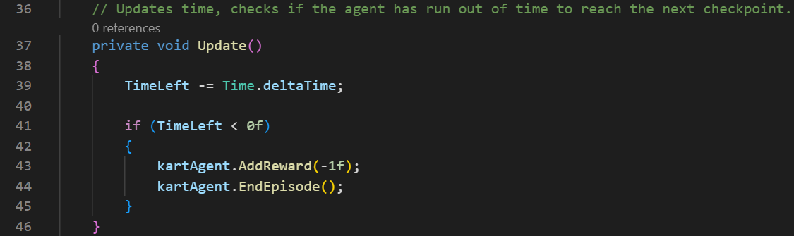

4) Training hyperparameter configuration:

According to the conclusion of Implementation part, PPO is used for training.

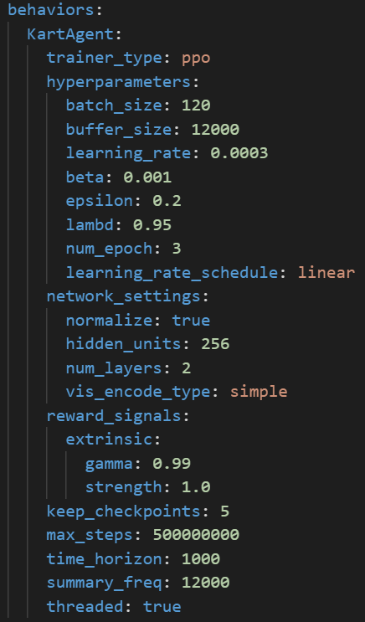

**7.1.4 Version1**

This version is the environment explained above.

1) Training results evaluation

The training effect is not very good, and the cumulative reward increases too slowly. The car has many strange movements (especially like hitting walls).

**7.1.5 Version2**

1) Change1 and evaluation

- Add a collision detect in KartAgent.cs:

I found that all the components of the entire track are labeled as “Wall”:

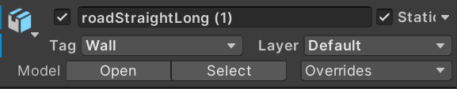

To reduce the number of times the car hits the wall and indirectly improve the speed of the car completing a lap, I added two methods: when the car hits or stays on an object with a tag of “Wall”, it is given a penalty.

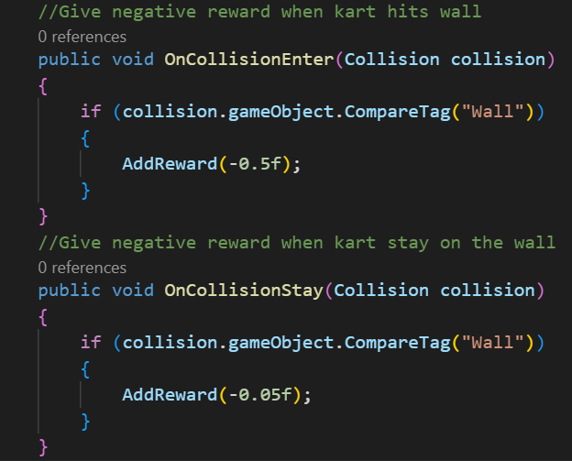

- Evaluation:

The cumulative score of the agent has a huge decline, while the training effect has not improved significantly. The reason for this phenomenon is that the walls and the track itself are integrated in the environment, and their tag is “Wall” as a whole. Therefore, the agent will always be in the state of “stay on wall” throughout the race, resulting in constant deduction of points.

2) Change2 and evaluation

- Change the whole environment

I added a series of phantom objects to the environment, which surround the entire track and are labelled as “Obstacle”. Add “Obstacle” in the list of label detected by Ray Perception Sensor 3D. Change the tag in CompareTag() in methods added in Change1 from “Wall” to “Obstacle”.

Screenshot:

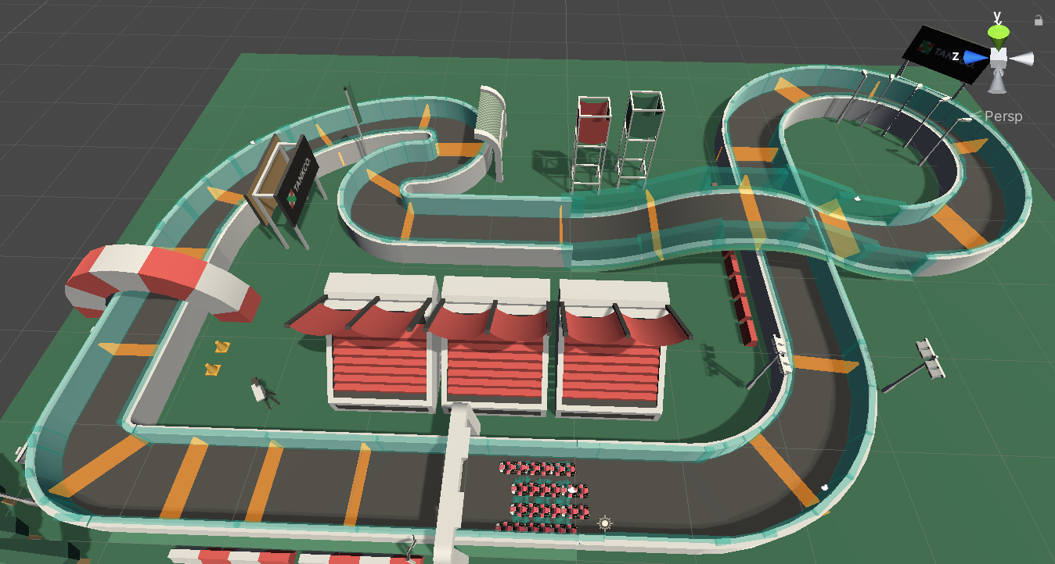

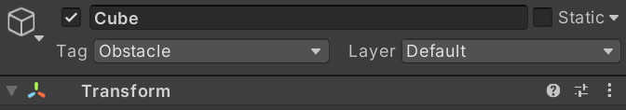

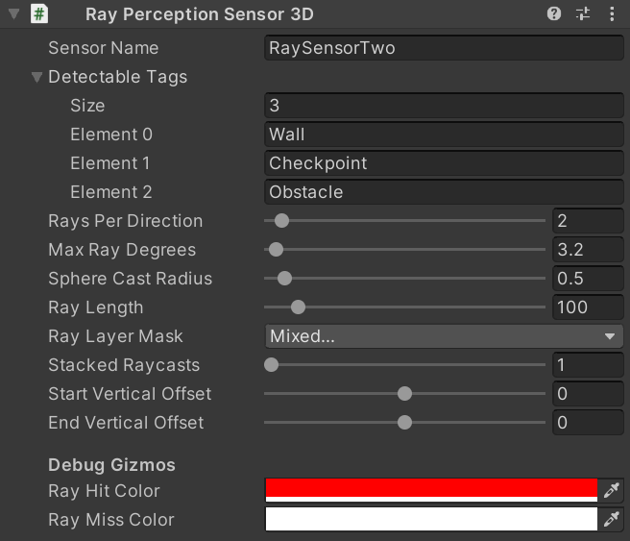

- Evaluation:

The cumulative score of the agent declines (which is inevitable because only punishment added without increasing rewards). The behavior of the agent has become more bizarre, often circling in place and not tending to move forward.

The reason for this phenomenon is that the punishment for hitting the wall is set too high, which is equivalent to the reward for reaching the goal, far exceeding the fixed penalty set to promote fast driving. Therefore, the agent tends to avoid hitting the wall rather than reaching the goal quickly. This is a typical reward setting problem in reinforcement learning, where excessive punishment/reward can overshadow the influence of other environment settings on the agent. Additionally, it was found that the agent repeatedly moves back and forth between two checkpoints, which is because the environment only provides a score reward for reaching a checkpoint, but does not differentiate between checkpoints, leading the agent to believe that it can accumulate score by moving back and forth between them (this problem will be addressed in the next version).

3) Change3 and evaluation

- Change the penalty setting in collision detect:

Set the penalty when kart hits the wall to 0.001, and when kart stays on the wall, give 0.0005 penalty every tick.

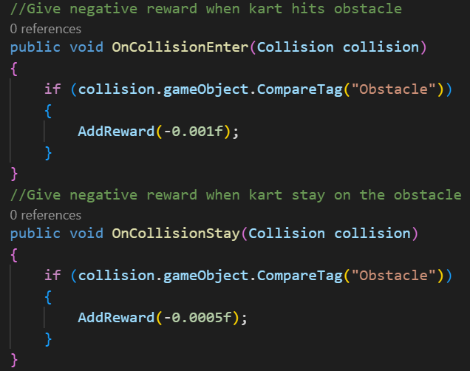

- Evaluation:

The training performance is good, and the cumulative reward is increasing faster than in version1.

**7.1.6 Version3**

1) Change1 and evaluation

- Add right checkpoint reward in collision detect:

When kart hits the right checkpoint, give 0.01 extra reward, but when it hits the wrong checkpoint, give 0.01 penalty. This can avoid the behavior of the agent to accumulate scores by going back and forth between two checkpoints, and encourage it to always move towards the next checkpoint until reaching the finish line.

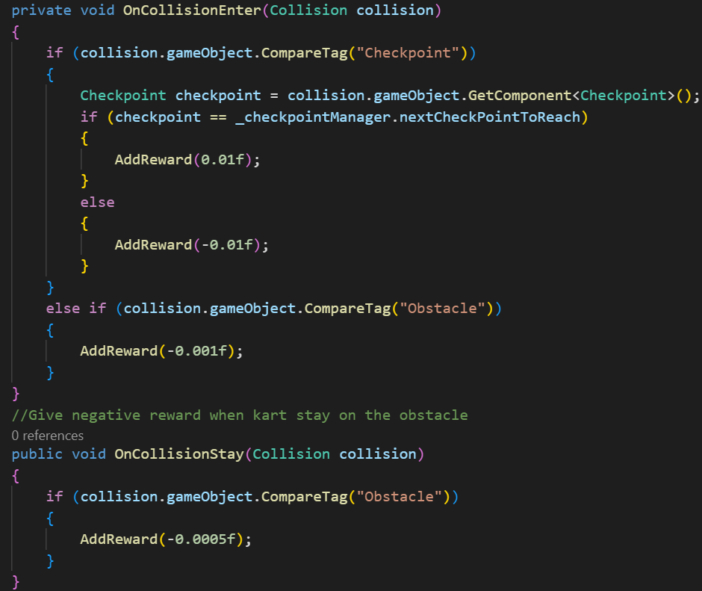

- Evaluation:  
The training performance is better than version2, the agent is able to complete the entire race at a very fast speed. However, in the most difficult turn of the track, the agent exhibits strange behavior:

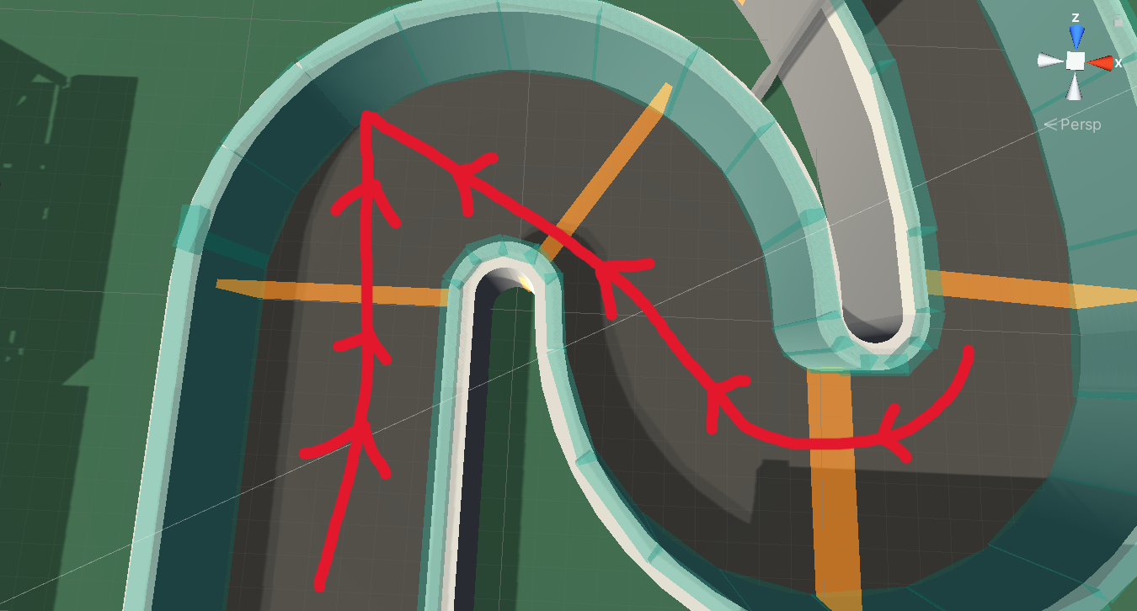

As shown in the figure, the line represents the trajectory of the agent, and the arrow represents the direction of the car's front. It can be seen that the agent chooses to collide with a wall once in this S-shaped turn and then drives backwards to complete the remaining race. This approach can ensure a relatively fast cornering speed, as there is almost no need to slow down, but it does not make sense. The reason for this phenomenon is that the maximum speed of the agent moving forward and backward is the same.

2) Change2 and evaluation:

- Add a penalty in OnActionReceived() method:

Add a very small penalty (for not overshadowing other settings) for reverse driving and slow down to 30% of its maximum speed. The reason for not directly setting a penalty when the speed is less than 0.3 is that if a penalty is set when the speed is less than 0, the agent would rather scrape against the wall to maintain a certain speed instead of adjusting its position by moving backwards. This would have a significant impact on the training.

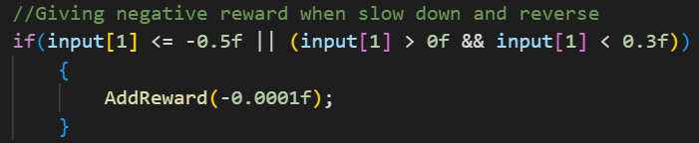

- Evaluation:

The training performance is very good. This is the final version.

**7.1.7 Final Version Show**

- Agent Script:

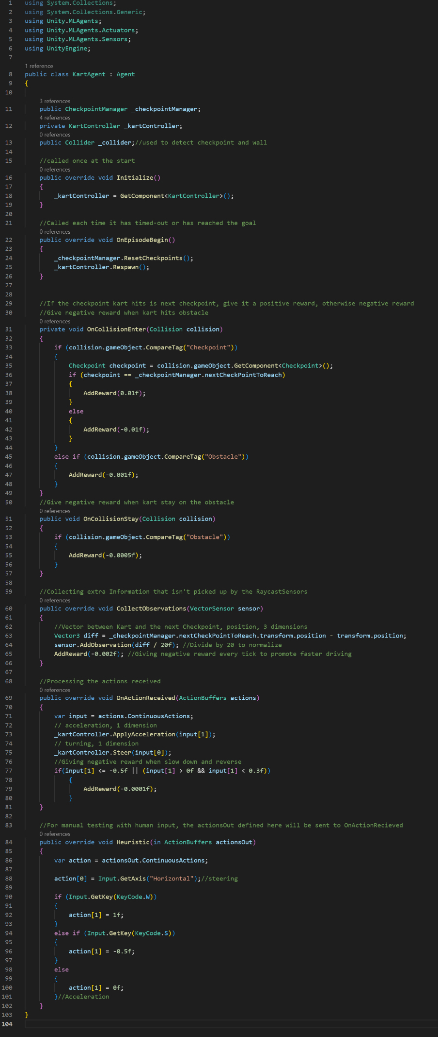

- Training result:

A large fluctuation in the cumulative reward may indicate that the agent is switching strategies.

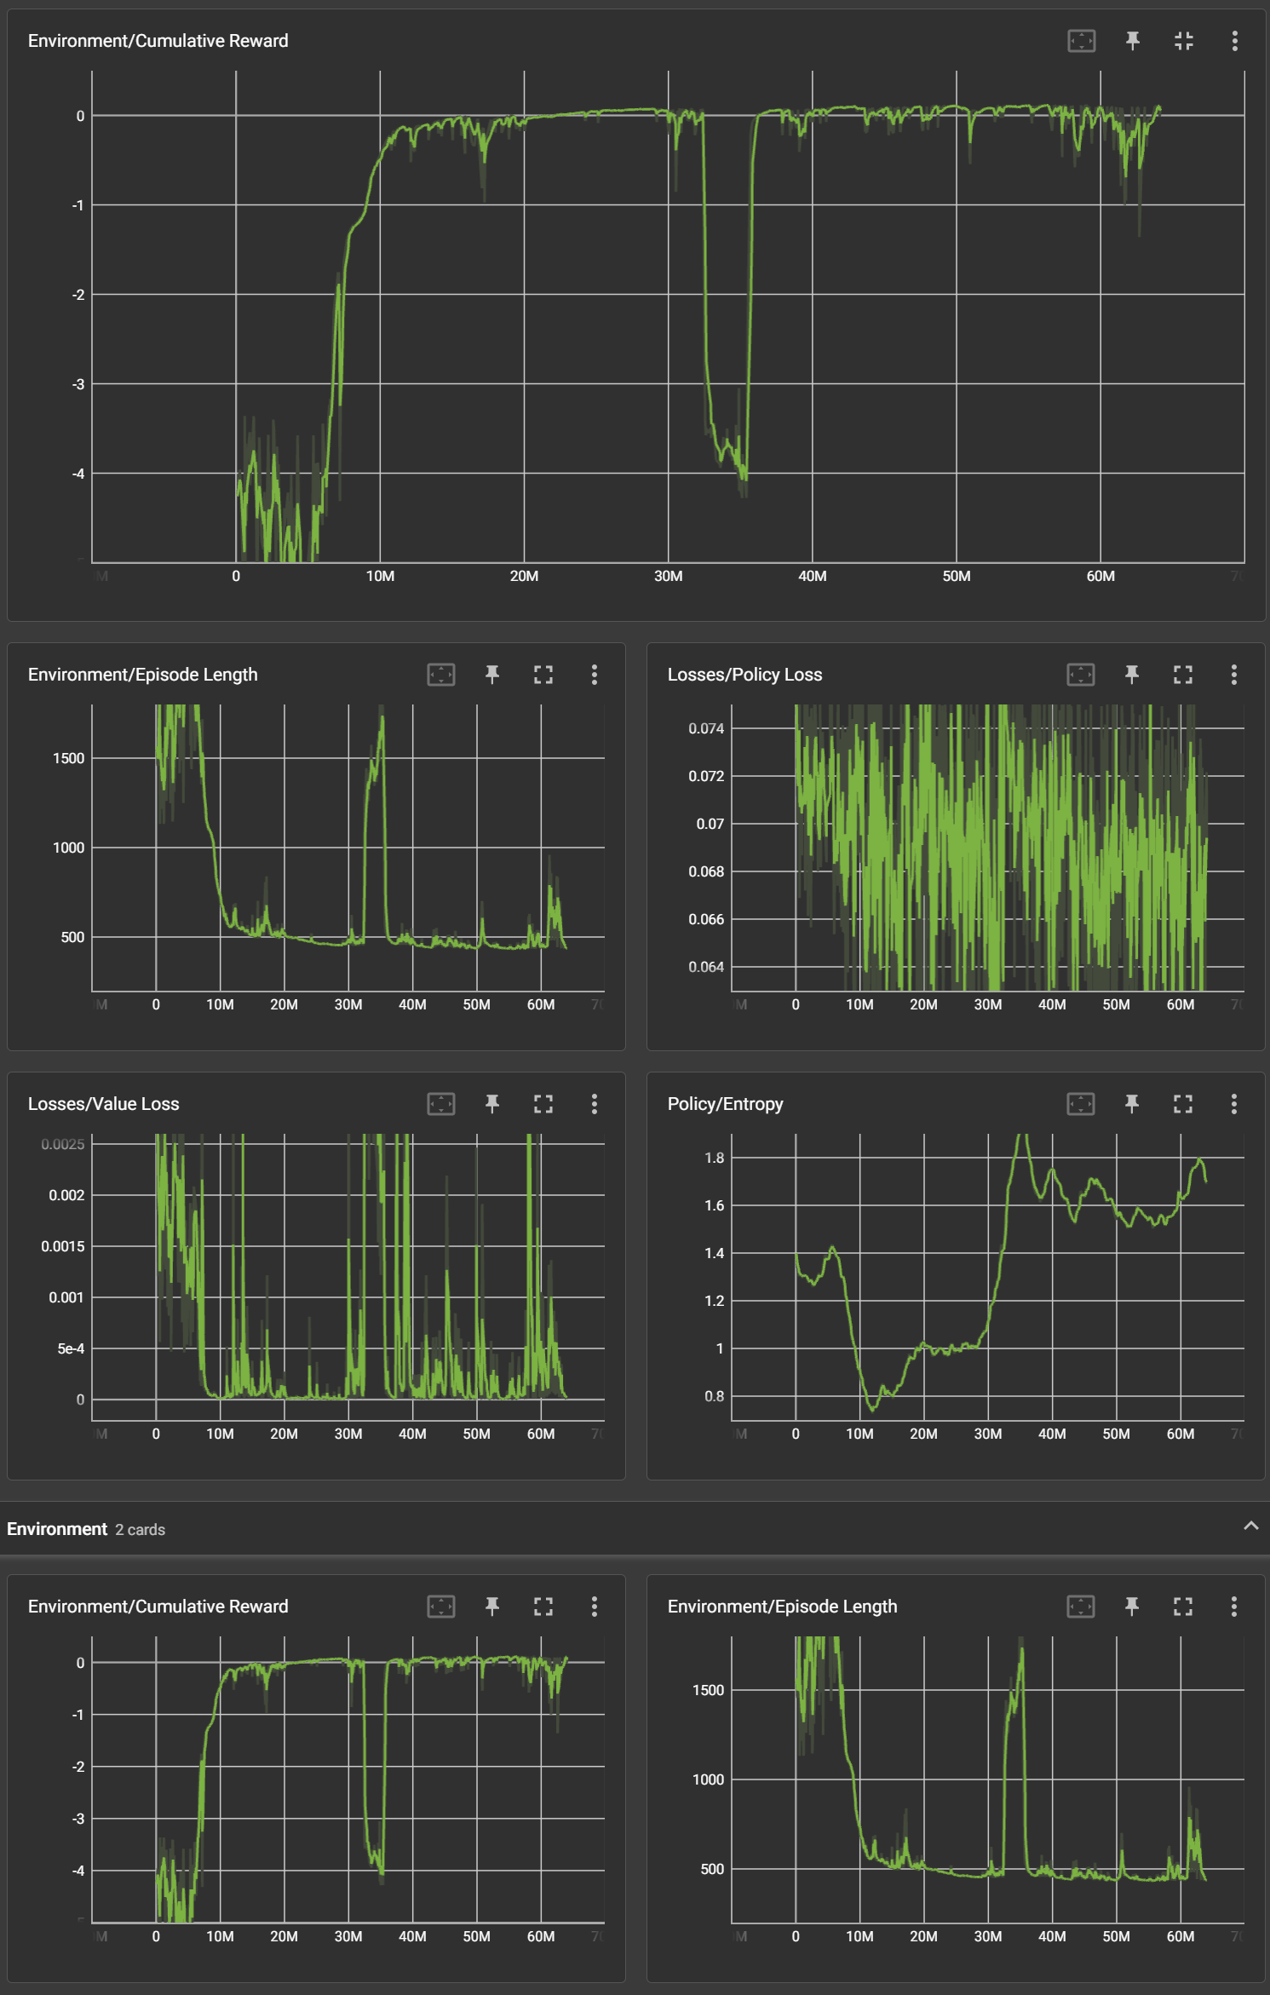

**7.1.8 Conclusion**

The most critical part that affects the training result of an agent in reinforcement learning is the reward settings in the script. Based on the exploration in the AI Racing Kart environment, there are two crucial aspects to reward settings:

1) The punishment/reward values need to be moderate

When the punishment/reward is too significant, it will overshadow the other environmental factors' influence on the agent. In this situation, the agent will persist in repeating high-reward behavior or avoiding high-punishment behavior without considering other factors.

2) Carefully consider the event scope that deserves punishment/reward

When setting the environment, one should imagine the AI as a mischievous child who will not miss any loopholes. Think carefully about whether the current settings may cause unusual AI behavior.

**7.2 Testing: PPO Reimplementation**

The reimplementation of PPO algorithm consists of 3 python files: my_ppo.py, agent.py and train.py. The following sections will describe the reimplementation on a file-by-file basis. The code within each Python file will be divided into several blocks for explanation purposes, so complete code screenshots will not be provided (the code has been well commented).

The Gym-Unity package of Unity Official ML-Agents Toolkit is used. Gym-Unity can wrap the executable file packaged by Unity into an environment that can be used to train reinforcement learning agents in gym. It is worth noting that Gym-Unity can only have one agent in the environment, so having multiple agents or copying multiple agents to accelerate training is not possible. However, the Agent's Time Scale can be set to 20 during build, which increases the agent's execution speed by 20 times and speeds up the interaction with the environment. The main part of the algorithm is mainly written using the PyTorch package.

**7.2.1 Introduction**

The variant of PPO chosen to reimplement is **PPO2**.

In the PPO2 algorithm, the agent uses two separate networks, an actor network and a critic network. The actor network is responsible for generating the probability distribution for selecting actions, while the critic network estimates the state values. The agent uses the PPO objective function to update the actor network, which includes a clipped surrogate objective that prevents the new policy from deviating too much from the old policy. The agent also uses the GAE technique to calculate advantage estimates, which combines the temporal difference error and future rewards.

**7.2.2 my_ppo.py**

This file defines two network in PPO: Actor Network and Critic Network.

1) Import

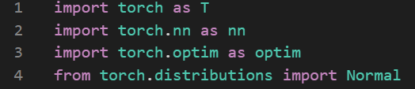

2) Actor Network

The Actor network is used to input the state and output the distribution of actions. As the action space is continuous, a probability distribution function is required, with the normal distribution being the mainstream choice. To determine this distribution, the mean and variance need to be specified.

Initially, the method used was to have the network output a tensor of size action_dim * 2, which were used for mean and variance respectively, but the results were not satisfactory.

The results difference between initial method (grey) and method below (blue):

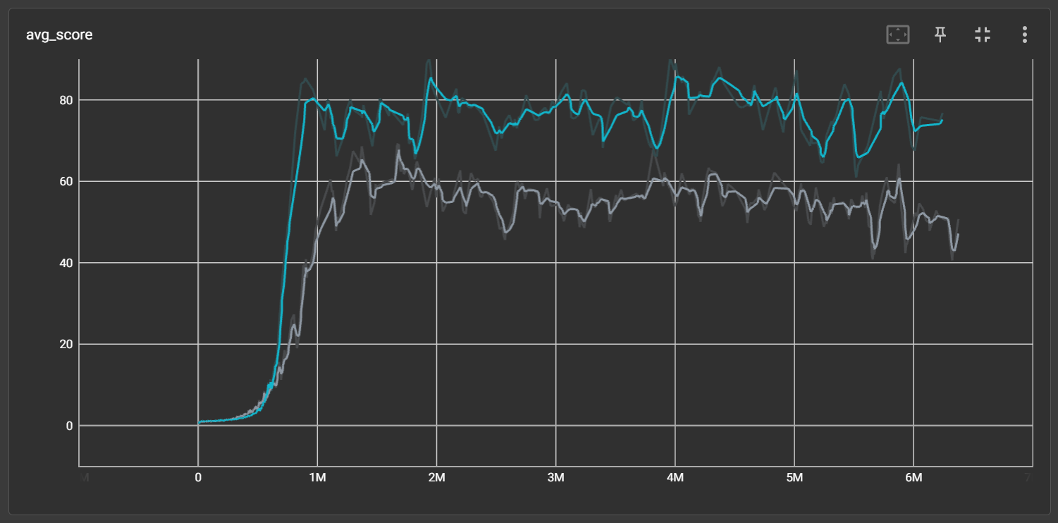

Then I learned that other researchers use a method where the network only outputs the mean, and then uses the Tanh function to constrain the mean to the range [-1, 1], while initializing the variance as a tensor of all zeros and training it as a separate parameter. Finally, the exponential function is used to ensure that the variance is greater than zero.

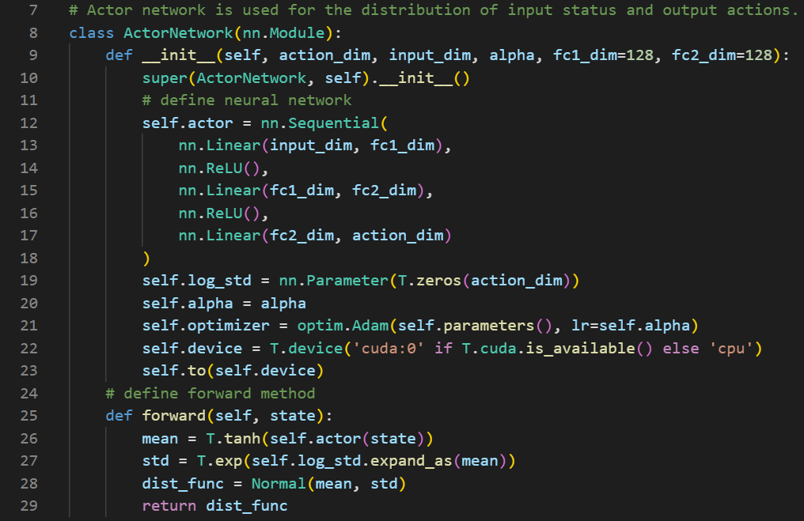

3) Critic Network

Critic network is used to input the state and output the value. There is nothing special to say about this class.

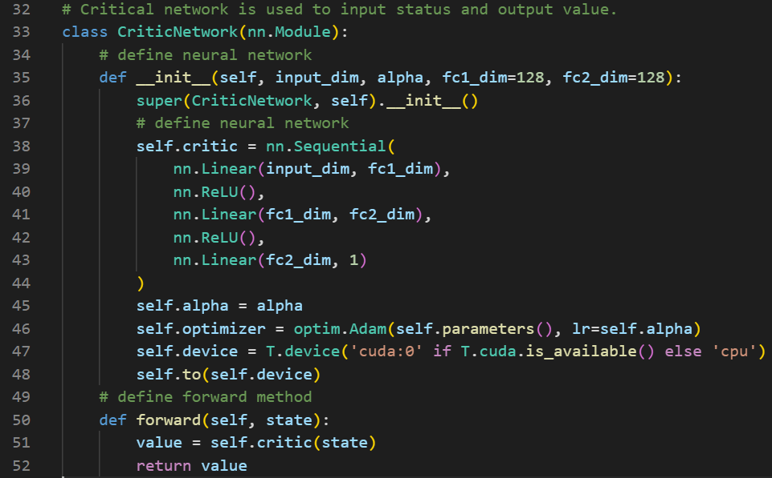

**7.2.3 agent.py**

1) Import

As shown in screenshot, two networks are imported from my_ppo.py.

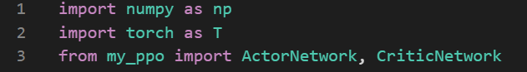

2) Memory class

This class is used to store agent training parameters.

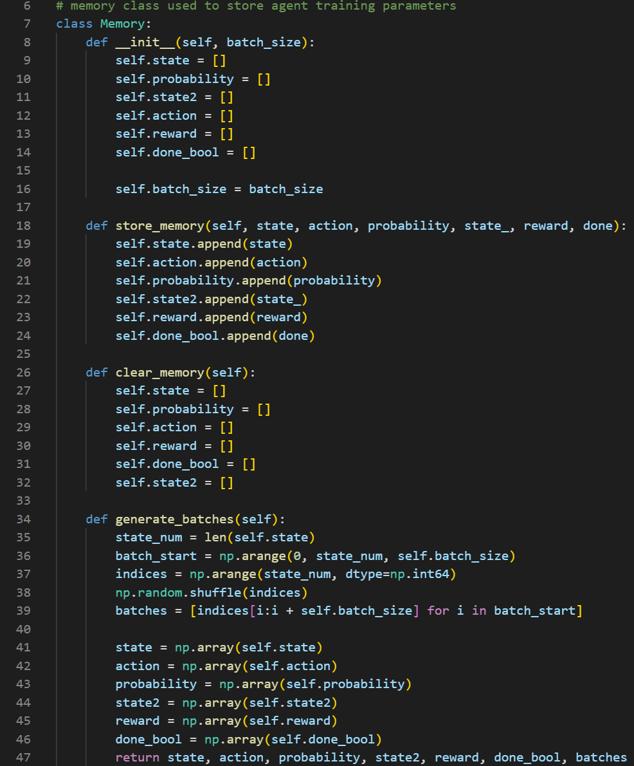

3) Agent class – select_action()

Agent class serves as the central component that interacts with the environment, stores experiences, and updates the actor and critic networks.

The first thing is sampling actions to interact with the environment and calculating the probability of sampling that action. A detail here is that since the action is two-dimensional, it is necessary to multiply the probabilities of these two dimensions to obtain the probability of this action. Thus, the log of the probabilities is added together, and this probability and action are added to the Memory used for training.

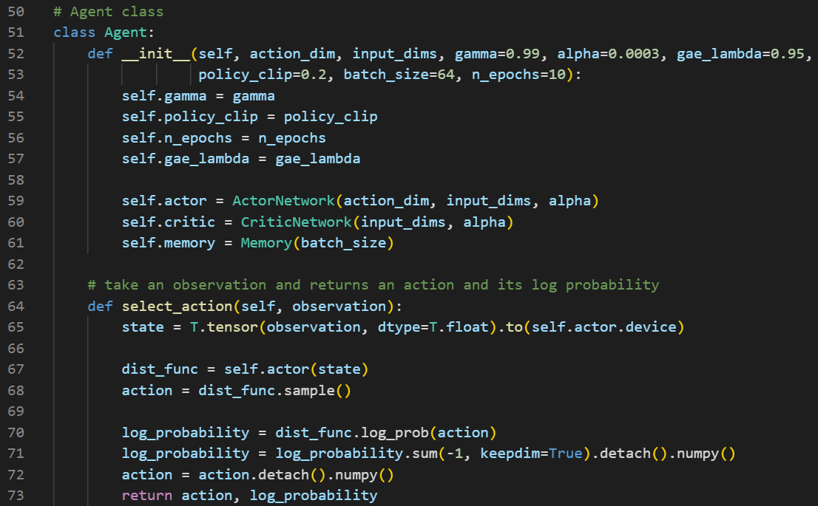

With this, agent can interact with the environment, and then add the collected information such as states, actions, probabilities, rewards, next states, and whether an episode is complete, to the Memory.

4) Agent class – learn_process()

Once a batch of data is collected, agent can calculate the loss and start learning the network.

First, the Generalized Advantage Estimation (GAE) need to be calculated, which is a good method for estimating future rewards, to compute the TD error and Advantage. Then, based on the TD error, the Critic's loss can be calculated to update the Critic network parameters. Next, the new log_probs of each sample in the batch for the new actions need to be calculated, which are used to compute the Actor's loss according to the PPO2 formula. Finally, the network parameters are updated based on the Actor and Critic's losses.

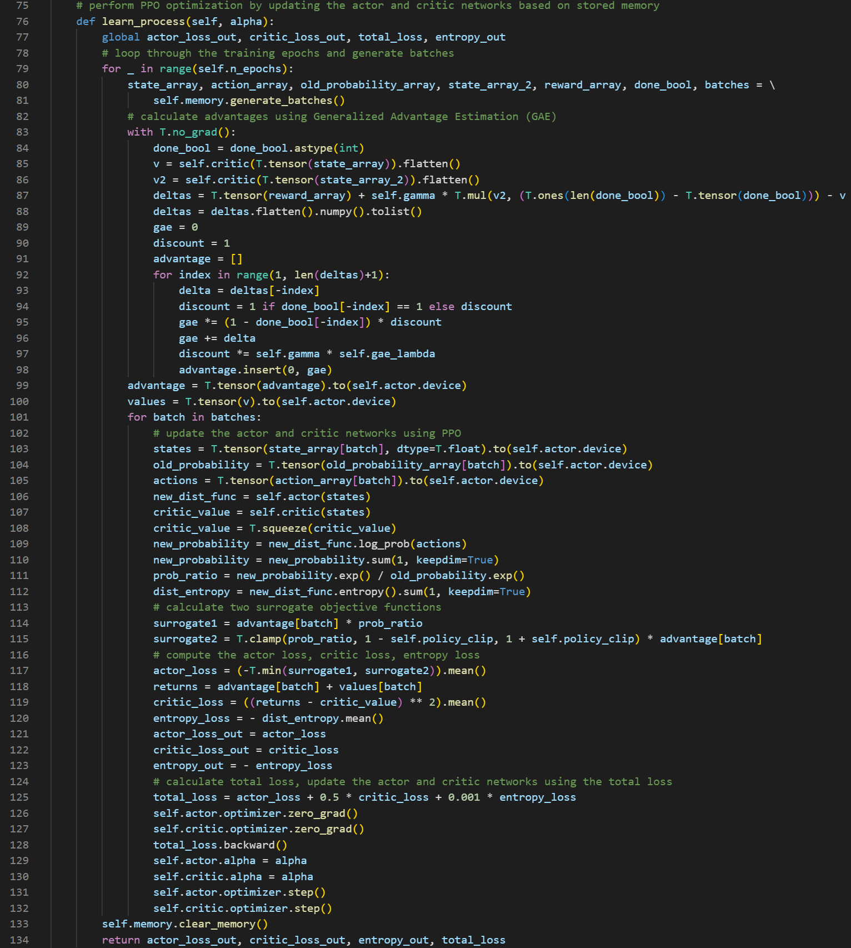

5) Agent class – other methods

- Update(): It stores parameters in memory.

- save_model(), load_model():Save and load the agent's model to and from local .pth file respectively.

(The .pth file is not an .onnx file and cannot be directly used in Unity.

.pth file: It is a file format specific to PyTorch that is used to save model weights and other information. This file format is specific to PyTorch and can only be loaded and used in PyTorch.

Not all deep learning operations and model structures are covered by .onnx file. Therefore, converting a custom algorithm's model to an .onnx file is relatively difficult. This project does not practice converting the model to an .onnx file.)

- model_to_network(): It updates the agent's actor and critic networks based on a given model.

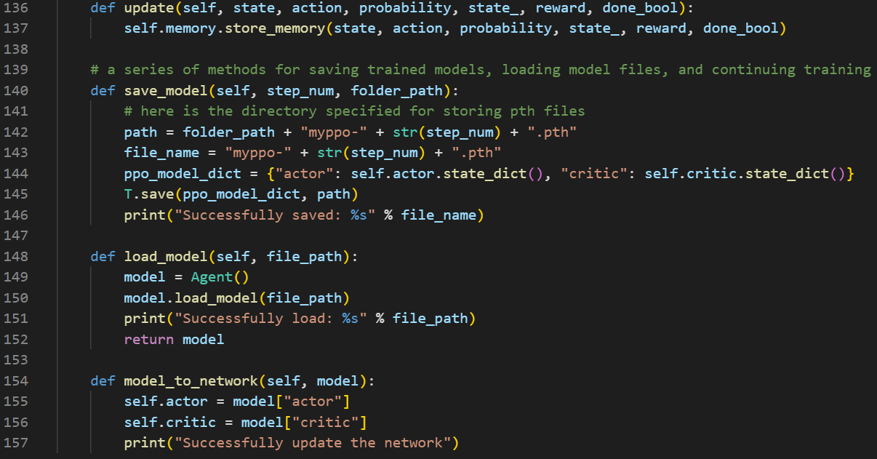

**7.2.4 train.py**

This file essentially serves as the hyperparameters configuration file (.yaml file). The entire code is well-commented, so there is no need to elaborate further.

1) Import

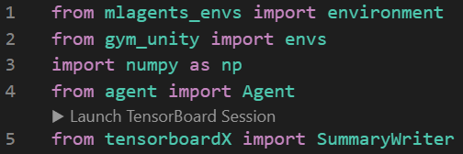

2) Settings before training

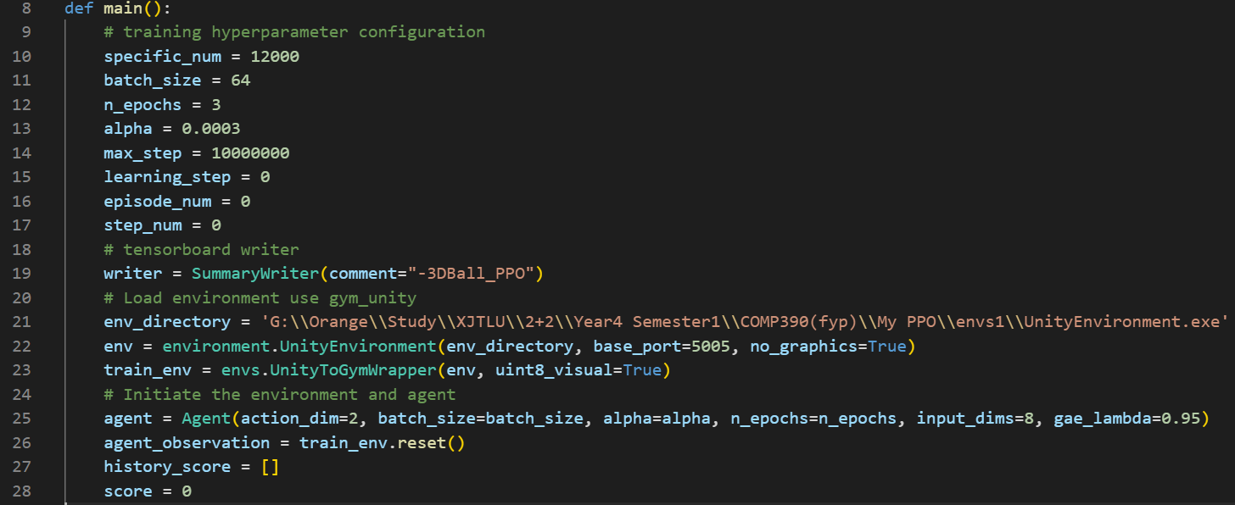

3) Start training

The learning rate was initially fixed at 0.0003, and after training for a while, the average return always started to oscillate severely, making the training process less stable. According to the PPO source code in ML-Agents, keep a small number, and the learning rate is set to decrease linearly according to the training progress. This makes the training process particularly stable.

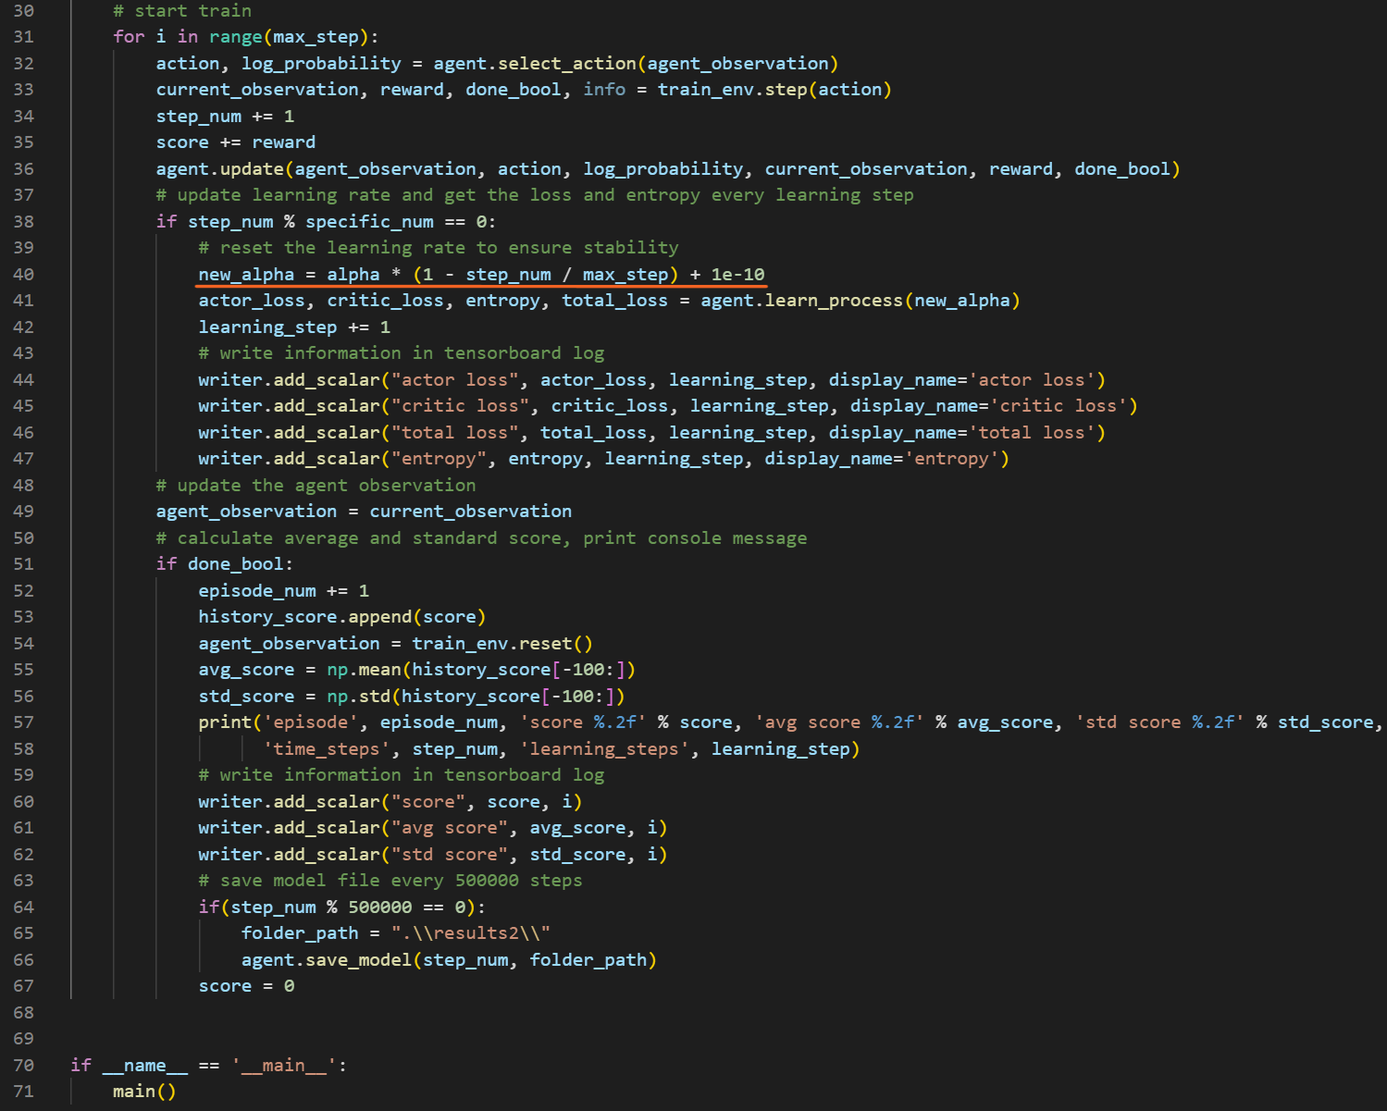

**7.2.5 Training Result and evaluation**

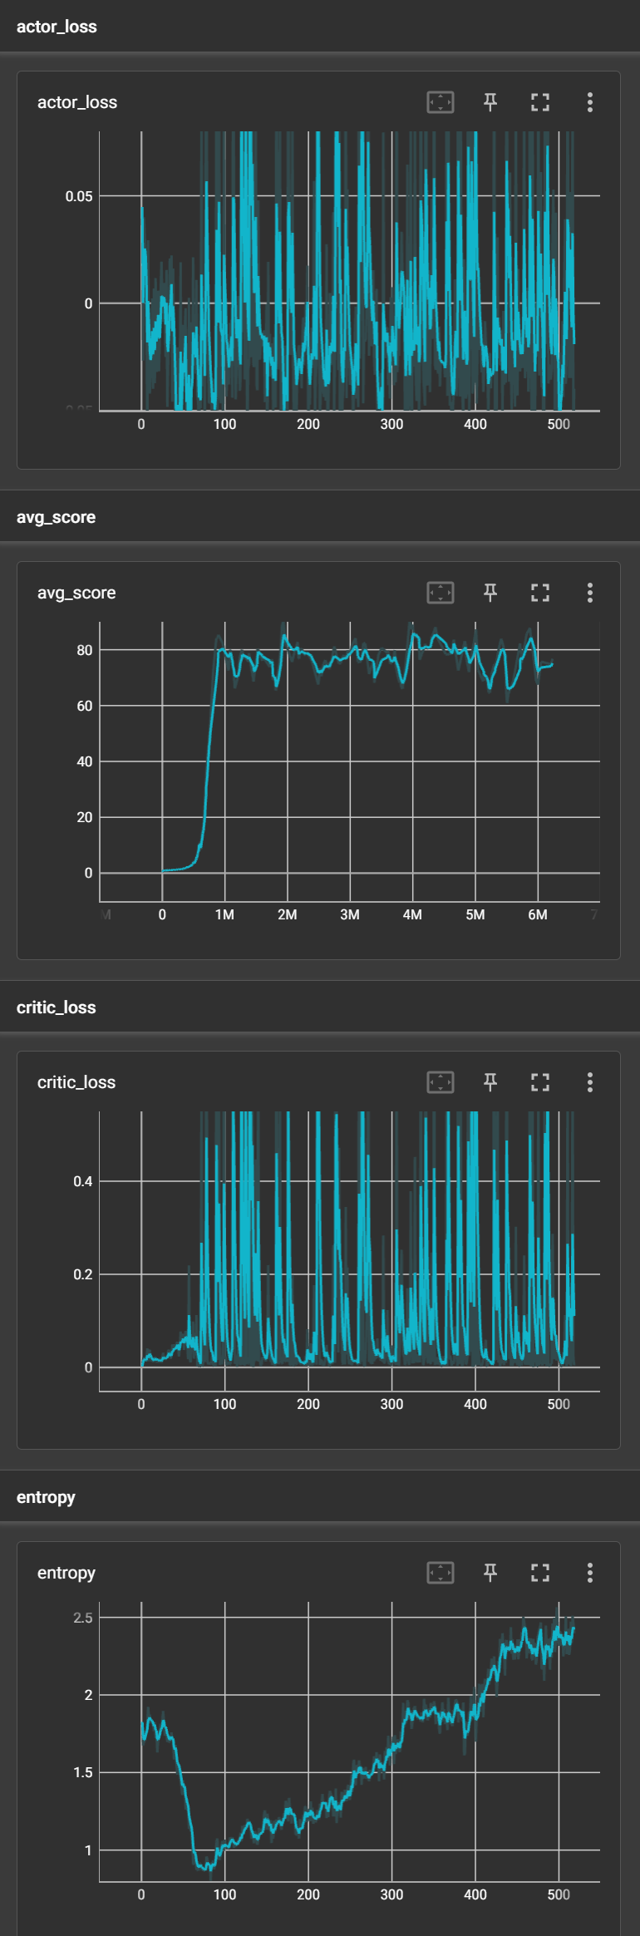

As shown in diagram, compared to the official PPO algorithm in ML-Agents, my algorithm's performance is much worse. First of all, the agent did not reach a perfect score of 100 points, but only hovered around 80 points, and the stability of the algorithm was also worse, with more pronounced oscillations.

**7.3 Evaluation**

As this project is a research-based project, the initial aims and objectives can be directly compared to check if they have been met. Below is the checklist:

**Aims**

* Use two different reinforcement learning algorithms to train agent model in 4 different simple video games. ✔
* Successfully analyse the training results and find a particular reinforcement learning algorithm performs better. ✔
* Explore how to train a better agent model by using existing algorithm in 1 more game and try to reimplement this algorithm. ✔

**Objectives**

* Successfully use Unity to run 4 simple video games. ✔
* Successfully understand the game environment (like reward setting) of each simple video game. ✔
* Successfully use PPO and SAC algorithm to train agent model in each game. ✔
* Successfully generate the training results which can be analysed. ✔
* Successfully identify the algorithm that performs better overall. ✔
* Explore the way to train a better agent model while using RL algorithm in a new game. ✔
* Successfully Reimplement the better algorithm at the code level. ✔

As can be seen above, all the aims and objectives are met.

**8. Conclusion**

**9. BCS Criteria & Self-Reflection**

**10. References**

[1] R. S. Sutton and A. G. Barto, Reinforcement Learning: An Introduction. Cambridge, MA, USA: The MIT Press, 2018.

[2] V. Mnih et al., "Playing Atari with Deep Reinforcement Learning," in NIPS, 2013, pp. 1-9.

[3] J. Kober and J. Peters, "Reinforcement Learning," in Künstliche Intelligenz, vol. 29, no. 3, pp. 285-295, 2015.

[4] M. Riedmiller, "Deep Reinforcement Learning," in Annual Review of Control, Robotics, and Autonomous Systems, vol. 1, no. 1, pp. 1-28, 2018.

[5] J. Schulman, F. Wolski, P. Dhariwal, A. Radford, and O. Klimov, "Proximal Policy Optimization Algorithms," arXiv preprint arXiv:1707.06347, 2017.

[6] A. Rajeswaran, S. Ghotra, B. Ravindran, and S. Levine, "EPOpt: Learning Robust Neural Network Policies Using Model Ensembles," arXiv preprint arXiv:1610.01283, 2017.

[7] T. Haarnoja, A. Zhou, P. Abbeel, and S. Levine, "Soft Actor-Critic: Off-Policy Maximum Entropy Deep Reinforcement Learning with a Stochastic Actor," arXiv preprint arXiv:1801.01290, 2018.

[8] G. Barth-Maron, M. W. Hoffman, D. Budden, W. Dabney, D. Horgan, D. TB, and N. de Freitas, "Distributional Policy Gradients," in Proceedings of the 32nd AAAI Conference on Artificial Intelligence, 2018.

[9] D. Yarats, A. Zhang, and S. Levine, "Improving Policies via Search in Cooperative Partially Observable Games," arXiv preprint arXiv:1901.08043, 2019.